Shaanxi
(Central):

(shan che) W & SW of Shanxi)

Xian
( T, D, N, T))
西安
(LP414m, 416m, 415, DK163m, 162 )
(
Xī'ān,
(KWL)
Climate: Nice! Oct: 66, 50-68 R-low Nov: 45, 37-54 R-low
Travel Agencies:
Golden Bridge Travel (tel: 725 7975, fax 725 8863) DIRECS: 2nd floor of Bell Tower Hotel.
friendly staff & willing info even if don’t use;
CITS: (LP416m, 417 )
(19A6) Zhongguo Guoji Luxingshe) branch is also on the 2nd floor of this hotel. (Tel: 524 1864)
(4B3) office on Chang'an Lu, short walk S of Youyi Xilu
TRANS IN:
By Xian TRN:
解放路）
Xian STA at N end of Jiefang Road (
.
RR STA: easy from anywhere, BUT several stops around station, but w/in
200 meters of STA.
By BUS
main LD Bus STA across from main RR STA.

TRANS IN:
1) If POSSIBLE: from Lishi > Xi’an: POSSIBLE, but circuitous 18 hr trip NO
2) BEST: Pingyao > Hancheng.
3) If NOT possible: PIngyao > Xi’an
BUS: REG , New South Bus STA,
Check Travel China Guide for SCHED
New Bus STA short walk from N Gate
TRAIN: from train STA (6 daily, 8 ½ hr-11 1/2hrs) BOOK EARLY:

SEE Pingyao > Xian TRN SCHED – separate page

MAP: Xi'an Tourist Map: everywhere.; bilingual; many listings; often updated - bus routes correct.
.
TRANS: LOCAL: lots buses & cheap taxis; Subway : maybe complete 2011
BUS:
#610: TRN >Bell Tower > Lttle Goose PAG > Shaanxi HIST MUS > Big Goose PAG
TAXI:
3 > 5pm shift change = rushing to handover points - won't STOP.
W/in walls = ¥10; longer trips > S = ¥12-20. Long rides: always insist on taxi meter.
st
Normal (green) taxis = ¥6 for 1
2 km & ¥1.5 ea added KM. Waiting times = ¥1.5/ min. After
11PM the starting price is ¥7.
Black taxis: ¥2.4 / KM, but nicer.
Airport Expressway road fee = ¥10 extra , so pay.

Money: (LP416m, 417)
Bank of China 2 branchs: (main) 223 Jiefang Lu, N of Dong Wulu. M-F, 8.30am > noon & 2pm >
5.30pm ; weekends: 9am > 3pm; also on Dong Dajie – foreign exchange w/ similar hours.

HIST:
Rome & later Constantinople vs Xian: greatest world city; 3,000 yrs history; aka Chang'an
(rectangular shape grid) in ancient times: 1,000 years: capital of 13 dynasties (Zhou, Qin, Han,
（丝绸之路
and Tang) & 73 emperors, root of C civilization; E end of Silk Road
). Today’s Central
Xian bounded by old city walls.

ROAD SCHEME:
钟楼
Enormous Bell Tower (
Zhōnglóu).@ centre, radiating 4 major streets: Bei. Nan , Dong and
Xi Dajie Enormous Bell Tower @ centre,:
北大街
North-Street (
Běi dàjiē).
南大街
South-Street (
Nán dàjiē).
东大街
East-Street (
Dōng dàjiē).
西大街
West-Street (
Xī dàjiē).
Nandajie, Nanda-Street, South-Street, South-Avenue are all the same.
NOTE: Nandajie, Nanda-Street, South-Street, South-Avenue are all the same.
EAT:
Tong Sheng Xiang Restaurant Yang Rou Pao Muo signature dishes: piece of bread & kettle of
lamb soup. How To: shreds bread with his hands into bowl, pour soup over shreds. The trick:
shred bread into super tiny
Biang Biang Mian local provincial specialty noodle dish - extremely good. wide spiced noodles
have a broth: include toppings: eggs, tomatoes, beef, etc. look for a complex character with about
57 strokes repeated twice before "
". popular chain has a red sign with white characters, and
includes the face of the "Noodle King".

ACCM: (LP363-4)


Han Tang Inn: (Y50
Shuyuan Youth Hostel D ¥30-50 (LP RECM’d)
Ziangzimen Y Hostel: Y 50
Qixian Y Hostel (Y40-60) Closest > TRN STA, but far from

Xi’an > Zhengzhou:
Length: 485km MAX SPD: 350km/hr
HI-SPD TRN:
237mph Project start date: ?: 02-2010; 2 hr

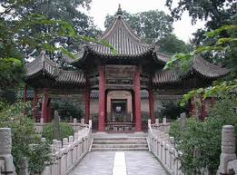
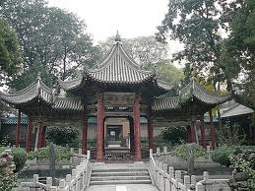

TOWN SITES:

INSIDE CITY

3 ¾ hr
13 Forest of Stelae MUS (LP416m, 13 B6, 418, DK162)

¾ hr
西安碑林
(
; Xīānbēilín), (Just inside the southern city wall, near the Wenchang Gate)
* Wolong Temple, (, 1-*B6, )

½ h
DIRECS: (1 blk N & E of Forest of Steles museum). Active Buddhist temple: 200BC; Recently
restored: vibrant and busy.
9 Bell Tower & drum Tower (LP416m, 9A6, 417, DK163)

¾ hr
钟楼
Bell Towers (
; Zhōnglóu), (In exact city center). ¥27 (or ¥40 including Drum Tower).
鼓楼
Drum Tower (
; Gǔlóu), (Just > NW w/in Muslim Quarter). ¥27 (or ¥40 including Bell Tower).
Muslim Quarter (LP418m, A5,)

1 hr
14 Great or Grand Mosque (LP416m, 14A6, 418, DK163)

¾ hr
清真寺
(
; Qīngzhēnsì), ().
(回民街
mix of Islamic / Chinese architecture styles, Muslim St. district
Huímín Jiē) surrounds it.
st
1
C mosque.
DIRECS: Behind Drum Tower : difficult to find through winding back streets . Only muslims can
enter mosque, but many accompanying courtyards OK.

12 Folk House (LP416m, 12 A5, 418) Note: misleading DIRECS:

¾ hr

OUTSIDE CITY WALS:

7 ¼ hr
Wall of Xi'an: (LP416m, 12 A5, 418, DK 162)

3 hr
World’s largest city wall, restored, wide enuf for 5 bikes wide;
BIKE AROUND: (2hrs) : hire one at top of S or E gate. NOTE: must return bike where you got it;
will not rent if rain, cuz top too slippery. Check weather before U buy ticket.
WALK ON TOP > S Gate: TO WALK: complete loop - approx 3 hrs. Landscaped park around
base of the exterior walls and moat also pleasant stroll w/different perspective.
Small MUS

½ hr
DIRECS: inside city walls at Hanguang Gate, about halfway between the SW corner and S
Gate, accessible from top of city wall itself. Look for a staircase down inside a covered
structure. Inside unrestored remains of a gatehouse and a calligraphy collection.
Night stroll pleasant.
W of Block:

4 ¾ hr
17 ? Temple of the Eight Immortals (LP416m, 17D!, 418, DK164)
1 hr
(LP416m, 17D1)

八仙宫
TEMP
(
; Bāxiāngōng).
An active Daois
Ancient MKT opposite

HIST of Pagaoda (DK 165 - SPECLAY)

S & SE of Block:

10 Big (Wild) Goose Pagoda & Ci'en Temple (LP416m, 10C4, 419, DK164)

¾ hr
大雁塔
大雁塔
(
; Dàyàntǎ),
(
; Dàyàntǎ),
DIRECS: bus 41 or 610 from main TRN STA.
（
Built by Emperor Gaozong
Li Zhi) in 652AD.
Fountain Show: see LP
Bus 610 & 609: see LP
15 Shaanxi Provincial History MUS (LP416m, 1C4, 419, DK 166-167 SPECLAY)
1½ hr
陕西历史博物馆
Shǎnxī Lìshǐbówùguǎn;
(
; Shǎnxī Lìshǐbówùguǎn; aka Shaanxi HIST MUS:
Local artifacts; Neolithic to Qing dynasty.; BEST: fabulously well preserved pottery from nearby
BanPo neolithic village; excellent Shang dynasty bronzes; some well-made but glorifying high-
definition movies
CAUTION: Arrive early to get one of 1000 free tickets (bring your passport)
18 Xi’an MUS & Little (Wild) Goose Pagoda (LP416m, 18B3, 419, DK164)

1 ½
Little (Wild) Goose Pagoda (Jianfu TEMP (Xiǎoyàn tǎ)
fairly expensive joint ticket
Climb pagoda
DIRECS: take bus 41 or 610 from the main train station).
652AD. Emblem of the city of Xi'an. pleasant parks nearby.

DAY TRIPS:

1 1/2D
E of XIAN:
TOUR Page 427 OPtions: (KEYS: ad fees, lunch, ENG guide, Exact ITIN (times) (no shop
tours)
Eastern Tour:
Terr Wariors, Qinshirhaungdi, Banpo Neolithic Village, Huaqing Hot Springs & maybe Big
Goose PAG (Y300, $50)
NOTE: if SOLO: tourist buses or BUS 306 pass by: Hot Sprgs, Qinshihaungdi, Warriors – in
that order
Western Tour: (longer) : (Y600 +85) probably not worth it
Xianyang City MUS, some IMP TOMBS (not important), maybe Famen TEMP & EMP Jingdi
TOMB (Y500+, $85)

See if Day Trip Tour possible & more efficient –

1D

兵马俑
1
ARMY of TERRACOTTA WARRIORS (LP424m, 1D2, 423, DK168-169 SPECLAY )
(
;

Blog: easy, early ½ D

1 D
Bīngmăyŏng),
TRANS - IN:
BUS 306: catch bus 306, also called Tourist Bus #5 (¥8) OR green Terrocata mini-bus
(1) Looking at central Xi’an train station, go to R to Bus 306 (Chinese bus green 5): > a

parking lot right in front of MUS’ ; 40 mins.
(2) Small buses which - used by the locals - also take you to the Museum THUS longer,
local small roads. Scenic???

STRAT:
START w/ onsite theatre; THEN visit pits in REVERSE
2 Bronze chariots & horses (DIRECS: R of main entrance)

) (on tour only)
NO :
Qinshihuang's Mausoleum,


8
Tomb of Emeror Jingdi: (LP424m, 8C1, 426. ) definitely worth a visit

½ D
(AKA: several other names)
DIRECS: (NO public TRANS so Either a Western Tour (p428) that goes there OR TAXI $34/
(Near the airport) OR (LP369
½ day OR on way to airport
MUS:
Excavation area: Real reason to vist
(157-141BC) Han tomb, 50,000 doll-sized terracotta figures. The excavation site has a glass
floor so that you can look down on ongoing excavations and is (although is best done as part
of a journey to or from the airport)
Famen Temple (LP424m, 3A1, 426, DK170 ) (115km NW of …)

4 hr

central Xi’an TRN STA
DIRECS: FROM
by Tour Bus 2 (DP: 8am, RET: 5pm) (also by
Western Tours) SUPERB MUS
N of XIAN:
Xianyang MUS
DIRECS: by BUS (REG, LD bus STA, 1 hr)

½ day
Liu Bang’s: 3k 50cm STATs: terracotta horses & soldiers; bronze & jade;
Imperial Tombs Qian Tomb (best) (BUT on tour only)

??? Taiping National Park, (44km southwest of Xi'an, north slope of Qinling Mountain).
Famous for its waterfall and the largest area of wild Zijing flower (the city flower of Hong

Kong) in north China.

Far N of Xi’an:
NO
Yulin GW: (LP414m) TOO difficult to reach vs reward

(Hancheng): Dangjiacun village
(p430)

(2D, 1N)
NOTE: May be able to to do enroute from Pingyao > XianConfucian Pagoda
{Central China Portrait: 174-181 SPECLAY Read B4 Nanchang }
DIRECS:
Mini bus/ 2 km walk or taxi

TRAIN - IN: Pingyao > Xian:
Train STA @ N_E edge of Block; Jiefang Lu south from station intersecting w/ Dong Dajie

http://www.chinatravelguide.com/ctgwiki/Special:CNTrainSearch
Total
Hard
Soft
Orgin-
To (in
Distance
Seat

DeptTime
Sleeper
Sleeper
From (in
ArrTime
Time
Destination
Chinese)
Chinese)
(km)
(RMB
(hh:mm)
)
(RMB)
(RMB)
Datong -
Pingyao
Xian
127/13
2671
00:34
08:43
543
08:09
Xian
平遥
(
)
西安
(
)
38/67
79/82/85
3
Taiyuan -
Pingyao
Xian
133/13
1095
20:47
07:22
571
39/70
82/85/88
平遥
西安
(
)
(
)
Lanzhou
10:35
9
Taiyuan -
2669
06:55
543
09:17
127/13
Pingyao
Xian
21:38
平遥
(
)
)
Baoji
西安
(
38/67
79/82/85
1095 STAs
Station Name in
ArrTim
DeptTim

Distance
Total Time
Chinese
e
e
(km)
(hh:mm)
平遥

Pingyao
20:44
20:47
108
01:30
介休

Jiexiu
21:09
21:15
139
01:55
灵石

Lingshi
21:40
21:42
166
02:26
霍州

Huozhou
22:19
22:21
209
03:05
洪洞

Hongtong
22:58
23:00
251
03:44
临汾

Linfen
23:20
23:26
274
04:06
侯马

Houma
00:16
00:20
334
05:02
稷山

Jishan
00:50
00:52
370
05:36
河津

Hejin
01:15
01:17
396
06:01
韩城

Hancheng
02:08
02:16
439
06:54
合阳

Heyang
03:52
04:06
517
08:38
张桥

Zhangqiao
06:08
06:13
603
10:54
西安

Xian
07:22
07:41
679
12:08
BUS > Hancheng: from Xian LD BUS STA (4hrs,every 30 min, 7a – 4p)

OVER NIGHT:
HUA SHAN MT
华山

: (424m, p428, p429m, DK171)
(1T,1 N,1T) Simplified C:
; traditional
華山
Chinese:
; Huà Shān) is "Flowery Mountain" or "Splendid Mountain"
EQUIPMENT: walking stick, nylon gloves, flashlight, spare batteries & warm clothing, hi-calorie food,

water, rain gear (warmth & rain)
CLIMATE:
BEST: OCt: 66, 61-75, R-low , SO, 43-57

°
ELEV: 6,500 ft (2.7
/1000ft = 18
Colder at top)
°
°
TRANS - IN:
1) BEST: Bullet TRNs from Xian > Huashan Mountain:
rd
a) Xian N RR STA(
@ intersection of 3
Ring Road & Loop
34° 22' 36.96" N 108° 56' 7.70" E;
Expressway:
CURRENT: 1)Xian – Zhengzhou 2) Beijing W – Chongqing
FUTURE: Lanzhou, Chengdu, Taiyuan, Beijing and Shanghai
DIRECS > N RR STA:
• By Bus: There are 4 new bus routes available now. Bus No. 263 (06:00-19:30): East Gate -
Daming Palace area - Xian North Railway Station (SUBWAY : SEP 2011???)
TIKS: TravelChinaGuide.com has on-line TRN tickets booking service
Xian RR STA: Ticket Hall: E of waiting hall
东立大厦
Dong Li Da Sha (Dongli Mansion
No.187, Huancheng Bei Lu
Platform TIK can be exchanged for a Valid TIK but WHY?
b) Xian-Zhengzhou bullet TRN > Huashan Bei (Huashan North) STA.
http://www.travelchinaguide.com/china-trains/xian-schedule.htm

G2002
Xian North
Zhengzhou
07:00
09:10

0d02h10m

505

G2004
Xian North
Zhengzhou
08:30
11:05
0d02h35m

505

G2006
Xian North
Zhengzhou
09:00
11:15
0d02h15m
505
c) Special Green minubuses outside Huashan Bei Station DIRECT to mountain Y10.
TRANS OUT / RETURN: From Huashan MT > Xian:
1. Taxi from Dongshanmen Parking Lot > Huashan Bei TRN STA (Y25)
2) Bullet > Xian N RR STA Then take bullet train back to Xian.
OR, 2a) Tourism bus line 1 from Dongshanmen Parking Lot to Xian Railway Station (17:00p,
Y22 None: Jan-Mar
3. REG BUS: from Xishan Gate (middle section of Yuquan Rd.) to Xian Railway Station(07:00
- 22:00, Y32

Bullet Train Schedule (or REGs also)

G2002
Xian North
Zhengzhou
07:00
09:10

0d02h10m
505
G2004
Xian North
Zhengzhou
08:30
11:05
0d02h35m
505

G2006

Xian North

Zhengzhou

09:00

11:15

0d02h15m
505

G2008

Xian North

Zhengzhou

10:10

13:00

0d02h50m
505

G2010
Xian North
Zhengzhou

10:45
13:15
0d02h30m
505
G2012
Xian North

Zhengzhou

11:30

13:58

0d02h28m
505

G2018
Xian North
Zhengzhou
13:00
15:32
0d02h32m
505

G2020

Xian North

Zhengzhou

14:30

16:35

0d02h05m
505

G2024
Xian North

Zhengzhou

15:30

17:20

0d01h50m
505
G2026
Xian North
Zhengzhou
16:00

18:15

0d02h15m
505

G2028
Xian North
Zhengzhou
17:00

19:01
0d02h01m
505
G2032
Xian North

Zhengzhou

17:45

19:55

0d02h10m
505

G2034

Xian North

Zhengzhou

18:15

20:25

0d02h10m
505

G2036
Xian North
Zhengzhou
19:30
22:00
0d02h30m
505

(OLD INFO)
TRANS - OUT: Xian > Huashan MT:
REG TRN STA: LP416m : Hancheng Beilu
Also: 1) LD BUS STA, 2) BUSesWarriors, My Huashan, Famen TEMP stops at E
Square, 3) Baoji – Xian Bullet TRN

1) PRIVATE BUS (coaches or minibuses, Y30, 2hr, 7am - 5:30pm)
Front of TRN STA: independent, front or E side (???) of TRN STA when ONLY FULL.
DROPPED OFF: on Yuquan Lu (main st) (LP429, 1B5,),
(Also RETURN BUS location: 7am > pm) )

2) Tourism Bus Line 1: Xian RR STA > Huashan MT. (DP: 08:00; Y22, 3 hrs) NO: Jan >MAR
Catch green tour bus in front of RR STA (big posters in front of bus advertizing price &
destination). Be sure dropped off @ Hua Shan village - not parking for cable car (bus
driver usually asks).
3) Visitors can go to Xian Cheng Dong Coach Station and take the regular bus from Xian to
Huayin (Mt. Huashan). BUS runs every 15 min btw 07:00 -- 19:15. BUS TIK: CNY 31.5 , 2hr)

TRANS OUT: Huashan village > Xian:
1) East Gate: Yuquan Lu & Xitong Gonglu intersection
2) frequent minibuses (until 7 pm, 2) then unlicensed transportation continues) and
3) worst-case scenario a rickety village taxi could surely be persuaded to make the trip back to
Xi'an for 300-500 RMB (about 50-75 USD).

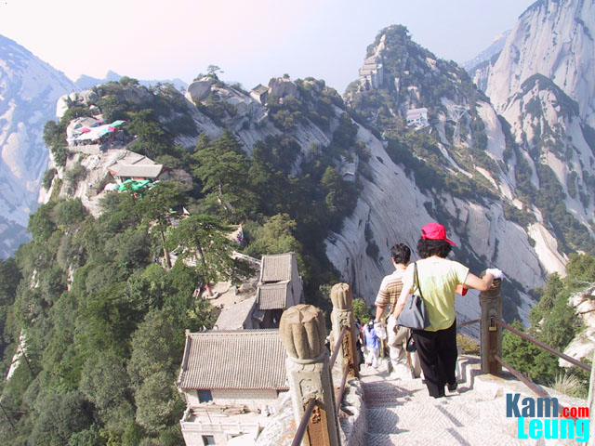
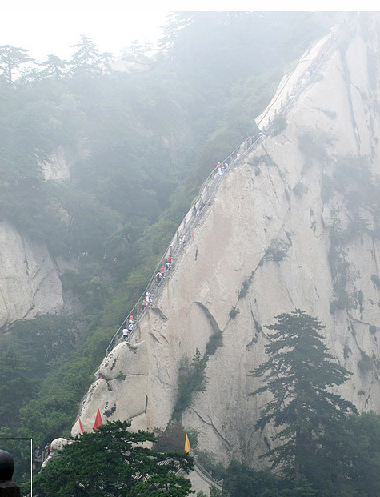
.
STRAT: 1) Cable car up > N Peak, 2) hike S > Hostel (2 choices: #5B4 & 1B5 (see ACCM), 3)
Sunrise @ S Peak (45 Min hike from East Peak). & SE loop, 4) Hike down MT
(@ 8a & ARV @10 & @ E Peak hostel @3pm (hiking)
(SKIP 2hr E hike up & 3-5 hr W hike up; All 3 options meet @ North Peak summit).
ACCM: ON the MT>:
5B4: Wuyunfeng Fandian Hostel DM Y65; ( good for doing the circuit
1B5: Dongfeng Binguan DM 4-10; Y80: best sunrise & restaurant
BOOK in advance??? major hostels?
BLOG: East Peak Hostel: arrived mid-afternoon, no booking PROB; others ARV: 6pm/7pm
1) Short walk uphill on Yuquan Jie towards the Jade Fountain (Spring) Temple to W TIK booth
entrance w/ plenty of indcators where > start hike.
1) Admission Ticket: 100 ¥ (??? Nat Park entrance: 120 yuan)
2) Buy mandatory (?) BUS ticket from the E Gate to Cable Car STA (DONE07:00-19:00)
??? Taxi . parking area
1a) Jade Fountain (Spring) Temple :
pond, thru Wuyou PAV > Long Corridor of 72 Windows > Qingke > “Huixin Rock” > 370
precipitpous steps
2) Go E by Shuttle bus > Cable Car (Suodao) Terminus (75¥ 1 way/ 110¥)
3) From N Peak: 4 hr loop top climb other peaks
Loop Sequence (N>E>S.W >N peak
North Peak (Bei Feng, Cloud Terrace Peak): ‘Ca’er” –the ear, cuz ear close to clif side to ascend
higher; Juzian Terrace,
"Black Dragon Mountain," cuz looks like dragon's wavy back; no more than 1 meter wide ( about 2
hours)

Green Dragon Ridge (also Blue dragon Ridge ???) (Canglong Ling): connects N Peak (Bei feng)
> E (Dong Feng), S (Nan Feng) & W (Peaks) As most of the climbing is done, the final assent to each
of the peaks is not too severe
"Gold Lock Pass." (Canglong Feng) : 1) narrow rock ridge w/ vertical cliffs on both sides (throat
i.e.corridor to other peaks) Here the route branches; 2) 1000’s of locks attached to iron chains); 1
huge gold lock in big rock (pure CU forged of 1,000 pror-left locks
Hongshen Terrace:
Jinsuo Pass ) N-S loop intersection
GO L > S > Yinfeng Pavillion
( ) Central Peak (Middle Peak): Jade Maiden Peak: Jade Maiden TEMP (Taoist) & Jade Maiden
Basin for Shampooing): Legend: of Qin Mugong’s (569 B.C.-621 B.C.) daughter loved a man who
was good Chinese tung-hsiao (vertical flute) player; she gave up royal life to be hermit who
cultivated her spirituality here,
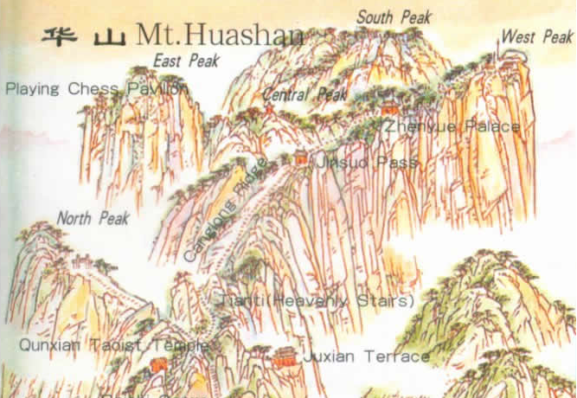
East Peak: (least busy,
Sunrise (4-6 hrs, 5:00a.m.-5:20a.m. in autumn NO!) from East Peak (Dong Feng) or S Peak (Nan
Feng) ;
Xiaqi Pavillion

South Peak (landing Wild Geese Peak cuz (legend) wild migrating wild geese srested briefly)
Highest, MOST crowded, At top of South Peak: Black Dragon Pool at summit and Greeting
Pines on SW cliff: 2 attractive resorts. On ea side of Landing Wild Goose Peak: 2 peaks
respectively called Songhui Peak (Pine & Juniper Peak) in E & Xiaozi Peak (Filial Son Peak) in
W form picture of a Titan sitting in chair.
Most dangerous place: called 'Changkong Zhandao' (a plank path built along the surface of a
vertical cliff) which is about 4 meters (about 13 feet) long & about 0.33 meters (about 1.1 feet)
wide. Below is the bottomless gulf which makes tourists shake with fear.
In addition, a Taoist TEMP called Baidi TEMP or Jintian PAL --host temple of Deity Shaohao
Yangtian Pool
West Peak (Lotus Flower Peak)
Very high cliffs (6,845 FT); Taoist temple (Cuiyun Palace) before which a huge lotus flower
looking rock i.e. Lotus Flower Peak. 7 Additional rocks where Chenxiang (Lotus Lantern movie
character) ripped mountain to save his mother (The Heavenly Goddess San Sheng Mu).
Go down MT on path on E side of W Peak.
BACK to N peak via Wuyunfeng Fandian Hostel (completing circuit)

Dangjiacun Village

(1T, 1D, 2N,1T)
(LP414m, 430, see SShots)

(9km NE of Hancheng):
STRAT: 1T/1D/2N/1T
nd
D1: 1) Pingyao train > Hancheng (2
Nite hostel- store bed) 2) Hancheng (tax / minibus) >
Dangjiacun 3) Overnight Dangjiacun
D2: 4) back > Hancheng hotel 5) overnight 6) DP . XIAN ON TRAIN #7002/7003
TRANS-IN:
Pingyao > Hancheng
Dep.
Arr.
Total
Trains
From
To
Dist(km)

Time

Hard
Soft
Time
Time
Sleep

Sleep

1163
Pingyao
07:35

Hancheng
13:13
331
18:10
$ 15
$ 23

1095
Pingyao
20:42
Hancheng

02:08

331

06:57

$ 10

$ 15

7003/7002
Hancheng - Xian
07:33
279 km
14:37
07:04

www.chinahighights.com

1163 STA/Times
平遥

Pingyao
07:33
07:36
670
12:30
介休

Jiexiu
07:58
08:04
701
12:55
灵石

Lingshi
08:29
08:33
728
13:26
霍州

Huozhou
09:10
09:13
771
14:07
临汾

Linfen
10:06
10:12
836
15:03
襄汾

Xiangfen
10:34
10:37
862
15:31
侯马

Houma
11:08
11:14
896
16:05
新绛

Xinjiang
11:29
11:33
912
16:26
稷山

Jishan
11:51
11:55
932
16:48
河津

Hejin
12:20
12:25
958
17:17
韩城

Hancheng
13:13
-
1001
18:10
TRANS: Hancheng > Dangjiacun village (LP430,)
NOTE: Hancheng’s New town on hill w/ RR STA, Old Town at bottom.

TAXI (Y15, 20min, 9km NE from Hancheng BUS STA)

Minibus (Y3) from BUS STA + 2km walk across fields
ACCM:
Dangjiacun: courtyard house DM 10Y
Hancheng:
Yongan Hotel:
Tang Yun Hotel:
Yinhe Hotel

TO DO:
DANJIACUN:
Dang's Siheyuan courtyard
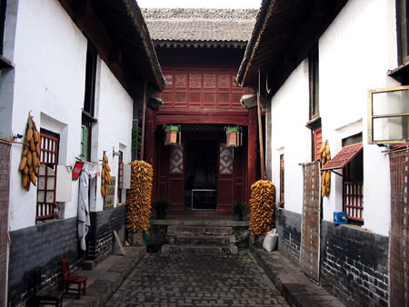
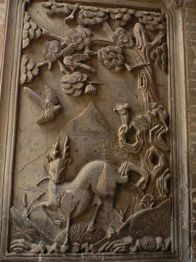
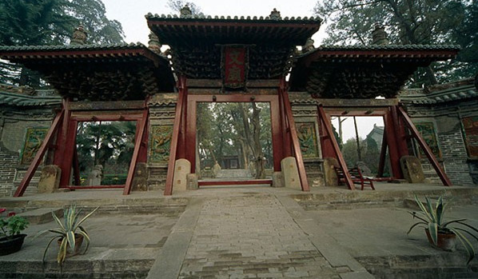
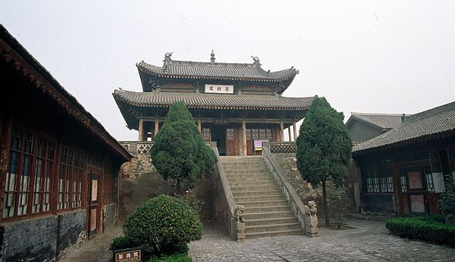

Well-planned defensive system, includ: Watching-building, Qinyangbao fortress,city
wall & double-layer wall, detined survival of ancient house / buildings in Dangjia Village .

; memorial Pishengzhu & goreously Chaste and Undefiled stele
th

14
C Merchant village Courtyard houses,
Dangjia village is the living fossil of the ancient and traditional
w/carvings & ATCH mix,
folk community of the orient mankind

Confucian Pagoda (Wenzxing ge)
As you approach the village the first building to catch the eye is the six-storey high
brick built Wen Xing Pagoda. With its wealth of carvings on its brickwork

Hancheng
: TIK covers both TEMPs
Confucious TEMP (Wen Miao): (LP430) Dongxue Lane, Old City (Bus 101 or 102 Taxi: Y5;
glazed dragon screens,

five main buildings & four tightly connected courtyards. Lingxing Gate = TEMP entrance > 1st
courtyard w/ flowers & shady trees: on E & W side: Clothes Changing Pavilion (Gengyi Ting)
and Fasting Room stand symmetrically. To N, 3 rooms situated by Vouge Gate(Ji Men),
nd
leading > 2
courtyard > Dacheng Palace.
Dacheng Palace: main temple part: sacrifices performed on memorial tablet of Confucius.
The thru doorway of angle > 3rd courtyard: site of Confucius “disabusing’ lessons. Across
th
Minglun Hall = 4
courtyard AND Zunjing Pavilion: store volumes of sermons.
Also Hancheng MUS, 1000s of cultural relics stored

Chenghuang TEMP: Sacrificing Hall: roof detail
DIRECS: when leaving Confucious TEMP, turn L, walk 400 mtrs , turn L down Huang
Maoxiang (also courtyard houses)
Yuanjue Pagoda: Old town
Hancheng TRANS OUT > Xian:

http://www.chinatravelguide.com/ctgwiki/Special:CNTrainSearch
Soft
TrainNo
Orgin-Dest
From
DeptTime
To
ArrTim
Dist (km)
Total Ti
Seat
Hard Slp
Slp
Taiyuan -
Hancheng
Xian
1095
02:16
07:22
98/102
韩城
(
)
Lanzhou
西安
(
)
240
05:06
19/32
61/64/66
Hancheng -
Hancheng
Xian
7003/7002
07:33
14:37
279
94/98
韩城
西安
(
)
Xian
(
)
07:04
18/33
57/60/62
7003/7002 STA/Times
Station Name in
ArrTim
Station
DeptTim
Distance
Total Time
Chinese
e
e
(km)
(hh:mm)
韩城

Hancheng
-
07:33
-
00:00
合阳

Heyang
09:43
09:49
78
02:10
韦庄

Weizhuang
10:32
10:34
107
02:59
大荔

Dali
11:02
11:04
121
03:29
Zhongjiacu
钟家村

11:49
04:16
n
11:51
153
张桥

Zhangqiao
12:02
12:04
164
04:29
阎良

Yanliang
12:26
12:29
184
04:53
三原

Sanyuan
12:55
12:57
210
05:22
咸阳

Xianyang
13:57
14:16
256
06:24
西安

Xian
14:37
-
279
07:04
BACK UP NOTES:
Hancheng from Xian:
BUS (7/day, 3 hrs) ; from long distance STA
TRAIN:
1) 4 ½ hr , 7:13am
2) also, daily local train (more fun?): p431)
Return : BUS until 6pm
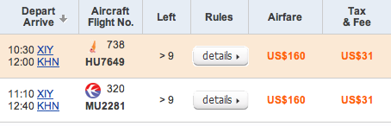

TRANS OUT
: Xian’s Xianyang (XIY) > Nanchang (KHN)
FLY:

www.chinatraveldepot.com me e29
INTRA CHINA: Air China , China 's national flag carrier, 2001: 46-yr safe-flying record; often ederly
discounts: Jun-Sep, RT are cheapest; travel agents best, not airlines;
1) Xian (SIA) > Nanchang (KHN): 1 ½ hr
AIR:
www.chinatraveldepot.com me e29
NOTE: Chinatraveldepot.com: Screens all airlines, allows morn-afternoon-night screen; says
Discount, but seems as LP suggests; could’nt get China Eastern Air to show any flights . Can’t
directly copy flight screen into Word. Use Screen Saver instead
NOTE: Airport Code confusion:
Before Xianyang Airport (XIY) was built, Xi'an airport was

Xi'an Xiguan Airport (SIA)

Xianyang Airport from Melody Hotel (???) 40km W : Shuttle bus (every 20-30 min, 5:40am-
8pm, ¼ of taxi cost
Xian’s Xianyang Airport Terminals:
nd
Terminal 1
DP on 2
floor; T1 airlines: China Southern Airlines (CZ), Xiamen Airlines
(MF), Sichuan Airlines (3U) and Chongqing Airlines (OQ
nd
Terminal 2
DP on 2
floor; T-2 airlines: Air China (CA), Hainan Airlines (HU), Shenzhen Airlines
(ZH), Shanghai Airlines (FM), Shandong Airlines (SC), East Star Airlines (8C), Lucky Air (8L),
Kunpeng Air (VD) and Grand China Express (GS).

TRAIN:
Main STA: N of city Wall BOOK EARLY
www.chinatour.net
st
Ha
Hard
1

ARV-
Last
Dura
Soft
Train No.
Train
DP
DP Ti
STA
Arv
Statio
Slee
Slee
T
rd
tion
n
Se
per
at
per
Lanzh
1182/1183
Regular
Xian
18:26
NanC
16:46
Shenz
22H
88
183
304
ou
19H
13
Nanc
Fuzh
our
254
411
1218/1215
A/CReg
Xian
Xian
17:12
13:05
6
hang
ou
53M
CNY
CNY
CY
in
18H
Air
17
K242/K24
Nanc
Xiam
our
308
486
Conditi
Xian
Xian
19:36
14:19
5
3
hang
en
43M
CNY
CNY
on Fast
CY
in

Xi’an > Tunxi: confirm
BACK UP NOTES:
NO GUD
Xi’an’s Xianyang Airport XIY > Huangshan Airport (TXN) (Tunxi) NO Direct & NO Ninjiang
> Huangshan flights
>): 40 km NW city centre) by train (p423: ??? hrs)
Hunagshan Airport ( I think that is the following info)
Airport > Town CNTR: airport bus : every half-hour, 1 hr, 6AM to 6PM, 25 rmb ticket)
Always a BUS for arriving flight,
airport bus route is the best way between city and the train station..
BUT taxi (100rmb) not recommended cuz raise price for non-local tourists
Air ticket offices located on Huashan Road, Tunxi District, near Christ Church and
Huangshan International Hotel.
flights to Beijing, Guangzhou, Shanghai, Hefei, Tianjin, Haikou, Shenzhen, Fuzhou,
Hangzhou, Wuhan, Xi'an
taxi will cost about 100rmb from the airport to downtown(Bell Tower).
Huangshan Railway Station is on Qianyuan North Road, Tunxi District. (This may be in
wrong ITIN section)

ISSUE/ PROB:
ITIN TRANS FLOW for Tunxi, Wuyuan & Hi Speed Train:
Possible SOL:
Hi Speed TRN: INVESTIGATE in BEI
Cud do Xian > BEI , from either BEI or Xian, if 1 DAY
Cud do from Wuyan or Changsha > Guangzhou if 1 day
Xian > Huangshan (Tunxi): NO!
FLt . Wuyan is OK, BUT no DIRECT TRN to Huangshan
Xian > Wuyan > Nanchang: NO!
FLt . Wuyan is OK, BUT
no DIRECT TRN to Nanchang
BUS OK
So far, ONLY SOL seems to be my oriiginal plan:
FLY: Xian > Nanchang
TRN: Nanchang > Wuyuan
BUS: Wuyuan > Huangshan (Tunxi)
TRN: Huangshan (Tunxi) > Yingtan or Xinyu See printouts
TRN: Yingtan or Xinyu > Changsha See printouts
Hi Spd TRN: Changsha > Guangzhou & back > Changsha
TRN: Changsha > Guiyang

AIR:
www.chinatraveldepot.com me e29
NOTE: Chinatraveldepot.com: Screens all airlines, allows morn-afternoon-night screen; says
Discount, but seems as LP suggests; could’nt get China Eastern Air to show any flights . Can’t
directly copy flight screen into Word. Use Screen Saver instead
NOTE: Airport Code confusion: Before Xianyang Airport (XIY) was built, Xi'an airport was Xi'an
Xiguan Airport (SIA)
Wuyuan, Jiangxi
:
(p488)
(KHN)
(SW of ANHUI / SE)
Central China Portrait: 174-181 SPECLAY Read B4
Current STRAT: Fly > Nanchang, then < Wuyuan (Qinghua) > Tunxi, Anhui
?: if Overnight in Nanchang necessary,
Nanchang:

(LP490m, 492m, 489, DK250 (many sites))
TRANS IN
: Xian’s Xianyang (XIY) > Nanchang (KHN) (1½ h) Changbei airport
AIR:
www.chinatraveldepot.com me e29
NOTE: Airport Code confusion:
Before Xianyang Airport (XIY) was built, Xi'an airport was

Xi'an Xiguan Airport (SIA)
Xian (SIA) > Nanchang (KHN):

ACCM:

EAT:
Xinya Restaurant : delicately cooked, brightly coloured & savoury local specialities, Xinguiyuan,
Shixianlou and Dongfanghong are also 1st class restaurants
Shuyuan Youth Hostel D ¥30-50
TOWN SITES: (p490)

DAY TRIP:
Luotiancuns: (p492)
By BUS: Nanchang > Anyi (1 hr frequent, 6-6pm)
By BUS: Anyi > Shibi (20 min, regularly when full)
By sanlunche Shibi > Luotiancun (10 min)
Self guided tour sites: p 492

TRANS-OUT: Nanchang > Wuyuan > Qinghua Village:
STRAT:
1) If DIRECT > Wuyuan: use BUS,
2) If OVERNITE in Jindezhen, use TRN & BUS COMBO option
th
: Jingdezhen 12
Imperial ‘industrial’ ceramic production center, assembly lines, 1000’s
NOTE
24hr shift workers, global commodity,
1) DIRECT Nanchang > Wuyuan BUS: (4/D ???,
(Changtu Qichezhan; 393 Bayi Dado (TIKS))
1) from Nanchang LD BUS STA: (4 hr)
(LPZ439) (Y85-120, 5 hrs.)

0725 (63.8 RMB)
1030 (60.5 RMB)
1415 (60.5 RMB)
1620 (63.8 RMB)
2) Wuyuan’s Main BUS STA OR ‘North’ LD BUS STA > Qinghua Village:
NOTE: seems easier to just take Nanchang BUS direct > Wuyuan unless OVERNITE in
JIndezhen.CUZ almost 7hr vs. vs 5 hr bus (5hr TRN + 1 2/3 hr bus), hrly
(LPZ447) Jindezhen
2) COMBO TRAIN & BUS: Nanchang > Jindezhen > Wuyuan

1) TRN > Jingdezhen, then
TRAIN
$4
--
$10/$10/$10
$15/$15
2240
Nanchang
Jindezhen RR STA
19:17
Nanchang
14:20
Jingdezhen
Jindezhen RR STA

04:57
302
$4
--
$10/$10/$9
$14/$14
2240
Nanchang
Xiangtang
Jingdezhen
19:17
14:50
Jindezhen RR STA

04:27
274
$4
--
--
--
5206
Nanchang
Nanchang
15:28
Jingdezhen
20:11
04:43
302
5206
Nanchang
Xiangtang
15:49
Jindezhen RR STA
Jingdezhen
20:11
04:22
274
$4

2) Wuyuan’s ‘North’ LD BUS STA > Qinghua Village: (hrly, 1 2/3 h)
NOTE: LP (p496) does describe TRN to Nanjing via Tunxi, BUT CAN NOT FIND
Jindezhen:m
(LP , DK 254-255 SPECLAY (ceramics))
TRANS: See Nanchang TRANS-OUT above

Also :
“Long March” DK SPECLAY 256-257

“Cult of Mao” DK SPECLAY 262-263

Wuyuan
: (p497, 498m)

(T, D, N)
(Don’t spend more time than necessary here, except maybe the MUS if stuck here)

GO directly FROM: Wuyuan’s N BUS STA > Qingyuan Village
TOWN SITES:
MUS … maybe
TRANS > Qingyan Village BASE::

QINGHHUA VILLAGE
BASE:: (un-intersting, BUT good base)
TRANS – IN:
BUS every ½ hr From either Wuyuan Main BUS STA or old N Wuyuan BUS STA >
Qinghua Village (6-5pm, 30 min)
TRANS AROUND Villages:

(LPZ444)
Motorbike taxis BEST
Sometimes bus??? (Grand loop???)
ACCM:
Laojie KezHAN: DY20 355 Qinghua Laojie (LPc); Stay in Qingyuan Village
TICKET / Pass OPTIONS: 2 days is ideal
(GET) 5D/Y180 for VILLs, & Rainbow Bridge; Big Likeng –seprate TIK; OUTER VILLs (Guankeng,
LingjiaoQingyuan, Changxi) may be free
Separate fee: Big Likeng (Da Likeng)
SITES:
Rainbow Roofed / Covered Bridge
Qinghua: most beautiful sites; Song Dynasty Built, the Rainbow Bridge: shapely
appearance.
Wander Qinghua Laojie (LPc)

Background:
ancient Qinghua Village; 800 yrs, S Song DYN; birthplace of Zhan Tianyou, 19th century C
railway pioneer. Brooks run through village w/sitting sheds w/ “beauty chairs” -- putting
your feet up makes people more beautiful. Sipping tea
N Villages:
(LP498)

1D
1) > Big Likeng (Da Likeng) Sites (Y20) :
Motorbike or bus
BEST: hiking the hilly countryside from Qinghua (guide or get lost)
Big Likeng village: ancient Li family settlement; green mountains & clear water; Ming
& Qing DYN Residences nestled against mountains w/ white walls & black tiles. Rivers
run parallel w/village lanes; bluestone wells dot local paths. Various wooden & stone
arching bridges.

IMP BLDGs: Dafudi (now,, converrted > antique shop) & Simadi & Tuochuan
2) >Sikou: (on site suggested walking routes)
Sixi (Cixi):
Delightful; film crews;
Tonji Bridge: prow-shaped , covered wooden bridge
Self-guided tour: residences – OPEN > public
Jingxu Hall:
Yancun: downstream (15 min)
BUS + motorbike
E Villages:
(LP499)

1D
1) > liitle Likeng (Xiao Likeng): POSSIBLE OVER NIGHT ??? most riverine picturesque,; tight
alleys, quaint bridges;
Sites:
* Tongji Bridge
* Shenming Pavilion
* Patina House’s
* Old stage
* spirit walls
* large Jingxu Hall - upstream
Li Zhicheng RES: X bridge & hike up hil then down to river to:

2) > Upper Xiaoqi: (NW of Little …)
upper Xiaoqi: old tea factory
Xiaoqi village: elegant Ming & Qing residences; tranquil & zigzagging lanes, paths
paved w/ green cobbles, lrg ancient trees; one of most charming ancient C cultural &
ecological villages.
Built 787, boasts houses w/ 600 history: magnificent structures w/unique characteristics
= precious treasures
Ancient rare trees park more than 1000 ancient camphor trees & firs.

Jinggang Shan
OVER NIGHT:
(LP500, DK 257):
DEPENDS on HOW I will get to next place after Tunxi
overnight
ISSUE: Doesn’t seem worth the effort of an
Consider train fare RT $15 + Budget
rm , 2 nite $20 + cable car $10 = $50/4 days for 3(?) hikes

TRANS - IN: TRN: Nanchang > Xiaping [Jinggang Shan] by TRAIN (p500: 3-5 hrs, NO sched
available on China Highlights)

BUS: N & W bus stations)
1 trav
TICKET REQ’D:
ACCM:
Stay at budget near RR ST
TOWN SITES: & AROUND Jinggang Shan
1) Self guided walks 2) Five Dragon Pools:5 falls or cascades (7km NW)walk &/or cable car;
ENG signs, 3) Huangyangjie (view; ???

TRANS-OUT: Wuyuan > Tunxi
BUS:
Tunxi: (2/D, 3 hr)
What times? (8:20am & 12:30pm, 3 hr) ???

Anhui

(LP436m, 438m, 437, DK234)
Tunxi (aka
)
Huang Shan or Huangshan Shi

TRANS IN: Wuyuan > Tunxi:
BUS: from Wuyuan > Tunxi
Tunxi: (2/D, 3 hr)
What times? (8:20am & 12:30pm, 3 hr) ???
Fly, TRN, TOURS www.travelchinaGuide.com, www.travelchinaGuide.com

TRANS-around Tunxi: pedicabs

ACCM:


Old ST Hostel (Koala IY Hostel)( D Y40, D4 w/bath; cafe, 1D tour > Xidi & Hongcun;
Huangsha DiRECT BUS
(LPZ383) AbcientTown YH,
Shuyuan Youth Hostel D ¥30-50

TOWN SITES:
Ancient/Old Song Street
Wancuilou MUS
Chengshi Sanzhai: res arch
Tea MKT

AROUND Tunxi:
Tunxi N-W-E Villages: see Google Earth map
What are Tourist Buses?

(LPZ383)
QIYUN SHAN MT p440

Great scenery
Deng Feng Bridge; hike up or cable car; Zhenxian Cave; , Taisu; Yuxu Gong temple halls
Huizhou Villages: p 440
Huizhou Architecture (DK 235 SPECLAY)
(LPZ384)
Huizhou Style
Tunxi to Taiping Lake: 143 kilometers (89 miles)

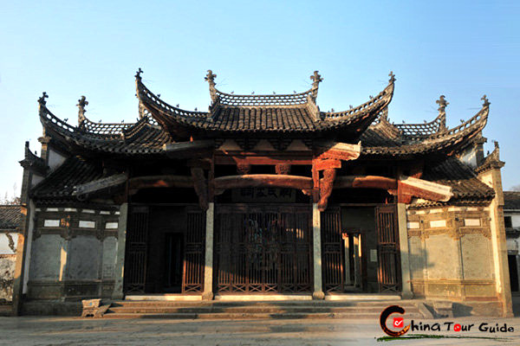
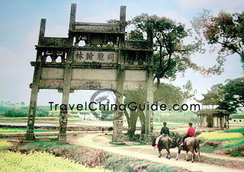
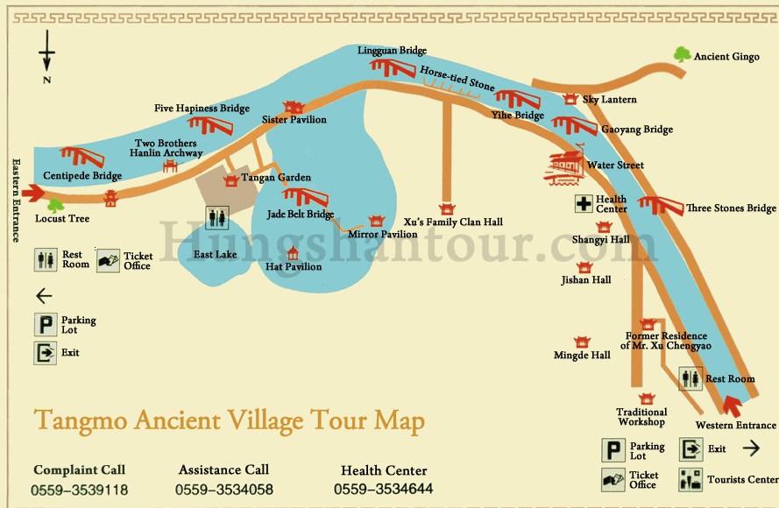
NORTHERN VILLAGES: (LPp443) (rarely visited by ind. Travelers)
NOTE: On G MAP “ Yansi > Chengkan & Tangmo the green arrow is Chengkan
DIRECS:
1) N City STA (aka Yansi) take BUS > Tangmo
TRANS: SEE below
CHENGKAN: (LP443, ):
TRANS:
1) Tunxi LD BUS STA > Yansi BUS Terminus
2) REG BUS or Pedicab > Yansi N BUS STA
3) BUS from N BUS STA > Chengkan (20 min); also Qiankou
Also CUD hire pedicab: 60/D
SITES: lush & bona fide slice of rula C country side
largest ancestral temple;;
Yanyi Tang: Notable structures: 600 yr
Qiankou Architecture MUS: DIRECS: reconstructed old buildings
Baolin Hall: typical Huizhou ARCH
Bao Lun Ge (aka Luodong’s Shus Ancestral TEMP) - not on city map
Tangmo Memorial Archway
TANGMO: (LP443, ): narrow village on canal; East & West gate (Google Earth map: see of Tunxi N
Foot of Mt HUangshan; 13 km from Shexian; 5km from Chengkan; 3km from Tangyue
TRANS: From Tunxi LD BUS STA:
a) Tourist BUS > (Qiankou) >Tangmo (hrly, 8a-4p w. 2 hr break: 11a-1p)
SITE:
From E Gate entrance: pathway along canal
Tan’qan Garden: large garden,
Canalside Qing RESs : DIRECS: along Shui Jie
Gaoyang covered bridge
Sjhangyi Ancestor Hall: DIREC: @ end of town; w/ 199 carved Peony blossoms

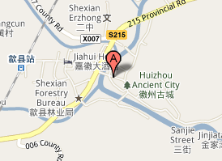
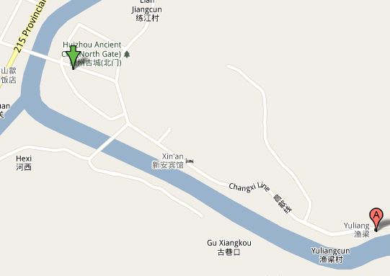

EASTERN VILLAGES: (LP444, DK234) DIRECS:
(Google Earth map: see of Tunxi E

SHEXIAN (DK234) (day trip from Tunxi); (See Northern Villages’s MAP)
GEN: 25 km E of Tunxi; E of Yansi
TIK/PASS: (Y80, includ. guide & Yuliang access, w/o Yuliang: Y60)
TRANS:
1) Tunxi LD BUS STA > Shexian (freq, 45min, From Shexian BUS STA (by the bridge) X bridge;
go thru modern gate > Yanghe Men dbl-eaved gate tower
HIST: Cultural cntr in Sui (581-618) & Tang DYN; Ming & Qing commercial cntr
SITES:
Across from BUS STA> X river bridge hru modern Gate Tower > along Yanghe Men DLB eaved
wood tower FOR TIK:
Climb gate / tower > Ming stone & views of Xuguo Archway (magnificent 4 sided ( only surving
China one)
CONTINUE > alleyway > Doushan Jie - old residential area; some res open to public
24 Filial Pictures: now kindergarten

YULIANG: (little visited) (LP444) Possible overnight: see LP444
TRANS:
1) pedicab or BUS #1 from Shexian:
Cobbled Yulina Jie alley;
tea shop @ NO 87
firewall separating bldgs
the Lion Bridge : ferry boat rides
NO Tangyue Archway, Tunxi Don’t think worth the Y100 in TOT costs + 1 D see PDF page

DIRECS: 5km W of Shexian
Tunxi to Tangyue Memorial Arches: 27 kilometers (17 miles)

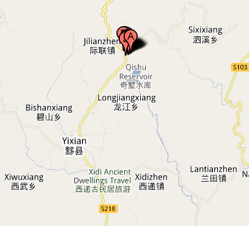
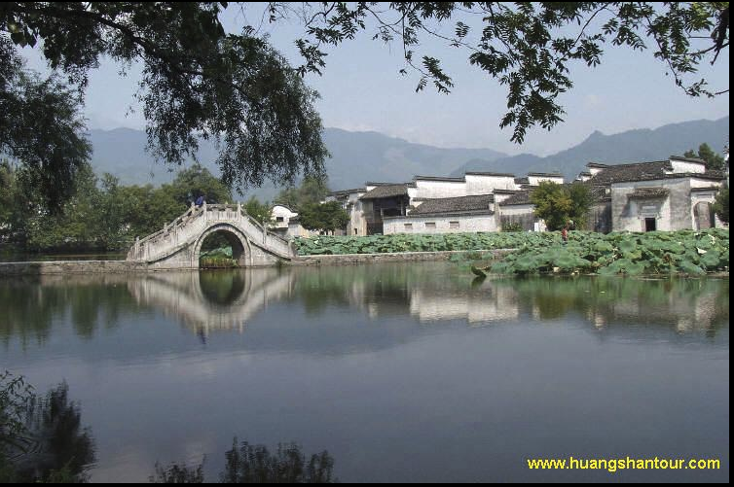
WESTERN VILLAGES

(LP441)
(Yixian): overnight recom’ (UNESCO)
MOST PICTURESQE in Anhui
STRAT: 1) BUS to Yixian 2) Hongcun overnight 2a) Mukeng Forest 3) Xidi 4) ? another
th
overnight at 3 or 4
villages 5) Tunxi return IYHostel: 1D tour > Xidi & Hongcun (Y180)
TRANS: From Tunxi LD BUS STA ‘Tourist Center” > Yixian (?) :
1) Tourist BUS (hrly, 8-4, 1 hr) > Xidi & then > Hongcun
2) or, Local bus> Yixian (1hr,frequent, 6-5pm)
2a) Then from Yixian: either:
1) green minibus (1/2 hrly; 7-5pm) >: NOTE: outside BUS STA make 2 R & x bridge
Xidi: (34 miles)
15 min

Nanping: 15 min
Guanlu: 20 min

2) REG bus: Hongcun
20 min
Pediacabs from Yixian:: Xidi, Hongcun,

Nanping, Guanlo

XIDI: (great walking):
(LPZ385)
SITE:

1) Huwenguang Paifang decoractive arch,
2) Diji Hall
3) Zhuimu Hall,
4) jing’ai Hall: largest hall
5) Dafudi (old LP) ???
6) Xiyuan sm house w/ exquiste stone carvings on windows, both sides, rejected $10k USD
offers
ACCM:
Pig’s Heaven Inn, 400 yr old house, 300 ¥
Possibly new facility availabe

HONGCUN: (65 km/ 40mi)
ACCM:
Hongda Tingyuan: upper village, rooms & lunch, if space
Qiuyuan Kezhan ($40
SITES:
Moon Pond w/in S Lake, West Stream & Leigang MT;
Chengzhi Hall; top floor railing ‘peep holes’ so girls can kook arr boys, ; alcove in mahjong room
hid concubine; gold brushed carvings
Hall of the Peach Garden
S Lake Academy: Overlooking pond:
Lexu Hall: Overlooking pond
MRKT : W of Moon PandHongji Bridge square on West Stream w/ 2 old trees
Biyuan Chalou tower in upper village
Lucun Village (1 km beyond Hongcun ); extreme extravagant wood carved RES -- Mudiao

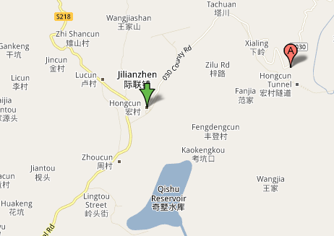
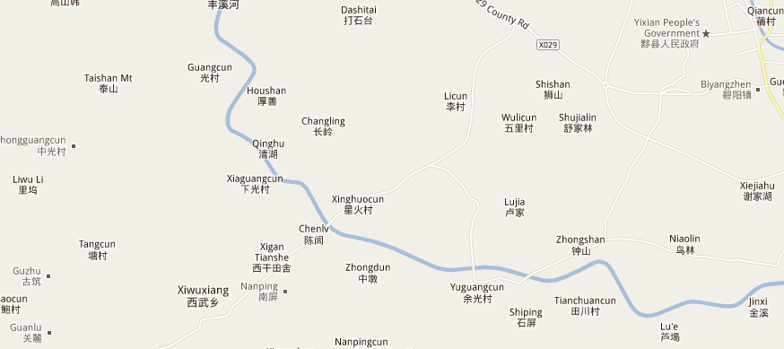
MUKENG
bamboo forest HIKE: (LP442, 5km NE of Hongcun): small hamlet destination b4
return Google Earth map of Tunxi area See downloaded map & info.
TRANS:
Taxi or pedicab: Y5/10 OR BIKE in Hongcun opposite Hongji Bridge
SITE: “Crouching Tiger fight scene”; same surname ‘Fu’;
HIKE: 2 hr loop w/ sm hamlet
“A” on map

Guanlu: (8km W of Yxian beyond Nanping)
SITES:
Fabuous households (Badajia) of 8 wealthy brothers: lights wells, carved wood work, ceilings

1 ½ hr BUS, ½ hr walk up mt. trail; 10 min drive from Hongcun

(Google Earth map: see of Tunxi W
NO?
Namping (p442):
NO? Tachuan:(3km N of Hongcun)
only if Stunning Autumn scenery; Hous #18: egreat wooden carvings

HAUNGSHAN MT: (LP445, p446m, DK236-237 SPECLAY)

(1T,1N, 1T)
(2T, 1N)
MAX PLAN / STRAT: 1) IYHostel DIRECT BUS, 2) Climb E steps (short , hard way, but NOT the
really hard way) or Yungu Cable Car if line(s) not long, 3) hike around top awhile , 3a)
OVERNIGHT ???, 4) hike down W steps OR do same w/cable car ; 5) afternoon BUS > Tunxi

SEE HuangShan Mt map PDF

CLIMATE: BEST TIME: Sept – Oct expect misty, thick fog, rain; ELEV: 5600’ Hi; hi 50s/low 60s

Huangshan Tourist Distribution Center: all regional travel plans, discounted TIKS ???

TRANS - IN:
1) BUS:
a) Hostels BUS: (6:10am) DIRECT BUS > mountain
b) Tunxi TRN STA or BUS STA (Huangshan Shi) > main base in Tangkou (1 hr, 6am-5pm,
when full) then onto N entrance
c) Minibuses: > Tangkou front of TRN STA
2) Either:
a) Yungu Cable Car STA: E steps & Yunggu Cable car
b) Mercy Light TEMP SA: W steps & Yuping cable car
BEWARE of BUSes > Huangshan Scenic Area that DO NOT stop in Tunxi:
RETURN: plentiful, fag down any bus > Tunxi

LOCAL MT TRANS: Shuttles to E , W & N steps

Cable Car Options:
BLOG NOTE 2 Cableway connection between White Goose Peak and Yungu Temple.
1) 2) Yuping Cable Car

ON the SUMMIT
ACCM:
st
Huangshan Gongshansuo D120-150 (look 1
) (not in new LP ???
Shilin Hotel : D9; shr bath Y200
Behai Hotel: D: Y20030% DIS
Paiyuniou: D: Y280, gud D views & shwers
Xihai Hotel: D: Y240: warm jackets; DIS Ds down to Y200,
Sunrise View from North Sea Refreshing Terrace
Enroute to N Sea, pause @ Flower Blooming on a Brush Tip
Beginning to Believe Peak

SITES: (See Huangshan Mt map pdf)
Sunset: Climb Purple Cloud Peak
Mobile Phone Rock (LP448)

TRANS – OUT / RETURN:
IYHostel Direct “return” BUS???
Many BUS from Tangkou: , LAST: 5:30p; can flag down

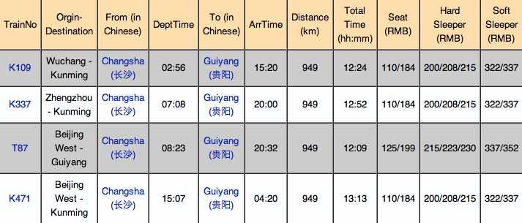
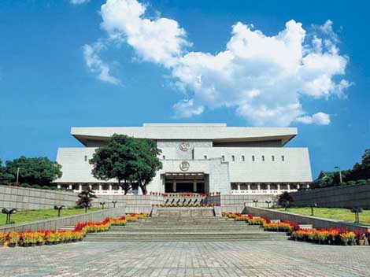
HIgh Speed Train ALTERNATIVE
TRANS – OUT: >

STRAT
1) TRN: Huangshan > Changsha (VIA Yingtan or Xinyu): See SCHED printouts
TRN: Huangshan (Tunxi) > Yingtan or Xinyu See SCHED printouts
TRN: Yingtan or Xinyu > Changsha See SCHED printouts
2) Hi Spd TRN: Changsha > Guangzhou & back > Changsha
3) TRN: Changsha > Guiyang Guiyang W & Guiyang N)

Changsha > Guiyang (shorter TRAV Time: 12 ½ h vs 14hr

4) Guiyang > Anshun:
1) ARV Guiyang 2) GOTO Tiyuguan (LP662m, 37B4) LD BUS STA, 3) BUS: Giuyang >
Anshun LD BUS STA (LP669m, 16B4) ( every 15 m, 2hr, 7a-10p)- near TRN STA)

Changsha, SITE: if time & inclination (LP 506 , DK260)
CHANGSHA: Hunan Provincial MUS w/ Lady Dai city capital of at No. 50, Dongfeng Lu ne
including items found in the tombs of the Marquis of Dai and his wife in Mawangdui xt to the
Revolutionary Martyr's Park. 180,000 objects

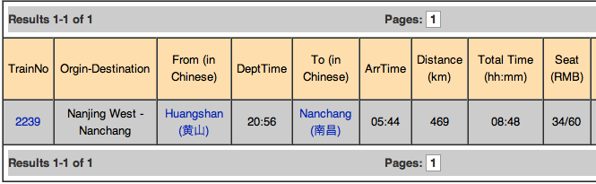
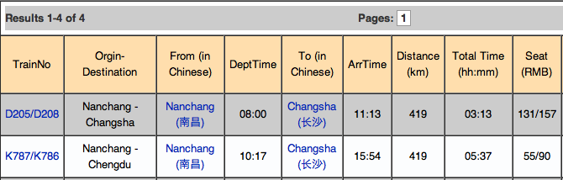
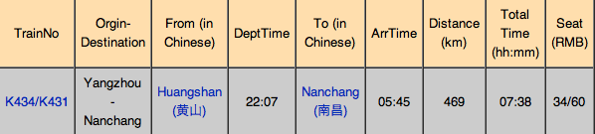
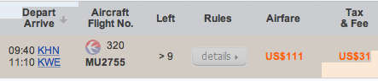
BACK UP ALTERNATIVE:
Tunxi > Nanchang > Changsha: 10hr
TRN: http://www.chinatravelguide.com/ctgwiki/Special:CNTrainSearch

IF DIRECT Huangshan (Tunxi) > Guiyang ALTERNATIVE:
NOTE: Possible DIRECT AIR : Huangshan > Guilin ( Then do Guiyang ???)
1)
TRN:
Huangshan
(Tunxi)
>
Nanchang
(KHN)
http://www.chinatravelguide.com/ctgwiki/Special:CNTrainSearch

2) AIR: Nanchang > Guiyang www.chinatraveldepot.com me e29
Confirm options w/ LP439-top suggested Tunxi Travel agency
?: Huangshan > GUiyang DIRECT ?

www.chinatraveldepot.com me e29

Guiyang, (KWE), GUIZHOU
(LP660m, 662m, 658, DK399m, 398)
(access > Anshun)
STRAT: 1) fly from Nanchang > Guiyang, 2) same day TRN/BUS from Guiyang > Anshun
(AVA)
TRANS - IN: Huangshan (Tunxi) > Nanchang (KHN) > Guiyang (KWE):
See above:
HIgh Speed Train ALTERNATIVE
IF DIRECT Huangshan (Tunxi) > Guiyang ALTERNATIVE:
Climate: BEST: Oct: genial year-around weather
ACCM:
* Star Hotel s Y158 next > TRN & BUS STA for late ARV
Yuyunyuan Binguan s Y138 near TRN & BUS STA
Yidu Y Hostel

TOWN SITES: (LP662, DK398 (many extras)
Hongfu Temple
WalMart
River walk
TRANS-OUT: Guiyang > Anshun
1) ARV Guiyang
2) GOTO Tiyuguan (LP662m, 37B4) LD BUS STA
3) BUS: Giuyang > Anshun LD BUS STA (LP669m, 16B4) ( every 15 m, 2hr, 7a-10p)- near TRN
STA)

OVER NIGHT ???:
Anshun

(Longong caves, Huangguoshu Falls, Zhijin) (LP660m, 669m, 668, DK400)

TRANS IN: Guiyang > Anshun:
BUS: Giuyang > Anshun LD BUS STA (LP669m, 16B4)(ea 15 m, 2hr, 7a-10p)- near TRN STA)
TRAIN: Why not?
$ 1
$ 2
$ 9
$ 14
6081/6084
Guiyang
06:35
Anshun
07:56
97
01:21
Inquire!

$ 1
$ 2
$ 10
$ 15
5637
Guiyang
08:46
Anshun
10:38
97
01:52
Inquire!

$ 1
$ 2
$ 10
$ 15
5637
Guiyang West
09:01
Anshun
10:38
86
01:52
Inquire!

$ 2
$ 4
$ 16
$ 24
K9475
Guiyang
09:19
Anshun
10:54
97
01:35
Inquire!

$ 1
$ 2
$ 10
$ 15
1235
Guiyang
10:46
Anshun
12:07
97
21:14
Inquire!

$ 2
$ 4
$ 16
$ 24
K9435
Guiyang
15:11
Anshun
16:32
97
01:21
Inquire!

$ 2
$ 4
$ 16
$ 24
K109
Guiyang
15:43
Anshun
17:12
97
18:23
Inquire!

$ 1
$ 2
$ 10
$ 16
K9463/K9466
Guiyang
16:00
Anshun
17:35
97
01:35
Inquire!

$ 1
$ 2
$ 10
$ 15
1224/1221
Guiyang
16:17
Anshun
17:51
97
24:02
Inquire!

$ 1
$ 2
$ 10
$ 16
K827/K830
Guiyang
17:08
Anshun
18:29
97
23:07
Inquire!

$ 1
$ 2
$ 10
$ 15
1257
Guiyang
17:42
Anshun
19:03
97
22:23
Inquire!

$ 1
$ 2
$ 10
$ 15
1271/1274
Guiyang
18:27
Anshun
19:48
97
30:46
Inquire!

$ 2
$ 4
$ 16
$ 24
K9367
Guiyang
18:41
Anshun
20:02
97
01:21
Inquire!

$ 2
$ 4
$ 16
$ 24
K159
Guiyang
18:55
Anshun
20:16
97
10:55
Inquire!

$ 24
K671
Guiyang
Anshun
19:42
21:03
97
$ 2
$ 4
$ 16
01:21
Inquire!

ACCM: San Xing Dajuidian

STRAT: Day trip from Anshun: combo: Longgong Caves (Dragon Palace Cave)
& Huanggushu Falls
SITES - Town

DAY TRIPS: (COMBO: Both in 1 day)
NOTE: p665 DIRECT BUS from Guiyang > HUangguoshu Falls (2 ½h)
TOUR: (LP663 )
CITS: (LP662, 4C2, 661)
$45USD, daily from: 1) TRN STA, 2) Main LD BUS STA or 3) special Tourist BUS STA > Falls &
Caves (transport, adm. fees, lunch ???)
st
(Do 1
?)
HAUNGGUOSHU FALLS (Rhino Pool) : (LP670, DK401)

TRANS - IN:
1) Mini buses between Huangguoshu & Huangguoshu (1hr, Mar>Oct, otherwise iffy) (NOTE:
Nov-Feb few or none
2) BUS: Anshun LD BUS STA (Zhonghua Nanlu & Huangguoshu Dajie (See new LP map))
(every 20min, 1 hr, 7:30 – 5 p) > Falls:
BUS RETURN > Guiyang & Anshun regularly 7-7pm (LP670,)
BLOG:
3 main SITES:
st
1) Doupotang Waterfall: best > visit 1
: DIRECS: upstream from main
waterfall (not as impressive, but very beautiful. TOT visit TIME: 1 ½ hr;
2) Huangguoshu: Short DIST: bus or taxi. TOT visit TIME: 3-4 hr: to walk
round the falls & larger area; shorter if use cable cars; If in full flow - get very wet
walking behind falls: path behind waterfall w/ ½ dz openings, actually see water
fall droppping & touch
WARNING: protect videocam from spray
3) Tianxing Resort (or Tianxing Bridge): might be anticlimactic, but NO -- TOT
visit TIME: 3-4 hr
:starts w/ 2 miles +/- of paved stones leading through wonderful unique rock
formations > you enter a cave w/ many steps (warned!). then out into sunshine &
down long paved path past limestone karsts & more impressive waterfalls > finish
through a mini stone forest

TRANS BACK: cable cars back to > car park or walk uphill 20 min
Remember, you exit park at different place from your entry SO taxi or bus back
to wherever you are going.

LONGGONG CAVES (LP670, DK400)
TRANS - IN:
Local BUS (30 min; hrly) from Anshun W BUS STA, W bus station) (RETURN: hrly > 5pm
SITES: Drift thru caves in row boats
TRANS: CAVES > Huangguoshu Falls:
2) Mini buses between Longgong & Huangguoshu (1hr, Mar>Oct, otherwise iffy) (NOTE: Nov-
Feb few or none
Beware of hawkers pests

NO Zhijin Cave: (p670) TOO far & LONG a day trip

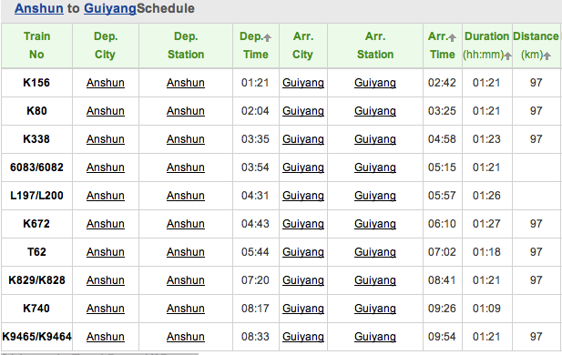
TRANS OUT > :
Anshun > Guilin, Guiling N:
TRN: NONE -
BUS: ???
Anshun > Guiyang:
1) BUS: (REVERSE?) Anshun LD BUS STA (Zhonghua Nanlu & Huangguoshu Dajie (See
new LP map)) (every 20min, 1 hr, 7:30 – 5 p) > Guiyang:

2) TRN

Total Time
Trains
From
Dep. Time
To
Arr. Time
Distance(km)
Hard Seat
Soft Seat
Hard Sleeper
Soft Sleeper
Book
(hh:mm)
K80
Anshun
01:53
Guiyang
03:14
97
10:49
$ 2
$ 4
$ 16
$ 24
Inquire!
1273/1272
Anshun
02:06
Guiyang
03:40
97
19:00
$ 1
$ 2
$ 10
$ 15
Inquire!
K338
Anshun
03:35
Guiyang
04:56
97
11:11
$ 2
$ 4
$ 16
$ 24
Inquire!
6082/6083
Anshun
04:07
Guiyang
05:31
97
14:57
$ 1
$ 2
$ 9
$ 14
Inquire!
K672
Anshun
04:31
Guiyang
06:00
97
11:44
$ 2
$ 4
$ 16
$ 24
Inquire!
T62
Anshun
05:47
Guiyang
07:07
97
10:24
$ 2
$ 4
$ 16
$ 24
Inquire!
K829/K828
Anshun
07:23
Guiyang
08:44
97
20:08
$ 1
$ 2
$ 10
$ 16
Inquire!
1223/1222
Anshun
08:52
Guiyang
10:13
97
17:02
$ 1
$ 2
$ 10
$ 15
Inquire!
K9465/K9464
Anshun
09:04
Guiyang
10:32
97
19:31
$ 1
$ 2
$ 10
$ 16
Inquire!
K9436
Anshun
10:26
Guiyang
11:53
97
03:53
$ 2
$ 4
$ 16
$ 24
Inquire!
5638
Anshun
11:07
Guiyang
12:56
97
04:45
$ 1
$ 2
$ 10
$ 15
Inquire!
5638
Anshun
11:07
Guiyang West
12:40
86
04:29
$ 1
$ 2
$ 10
$ 15
Inquire!
K110
Anshun
16:19
Guiyang
17:40
97
10:32
$ 2
$ 4
$ 16
$ 24
Inquire!
K9476
Anshun
16:36
Guiyang
18:09
97
04:15
$ 2
$ 4
$ 16
$ 24
Inquire!
1258
Anshun
16:55
Guiyang
18:19
97
10:59
$ 1
$ 2
$ 10
$ 15
Inquire!
K160
Anshun
20:38
Guiyang
21:57
97
10:17
$ 2
$ 4
$ 16
$ 24
Inquire!
K156
Anshun
20:49
Guiyang
22:14
97
11:06
$ 2
$ 4
$ 16
$ 24
Inquire!
K472/K473
Anshun
21:06
Guiyang
22:31
97
11:59
$ 2
$ 4
$ 16
$ 24
Inquire!
K168
Anshun
21:25
Guiyang
22:48
97
10:27
$ 2
$ 4
$ 16
$ 24
Inquire!
K9368
Anshun
21:50
Guiyang
23:23
97
03:57
$ 2
$ 4
$ 16
$ 24
Inquire!
1236
Anshun
23:20
Guiyang
00:46
97
12:18
$ 1
$ 2
$ 10
$ 15
Inquire!

Guiyang > Guilin (KWL)
TRANS – IN:
Air:
www.chinatravelguide.com/ctgwiki/Special:CNTrainSearch?from=Anshun&to=Liuzhou
AIR: >Guilin: (y630/$100usd, CSA
GS6463 - TIANJIN AIRLINES

Support E-Ticket
Depart: 09:30
Guiyang(KWE)
Duration: 0H50m
Aircraft: ERJ
Arrival: 10:20
Guilin(KWL)
Stopover: 0
Dining: NO
¥710
Select it
Econ Class(Y)
($111)
≥9 Seats
All classes
G52647
Support E-Ticket
Depart: 14:50
Guiyang(KWE)
Duration: 2H30m
Aircraft: CR2
Arrival: 17:20
Guilin(KWL)
Stopover: 1
Dining: YES
Select it
¥580 ($91)
Econ 21% Off
3 Seats
All classes

MF8422 - XIAMEN AIRLINES
Support E-Ticket

Depart: 20:45
Guiyang(KWE)
Duration: 0H45m
Aircraft: 757
Arrival: 21:30
Guilin(KWL)
Stopover: 0
Dining: NO
¥760($119)

BUS:
BUS: Guiyang > Guillin: NEW MAIN LD BUS STA (western Surburbs, Y260, 11hr , 2/D: (10 hr,
2 daily, noon & 8pm
TRN:
Guiyang, N , W > Guilin, N: NO direct, INdirect : shortedst -10hr
TRN / BUS / OPTION > Guilin
1) TRN: K156 > Liuzhou: (Bullet?)
www.chinatraveldepot.com me e29
http://www.chinatravelguide.com/ctgwiki/Special:CNTrainSearch
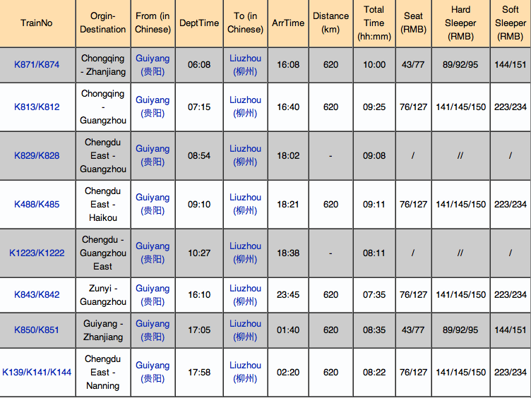

2) BUS: Liuzhou > Guilin: NO INFO; GET ON SITE

NO Yunnan Province: 678
Yuanyang Rice Terraces:
Tiger Leaping Gorge:
Lijiang: see lijian – China Visa service
Shaxi village:

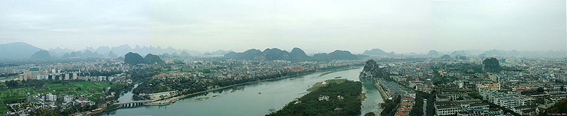

Guangxi
(SSE of Guizhou)
(LP 632m, 631,

Guilin (

(T,D,N,T)
KWL) (LP634m, 634)

