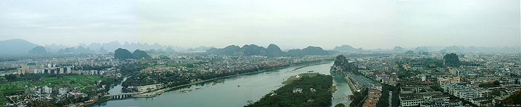

Guangxi
(SSE of Guizhou)
(LP 632m, 631, DK 414)
Karst Topography DK 412-413 SPECLAY
Guilin (

(T,D,N,T)
KWL) (LP634m, 634)

Climate: BEST: Oct: 70-83
, low R
°
TRANS IN: Guiyang > Guilin (KWL)
SOURCES:

www.chinatraveldepot.com
www.chinatravelguide.com/ctgwiki/Special:CNTrainSearch?from=Anshun&to=Liuzhou
AIR: >Guilin: (y630/$100usd, CSA

GS6463 - TIANJIN AIRLINES

Support E-Ticket
Depart: 09:30
Guiyang(KWE)
Duration: 0H50m
Aircraft: ERJ
Arrival: 10:20
Guilin(KWL)
Stopover: 0
Dining: NO
¥710
Select it
Econ Class(Y)
≥9 Seats
($111)
All classes
G52647
Support E-Ticket
Depart: 14:50
Guiyang(KWE)
Duration: 2H30m
Aircraft: CR2
Arrival: 17:20
Guilin(KWL)
Stopover: 1
Dining: YES
Select it
¥580 ($91)
Econ 21% Off

3 Seats
All classes
MF8422 - XIAMEN AIRLINES
Support E-Ticket

Depart: 20:45
Guiyang(KWE)
Duration: 0H45m
Aircraft: 757
Arrival: 21:30
Guilin(KWL)
Stopover: 0
Dining: NO

¥
760($119)

Airport > Guilin: (½ hrly shuttles from CAAC office (Civil Aviation Mansion) ,
6:30am – 10pm, 40 min)
TR STA: S end of Zhongshan Nanlu
LOCAL: bike but beware of traffic
$: Banks :
Bk of China – main: on Shanhu Beilu; branches: 1) Shanghai Lu & Zhongshan Nanlu – corner,
next to the train station , 2) at Zhongshan Nanlu, near Yinding Lu. Most tourist hotels
BIKES: 19D1 Ride Giant
ACCM:
Back Street Youth Hostel D ¥45: superb LOCATION, ENG, some smelly RMS
Wada Hostel: NEW (D Y35) ; out of the way, but all accessible by BUS 10; all Yangshuo bus stop
;
@; new, cafe, DIRECS: 212 Hangcheng Xiyii Jie, 86-773-2154888, CELL: 86-1897-8662-978
wadahostel@yahoo.com

Guilin Flowers YH D 40 (OUT of new LP)

EAT:
Zhengyang Tangcheng: Soups: 8 Zhengyang Lu: (11:30a- 3am) CAUTION: sea bass soup)

我对鲈鱼过敏。
鲈鱼
sea bass:

Wǒ duì (sea bass) guòmǐn.
HIST:
Prefecture in 214 BC / Qin dynasty; a transport centre of Ling Canal linking important Zhu Jiang
and Chang Jiang systems. Ming DYN: provincial capital, until 1914 then Nanning; 1930s & WWII
- a Communist stronghold; refugees swelling population from 100,000 > one million+.
MAP: Tourist Map of Guilin (Y4) GUD w/ bit of English.
TOWN SITES:

15¼ h
2+D
N End: Start walk
N:
Jinjiang Prince’s Palace & Duxiu fFeng (DK415)
City Wall:
East Gate:

¾ h
DIRECS: NE edge Mulong Lake Park

Mulong Lake Park

¾ h
See Downloaded page

Other nearby hills (LP636, DK415)

¾ h

(W) Wave Subduing Hill (Fubo Shan) (& Returned Pearl Cave:
etched Buddhist carvings)
Folded Brocade Hill (& Wind Cave :

¾ h
more carvings

Solitary Beauty Peak (Duxiu Feng) (DK415) &

1 h
Palace & Wang Cheng Prince’s mansion

W Side:
South Gate: north shore

¾ h

CENTRAL: AROUND Rong Hu & Shan Hu Lakes:

3 hr
Rong Hu LK:
Banyan tree : 800 yr (W shore)
old S Gate (Gu Nan Men) (N shore) only Ming Wall remains
Arched bridges:
Shan Hu LK
Sun & Moon (Riming Shuang) Twin Pagodas (LP634m, 17/17B2, 637, DK414) twin pagodas
Pretty @ nite walking around lakes

S END:

(S) Elephant Trunk Hill (Xiangby Shan):(LP634m, 636, DK416)

1½ h

(BEST seen from bamboo raft)

looks like a giant elephant dipping its trunk into the river.;
features: - Water Moon Cave
Elephant's Eye Stone
Yunfeng Temple .
Water Moon Cave (Shuiyue dong): at riverside w/ Li River flowing thru;
looks like full moon floating on water surface w/ moonlight reflected
on waves.
70+ Tang & Song inscriptions on walls in / around cave, praising
the beauty of hills and waters nearby.
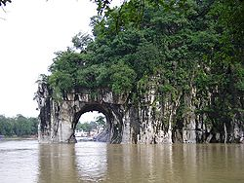
Puxian Pagoda: On top. Ming (1368-1644), looks like handle of a sword;
E SIDE (& of River):
Seven Stars Park (Qixing Gongyuan): (LP635m - D2; DK414)

1½ h
Sui tourist attraction;

DIRECS: eastern side of the Li River, 1 kilometer from the city center
Moon Tooth Hill (Yueya Shan) (NO! on zoo)

Reed Flute Cave (Ludi Yan): (DK415)

3 h
TRANS: Bike or BUS3 & free BUS 58
DIRECS: 5 km; on Guangming Hill ‘s (Bright Hill) south shoulder ; Legend: name cuz believed
that reed by cave's mouth cud made into flutes. Length: 240 mtrs/750 ft; offers majestic karst
caves fairyland: stalactites, stalagmites, stone pillars, stone curtains, birds, plants and animals
in fantastic shapes and colors, all glistening in colorful lights w/landscape & rural scenery.
Tang DYN tourists; 77 stone inscriptions.
Crystal Palace of Dragon King grotto, hold 1000 peeps. During war (???), air-raid shelter;
highlight great slab of white rock hanging from ledge like cataract, w/ human-shaped stalactite
on opposite side.
Water Tours: (LP637) CITS or hotels

each
3 hrs ???
1) Two Rivers & 4 Lakes

1½ h
2) Li River:

CITS:Could I take this > Yangshou one-way ONLY??? SEE a couple of pages

AROUND Guilin:
Google Earth map of these villages
Jiangtouzhou: (p639 & p648 Great Rides) arched Hulong Bridge

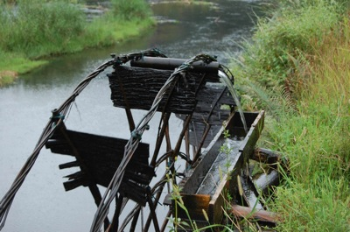
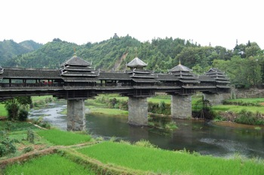
OVER NIGHT:
NOTE: Left Lugggae OPTION for Chengyang & Dazhai:
BEST: @ hostel or 2) Left luggage at Guilin bus or train station
10-26-2009: End of tourist season & rice growing, so room bargains

1) Chengyang BRIDGE & Dragon’s Backbone (2T/ 1D/ 3N/ 1T)

4D

st
Chengyang Wind & Rain Bridge (LP632m, 641, DK421 embedded in 1
column): Sanjiang
TRANS IN:
1) Guilin BUS > Sanjiang E BUS STA (4 hrs)
2) Sanjiang West BUS STA > Chengyang Bridge
(also mini vans on main rd outside W BUS STA after hours)
DIRECS > W BUS STA:
1) turn R from E BUS STA
2) R again to X RIV
3) R again after Xing RIV
4) 20 mtrs on L & UP steps > TIKs
林溪
(
)
via BUS >
Linxixiang: ½ hrly, 30 min, 7:30 – 5:30pm) (Ask driver > go to Chengyang
Qiao)
rickshaw drivers congregate outside Sanjiang E BUS STA: 10-15 RMB for ride to bridge

??? Bike (see LP649)
ACCM:
Ma’an Village:(behind Chengyang Bidge)
Drum Tower Folk Hostel: ON HILL; spectacular view: charming scenery


Dong Village Hotel: (old LP ;Chengyan Bridge National Hostel): Next > wooden water
wheel; DIRECS: From BUS STOP , X bridge turn L
bike rentals
INside Village:
SITES:
Bridge: No nails or rivets – all doeve tailed, 5 tower-like w/”horns” & ‘flapping bird-like wings;
nearby Dong stockade villages:Ma'an, Pingzhai, Yanzhai, Chengyang-Dazhai, Pingpu ,
Pingtan, Jichang and Guandong.
Nearby village WALKS: (LP641, 649) Pingzhai, Dongzhai, Dazhai, Pingpu & Guangdong
(???) Yinshui Dong village: typical Dong village w/picturesque scenery; in very steep mountain
sloped valley; waterfall; unique village architecture with a distinctive - Drum Tower with square piled-
eaves.

TRANS-OUT > Dragon’s Backbone: See TRANS – IN: next page
龙脊梯田
2) Dragon’s Backbone (Longji) Rice Terraces (
):
(LP640, DK420 under
Longshen)) (Longshen)
TRANS-IN from Chengyang Bridge > Dragon’s Backbone:
1) BUS from Chengyang Bridge > Sanjiang W BUS STA
2) GOTO Sanjiang EAST BUS STA
3) BUS from Sanjiang E BUS SA > Longshen (reg, 1½ h; 6:30am- 5:30pm)
reach the terraces, you will need to pass through the town of Longsheng
NOTE:

3) BUS: Longsheng BUS STA (buy TIK on bus) > Dazhai; (Every 20 min; 1 ½ hr, 7:00am >
6pm)
Between Longshen and Dazhai is a "Gate" where you have to pay 50 RMB entrance fee to
Yao reservate.
3a) Dazhai > Heping > Ping’an; (Every 2 hr, 1 hr, 7:40am > 5pm)
TRANS: 1) Just tell driver you want to go to Dazhai or Ping'an and he will drop you off at
intersection (a bit before Heping) that leads into valley.
2) At intersection: Longsheng buss -- about every 20-30 mins.-- Some > Ping'an, others >
Dazhai.

ACCM:
meat dishes cost two to three times as much as the vegetable and tofu dishes

(大寨):
Dazhai
quieter, less tourists & tour buses

10-15 min walk: parking lot > Dazhai village
Dazhai guesthouses (NOTE: Dazhai area OF guesthouses is called Tian Tou Zhai):

Minority Cafe & INN GH: (r Y40)
Yinhe Luguan
Tian Ti GH (86-773-7584203)
Jin Keng GH (86-773-7584196) Jin Tian GH (86-773-7584169)
Dazhai GH (86-773-7584175)
:

(平安)
Ping’an

Most GHs = traditional-style wooden houses, family-cooked meals, shared baths, H&C shower
(common features). Y15 – 20/ bed, 6Y+/ meal, 3Y/ btl mineral water (some exceptions).

Wangji Peasant Family Happy (beds; Y20) (modify new name)

st
Li Qing Guesthouse, 1
& largest GH in Ping An; run by 2 sisters Liao Yan Li (phone & fax
86-773-7583021) and Liao Yan Qing (86-773-7583048, liqing_gh@hotmail.com) PERKS: 2
houses, great view at new house / 70 beds / D Y15 per bed/ large porches/ some English /
Internet Y10/hr

View Place Inn (Lan Yue Ge, 86-773-7583005, mianbao-cha@163.com), highest point in
village, best views, 48 beds / Y15, 20 or 25 per bed depending on room’s view / porch view /
Internet Y10/h

Longji Hotel (86-773-7583047 & 86-773-7511335 in Longsheng), approx. new , English
teacher / located on path to Viewpoint 1 ? / 46 beds / D Y10 or 15 per bed, / western food
offered, BBUT C food: more expensive than others

Countryside Cafe & Inn (86-773-7583020),
/ located near Li Qing GH
approx. new
(above) / 14 beds / Y20/bed / expensive western food, good Eng

HIKE:
ALT #1: (I prefer): 1) Dazhai early monring TRANS > Heping > Ping’an, 2) hike Ping’an >
Dazhai (4hr)
TRANS: 1) Just tell driver you want to go to Dazhai or Ping'an and he will drop
you off at intersection (a bit before Heping) that leads into valley.
2) At intersection: Longsheng BUS -- about every 20-30 mins.-- Some >
Ping'an, others > Dazhai.

DIRECS: 4-5 hr HIKE : Ping’an > Zhongliu > Tiantouzhai > Dazhai:
* Route clearly sign posted ** viewpoints are numbered,but don't confuse them; consult map
Minority villages: (LP640, DK420)
Dazhai: BEST: 700 years; women embroidered pink costumes, heavy silver earrings w/hair
more grand than Longji. Yao villages: Zhonglu, Dazhai &
extremely long/ in the world;
Xiaozhai.
田头寨)
(

Tiantouzha
: MOST REMOTE, most spectactular terraces
Yao village, (Middle Six); half way btw Dazhai & Ping'an. Right after
Zhongliu:
village, in bottom of gorge, a running creek w/gurgling water = ideal place 4 lunch

Ping’an: heavy tourist, but best facilities Zhuang villages: Ping’an & Longji
Zhuang women wearing white shirts, black pants, & brightly colored towels on their heads.

HIKE ROUTE: hike mostly “up”
to Ping’an (???)

NOTE: stone paths / steps network leads from Dazhai (same
;
a) Ping’an > Zhongliu (1/2 way) > Dazhai VP #1 (1hr) “Music from Paradise”
田头寨
(
) (@ top):
b) Dazhai VP #1: > Tiantou:
(1 ½ hr) Great Views! BUT highest viewpoint,
西山韶乐
called

c) Tiantou > Dazhai VP#2: “Qiancheng Ladder>Heaven” thru Zhuang Jie (?) (45min-1hr, dn)
d) Dazhai VP#2 > Dazhai
Skip attempt > Viewpoint #2 > Viewpoint #3 – just get lost
Possible Confusion: as i begin to enter Tiantouzhai village -- having left Dazhai VP #1 above -- I
take road or path down > turn R onto road. Misleadingly element, I will know correct road/path
becasue as I leave path from above, to my L a few meters from this intersection a sign for
Ping’an, indicating I turned incorrectly L instead of correctly R toward Tiantou
After 3 hr hike across rice terraces > & through Yao village: Zhongliu > Ping’an,
Zhuang village.
Relatiely, this part = “road less traveled”: almost no hawkers / tour guides & relatively
flat; last 45 min: less scenery, walk road rather than path through terraces

Ping'an viewpoint #1: "Nine Dragons and 5 Tigers"
Ping'an viewpoint #2 : "Seven Stars Accompanying the Moon"
Ping’an’s rice terraces more beautiful, Dazhai views more majestic.
Yao woman’s turban wrapped, long hair-let-down photo OP: Y5: larger bundle - more
beautiful.

ALT #2: hike Dazhai VIL > Ping’an (4hr) > RETURN TRANS > Dazhai
DIRECS: 4-5 hr HIKE : Dazhai > Tiantouzhai >Zhongliu> Ping An:
*** Route clearly sign posted *** viewpoints are numbered, but don't confuse them; consult
Minority villages: (LP640, DK420)
Dazhai: BEST: 700 years; women embroidered pink costumes, heavy silver earrings w/hair
more grand than Longji. Yao villages: Zhonglu, Dazhai &
extremely long/ in the world;
Xiaozhai.
田头寨)
(

Tiantouzha
: MOST REMOTE, most spectactular terraces
Zhongliu:
Ping’an: heavy tourist, but best facilities Zhuang villages: Ping’an & Longji
Zhuang women wearing white shirts, black pants, & brightly colored towels on their heads.
1) HIKE ROUTE: hike mostly “up”
to Ping’an (???)

NOTE: stone paths / steps network leads from Dazhai (same
;
a) Dazhai > Dazhai VP#2: “Qiancheng Ladder>Heaven” thru Zhuang Jie (?) (45min-1hr up)
田头寨
(
) (@ top):
b) >Dazhai VP#2 > Tiantou:
(1 ½ hr) Great Views!
西山韶乐

BUT highest viewpoint, called

c) Tiantou > Dazhai VP#1
d) Dazhai VP #1 “Music from Paradise”: > Zhongliu
e) Zhongliu > Ping’an (1hr)
Ping'an viewpoint #1: "Nine Dragons and 5 Tigers"
Ping'an viewpoint #2 : "Seven Stars Accompanying the Moon"
Skip attempt > Viewpoint #2 > Viewpoint #3 – just get lost
Possible Confusion: as you leave Tiantouzhai village -- having left the village below you -- you
need to take path up to L. Misleadingly element, this correct path to the Left is signposted a few

meters AFTER the the turn point. ….SO… if see a sign here for Ping’an, your have gone too far
Relatively, this part = “road less traveled”: almost no hawkers / tour guides & relatively
flat; last 45 min: less scenery, walk road rather than path through terraces

Ping’an’s rice terraces more beautiful, Dazhai views more majestic.
Yao woman’s turban wrapped, long hair-let-down photo OP: Y5: larger bundle - more
beautiful.
TRANS OUT /
of PIng’an back to Daizhai
TRANS-IN:
TRANS: 1) tell/show driver you want to go to Dazhai or Ping'an and he will drop
U off at intersection (a bit before Heping) that leads into valley.

2) At intersection: Longsheng BUS -- about every 20-30 mins.-- Some

> Ping'an, others > Dazhai.
By BUS btw dazhai & pinyan: change bus at dragon bridge. Villages have only direct BUS >
Longshen and routes connect at dragon bridge

3) Longsheng > Dazhai; (Every 20 min; 1 ½ hr, 7:00am > 6pm)

3a) Longsheng > Ping’an; (Every 2 hr, 1 hr, 7:40am > 5pm)
(???) BUS from Ping’an > Longsheng BUT get off & switch > Ping’an BUS at Heping
(6/day, 1 hr, 8 RMB). In Afternoon BUS times: 1, 3 and 5 p.m.

TRANS_OUT:

Longshen > Guilin by BUS (every ½ hr, 1 ½ - 3 hrs, 6:30am-7pm)
Quan Jing Lou Hostel
See Downloaded pagesfrom Ping’: 1) a trail down to main road from
near toilets at entrance gate, JUST IN CASE you miss infrequent Longsheng buses, 2) once on
the highway you can flag down a more frequent Dazhai - Longsheng bus.
?? ? Longsheng Hot Springs National Forest Park: See Downloaded map & pages dense
primeval forest, famous hot springs; weather very pleasant, many mountains 16 hot springs: spout
from 1,200 meters underground; water is pure and clear to drink

Yangshuo
10D
(1T, 9N/ 8 days/ 1 trav)
(LP644m, 641, DK419m, 418)
TRANS IN: Guilin > Yangshou by:
BUS: from main BUS STA, N of TRN STA (1 ½ hr, every 15 min)
Boat – possibly ??? : Li River:

Could I take this > Yangshou one-way ONLY??? SEE a couple of pages
BIKES: 1C1 Bike Asia: 882-6521

ACCM: (LP594-595)
Bamboo House Inn D ¥25 noisy location wifi, bikes, 2 building (LP old)
Giggling Tree D ¥50 (LP old)
Trippers Carpe Diem D Y35 (new) 1.5 KM N of Xie Jie, walkable, Yangshuo Outside Inn¥ 50-
100 BUT 4km S
NO - Monkey Jane’s HGHG D ¥20 PART HARD gloomy, damp, needs maint, wifi, views,
NO - Yangshuo Culture House D ¥70 w/ 3 free meals (looks like a premium for meals
IN-Town SITES: (LP642m, DK419m)

1D
Xi Jie (DK418)
Bilian Feng (Peak) (DK418) (1 hr, fee)
Yangshuo Park: Man Hill, Lady Hill
Dragon Head Hill (DK 417)
Markets: (p647) ask hostel for mkt days
AROUND Yangshou:

1D
Moon Hill (Yueliang Shan) by bike (DK419); nesrby Big Banyon Tree

4h
Black Buddha Caves & Water Caves (DK418-9) by bike or tour; underground waterfall

4h
Village MKT days??? ask at hotel
DAY TRIPS:
LI River: Yandi > Xingping (24 mi) (LP646m, DK 416-17 SPECLAY)

1) The Hike: 4-5 hrs
DIRECS:

1D
1) Yangshou > Yangdi by BUS (Y8)
2) Hike back from Yangdi > Xingping
3) Then, Xingping > Yangshou by BUS or Raft

2) Li Valley Boat & bike (LP649) Yangshou > Xingping & Back via Fufi village

1D
See Downloaded map & pages
DIRECS: Great Bike Rides : (See box p649)
1) Boat > Xingping
2) Bike S thru villages > Fuli Cun (DK419) Hand made fans) > Yangshou
Fulicun: MRKT Days: ending in 1, 4 7; stone house, cobbled lanes;
DIRECS:
1) Bike S from Guilin
2) Turn E over bridge > Dutou Cun
3) Bike onto ferry > Fuli on other side

3) Yulong River: by bike > Dragon Bridge (p646m) etc.

1D
DIRECS: 6 KM S of Yangshou; Great Bike Rides : (See box LP648)
1) Bike thru Jima cun > Dragon Bridge
??? Baisha Village See Downloaded map & pages

4) Shitoucheng village (Stone Town) (LP647) Google Earth

1D
Steep 50 min hike; 4-5 hr ruin explore
DIRECS TO:
1) any Guilin bound bus > Putao; (main intersection & mobile phone store)
2) motorbike taxi (mototaxi Y35 – 6mi, ) or tractor > Shitoucheng
3) DR Liao (Baobao)
RETURN: Reverse above
1) motorbike > Putao)
2) flag down S BUS > Yangshou
SITES:
50 min hike UP > Old Town
Ancient garrison walls & gates; 4-5 hr walk around
Shitoucheng valley is hanging valley surrounded by karst formations. INherently defensive
location
TRANS OUT of Yangshuo Options:

OPTION !: Yangshuo > Nanning
BEST
BUS: (6 ½ hr, 2/D -- 8am & 11:3am)

NO trains
OPTION 2: Yangshuo > Guilin > Nanning by:

Doesn’t make sense to go back to GUilin by BUS rather than direct to Naning by BUS
BUS: REG 5 hrs

TRAIN:
www.chinatraveldepot.com

Distanc
Hard
Train
Dep.
Dep.
Dep.
Arr.
No
City
Arr.
Station
Time
City
Arr.
Duration
Soft Seat.
Hard.
Soft.
e
Seat.
Station
Time
(hh:mm)
(1nd Seat)
Sleeper
Sleeper
(km)
(2st Seat)
$6
--
$12/$12/$11
$18/$18
2513
Guilin
Guilin
04:39
Nanning
10:50
06:11
431
Nanning
$9
--
$19/$18/$18
$28/$27
1561
Guilin
Guilin North
04:46
Nanning
Nanning
11:15
06:29
437
$9
--
$19/$18/$18
$28/$27
1561
Guilin
05:03
431
Guilin
Nanning
Nanning
11:15
06:12
$9
--
$19/$18/$18
$28/$27
1627
Guilin
Guilin
05:52
431
05:48
Nanning
Nanning
11:40
$9
--
$19/$18/$18
$28/$27
1557
Guilin
Guilin
07:11
Nanning
Nanning
13:30
06:19
431
$11
--
--
--
K9301
Guilin
Guilin North
07:40
Nanning
Nanning
13:10
05:30
437
$11
--
$20/$19/$19
$29/$28
K584/K581
Guilin
Guilin
Nanning
07:50
Nanning
14:00
06:10
431

$11
--
K9301
Guilin
08:09
Nanning
Nanning
13:10
Guilin
05:01
431

st
AIR: NO cuz must GOTO Guilin 1

OVER NIGHT:
黄姚广西
HUANGYAO Cun (SW of Yangshou)
(1T,2N,1T)
3D
TRANS TO:

BUS 11:10 ONLY : DIRECT from Guilin STOPS in Yangshuo ONLY IF NOT FULL
MISC Sources:
just take bus to Hezhou and switch anotherbus to Huangyao
take a bus from Guilin(8:00-17:30, frequent at every 30 minutes, 4hrs
journey)

TIKS & ENTRANCE:
-- Walk 5 min > W Gate & TIKS (Y68) , or
-- IF no want guide (or pay entry) use entry of locals off modern city street near market.
GEN:
entrance statuary: ancient stage on L side, R side = patriotic education base: protected
many cultural celebrities during Sino-Japanese War; now National Patriotism Educational
Center. Inside: historical photos of Sino-Japanese War and American Flying Tigers info
limestone caves, pavilions, temples and shrines, ancestral temples, ancient trees, couplets
and steles...
8 streets paved w/ blue flagstone (blue bricks & black tiles) : 99,999 (???).; Yaojiang RIV =
old bridges everywhere.
TO DO:
Boat ride ???
SITES:
Ancient banyan tree stands in courtyard: silent witnesses.
2 Banyan trees 2500 yr @ RIV edge
Stone Jumping Bridge: many dis-connected stone blocks, forcing U to X w/ bounds & leaps:

local cattle / sheep all do,
10 ancestral temples built by rich like other famous ancient towns
old houses & antiques perfectly reserved: defensive mt on 4 sides
calligraphy of Hanyu, 800 AD, the great scholar and calligraphy of Song Dynasty,He

xiangning and Gao shuqi's residential houses and many other inscribed boards,couplets
and steles FOOD: try herbal pudding & soy bean soaked and dried with garlic.
Architecture: array of Nine-Palaces & Eight-Diagrams, most Ming or Qing, two-storied tile
structure: 600 families Ming and Qing Dynasty style.
The Painted Veil

TRANS BACK > Yangshuo:
2 hours walkabout time;
BUS from Gongqiao > Guilin passes Huangyao at about 14:30 in afternoon from same place
LP ALT
Guilin LD BUS via Yangshou (2:50pm; 3 hr) > Huangyao VILL BUS (8am) ???
One bus per day, (3 hrs @ 2:50pm) (p647)
ACCM: IF overnight ???
Booker Inn:, D Y50,
Chance: Y80 across RIV
Jinlanju Guesthouse - the highest and best hostel in town, good location, Y20~30/bed
Shichang Lvshe (Market Hotel)/市场旅社- the condition is just average of Y10-
15/bed. But 6th floor; nice town panorama; BEST for welcoming sunrise.
Tianranting Lvshe/天然亭旅社 - Y10/bed, more comfortable than Shichang Lvshe.
But both are located outside the old town on the 2 sides of the market, very noizy.

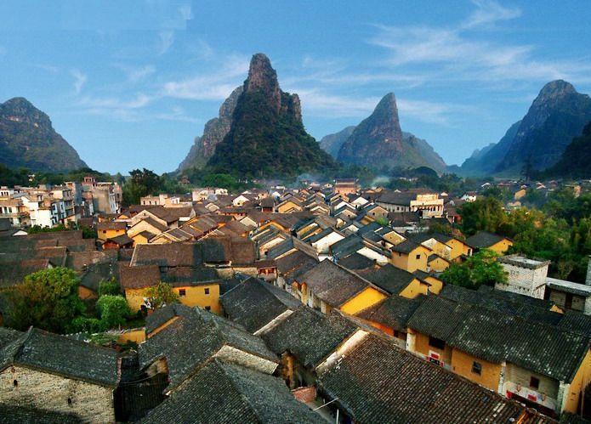
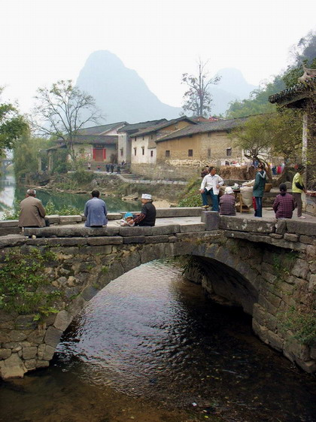
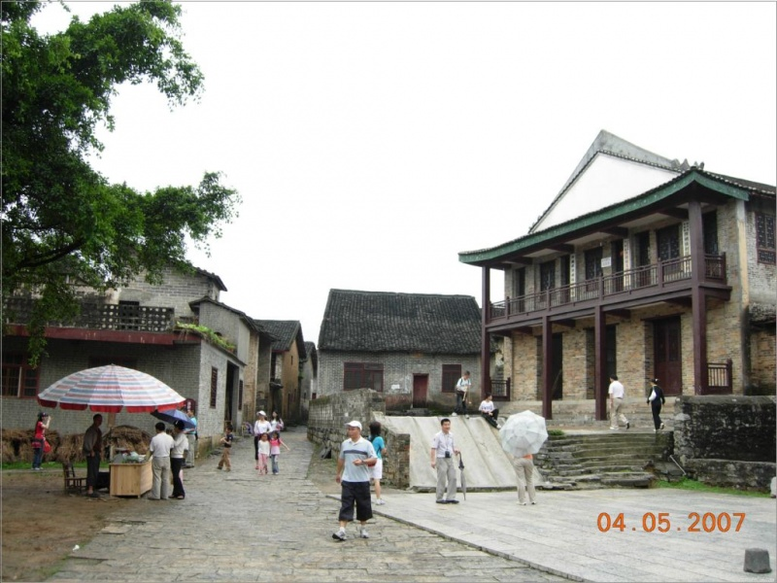
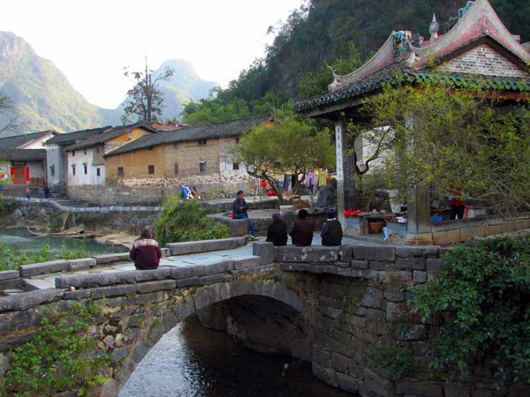
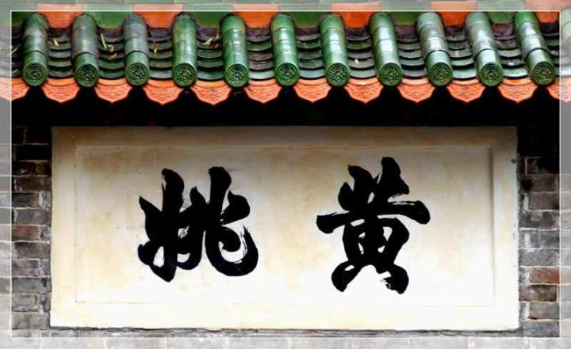
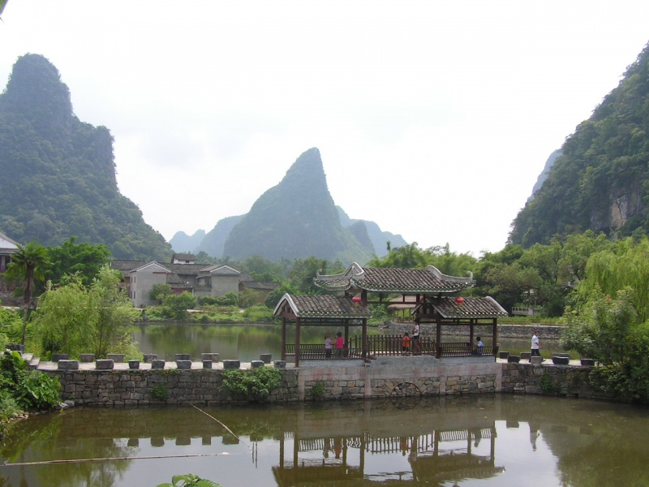
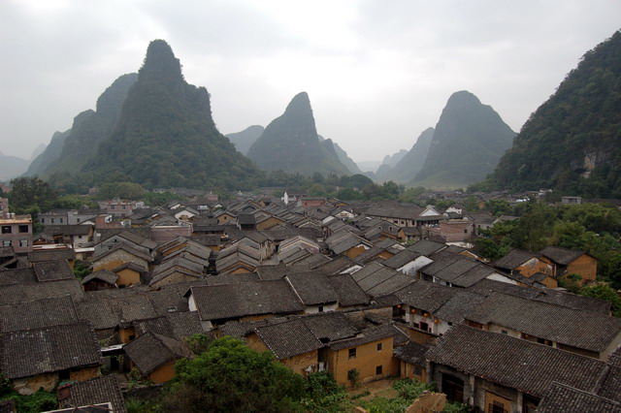
(BLOG) not gud, return > Yangshuo

Nanning Guangxi
> Detian Wrfall

(2 N/ 0 D/ 3 T)
(LP 650m, 649, DK423) )
TRANS IN Options:
BUS: Yangshuo > Nanning
BEST cuz I will fly from Nanning to HKG so
BUS: (2/D, 6 ½ hr, 8am-8:59am)
might as well base there & take DIRECT Nannning BUS > FALLS

NO trains
OPTION 1: Yangshuo > Guilin > Nanning by:
BUS: REG 5 hrs
Possible Option: Intercept Direct Guilin > Falls BUS ???
Yangshou > Nanning by TRAIN (p6: hrs) Several trains from Guilin thru Yangshou

ACCM: Lotusland Hostel

TOWN SITES: (DK423- extras)
NOT MUCH, but:
Guangxi PROV MUS: Dong bronze drums; ; Dong & Ming hoouse, nail-less Wind & Rain Bridge
w/restuarant
Sunken alleyways : e side of Yong RiIV Bridge just S of Suthgate MKTto wander P650
AROUND Nanning:
If STUCK, see p 652 for suggestions

TRANS – IN > Detian Waterfall:

(LP657, DK425)

1D
OPT !: DIRECT Nanning BUS from INTER Tourism distribution Center (LP650m , 18C1)
(Y90 RT, 3 ½ hr, 7:40am) > Detian Falls (9am, 3 ½ hr)

OPT 2: Difficult OPTION:
1) BUS From Nanning > Daxin
2) turn L from BUS STA & walk 5-10 min down Minsheng Jie @ Lunli Lu juction (w/ traffic
lights)
2a) There, on your R minibuses > Shuolong (Y10, 1 hr, up > 6pm)
Minibus > Shuolong
@ Shuolong: minibuses & rickshaws under big tree > Detian Falls (Y20 & Y15, 20 min)

Detian Waterfall
OVER NIGHT:
(LP657, DK425)

ACCM: at Falls Guesthouses ¥80
TO DO:
1) Falls ¥80
2) Bamboo rafts to near falls
3) Climb Ft Mountain (1 ½ hr)

TRANS-OUT Detian Falls > Nanning:

1) DIRECT BUS . Nanning: DP : 3:20p
2) a) Last BUS Shuolong > Daxin: 4pm
b) REG Daxin BUS > Nanning: : . 8:30p

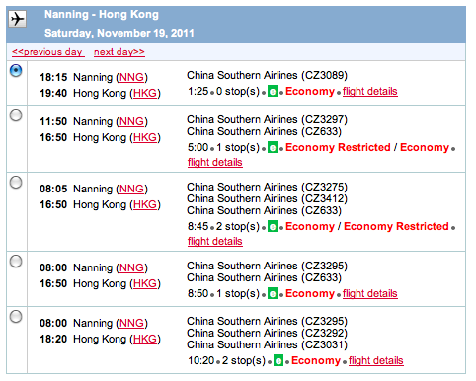
NANNING (NNG) > HKG:
TRANS – OUT: FLY: $300
China Southern Air

http://www.flychinasouthern.com/index.php?lang=en
TO Airport: CAAC Airport Shuttle:
(2/hrly, 40 min, 5:30am – 9p) DP outside this office

(LP651)
CUSTOMS DECLARATION: --- CASH: Declare US$6,000+: CAUTION: GET Declaration
receipt ; to show Customs @ China departure. ON DEPARTURE declare between US$6,000 and
US$10,000 w/ Chinese bank permission

CAAC (Civil Aviat Admin.C, Zhongguo Minhang), 82 Chaoyang Lu (LP says: 24
hr; 243-1459) (Airport Shuttle)
CITS 76 Chaoyang Lu (daily 8am-noon & 3-5.30pm; 0771/2804960, 2806025,
citsgx@public.nn.gx.cn). A whole courtyard full of CITS offices; try and track
down Ms Zhou Run LIng , some ENg, works upstairs in building ahead of you os
you walk in off the street.

BACK UP OPTIONS: CITS
GOTO Gunagzhou or Shenzhen

Hong Kong,

(T, D, N/ 3 T> TUS)
(LP 526-535m, 522,DK308-9m, )
USD > HK$: $1USD + 7.8HKD
TRANS – IN: SEE Nanning TRANS - OUT --- AIR
TO/ FROM AIRPORT:
Airport Express: Central (HK Airport Express STA: every 12 min) & Kowloon STA
GETTING AROUND: Octopus Card:
HK$50 + refundable deposit (HK$50) ; most TRANS, some stores, ADD-Value machines :
MTR TIK off & 7-11 Stores
ACCM:
Kowloon: (Tsim Sha Tsui): cheapest: either side of Nathan Rd (DK316)
Park GH: HK$200/ $26
Mei Lam GHH: HK$200/ $26
World Wid GH: HK$250/ $332
Man Hing Lung HOT: HK$150/ $
New Yan Yan GH: HK$150/ $
WElcome GH: HK$200/ $26
Chungking House (???)HK$200/ $26
ad 13% in taxes; prices fall in shoulder season HI Season: Oct & NOV
Al but cheapest have: Eng cable, A/C, private bath

FOOD:
SITES: 4 main areas
KOWLOON
:
Tsim Sha Tsui (DK316)
START WALK @: (NLP) Kowloon-Canton RR clock tower: near Star Ferry Concourse
(DK315) Where? not on map
Space MUS: IMAX ?
Kowloon Park
HK MUS of Art (LP538, DK316)
Yau Ma Tei / Mong Kok: (N of Kowloon) (DK317)
Jade MKT
Tin Hua TEMP
Signal Hill Garden & Tower (NLP)
Temple ST night MKT
Yuen Po St Bird Garden
New Kowloon: (N of Mong Kok)
Sik Sik Yuen Wong Tai Sin TEMP
Chi Lin Nunnery
Kowloon Walled

NEW TERRITORIES
:

Chi Lin Nunnery (NLP) (LP483)
Kam Tin & Mai Po Marsh: 2 Walled villages: (DK321)
Kat Hing Wai: (LP526m, 540)
Shui Tau Tsuen: (LP526m, 540)
Sha Tin:
Ten Thousand Buddhas Monastery (LP 526m, 540, DK320)
HK Heritage MUS (LP526m, 541, DK320)
City Park
HONG KONG Island
: N side (urban jungle) & S side (green , relatively UN developed) ;
center: (protected convenient hking area)


Star Ferry boat ride (DK315)
1) Sheung Wan Walking Tour: 1 hr; (LP542, )
Western MRKT (DK315)
2) CENTRAL: (DK310)
* Peak Tram:
* Victoria Peak: (DK312-3 SPECLAY)
3.5 walking trail around peak (also, can walk down to Central track
? HK Zoo & Botanical Gradens (DK311)
? Cenotaph (NLP)
Li Yuen ST E & W: if en route somewhere

嘉咸街
Graham St MKT
(& Peel St MRKT) Victoria City of Hong Kong. Located in Central,
the street starts from Queen's Road Central and runs uphill and south to Staunton Street, c

Central-Midlevels escalator: (DK314) worlds longest
Man NO TEMP: (DK314)
Western MKT
st
nd
PUBLIC TOILET: second floor (3rd floor); not 1
(2
flr) Completed in 1906, impressive
building has a red brick exterior with a handsome granite arch over its entrance. The
market now houses shops formerly located in old alleys Central, selling all manner of
cloth; also traditional handicraft stalls & cafes. top floor: Grand Stage dancing & dinner
3) Admiralty: nothing
Flagstaff House MUS of Tea Ware
4) Old Wan Chai: (DK310) (Best – walking)
Blue House (NLP)
Wan Chai MRKT (NLP)
Golden Bauhina 11B2HK
Convention & Exhibt CNTR (LP532m, 13B3)
5) Causeway Bay: (DK311)
Pak Tai TEMP (NLP) Where? not on map
Lin Fa TEMP Where? not on map
Hung Shing TEMP Where? not on map
Tin Hua TEMP 16H3
Island South:
Repulse Bay bus ride
Longevity Bay
Deep Water Bay:
Aberdeen (p526m)

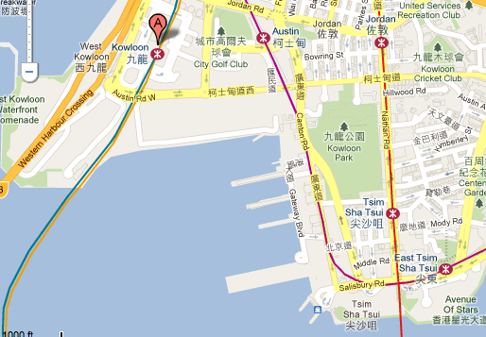

HONG KONG > TUCSON: WED NOV 23: 12:50 pm (noon)

TRANS - OUT
--- AIR

TO/ FROM AIRPORT:
Airport Express: Kowloon STA Octopus Card - ??? Central (HK Airport Express STA: every 12
min) &

UAL eTicket Number:

800-538-2929 (say ‘Agent’ or “hit “0”)
0058668467270

UAL Reference Code:

N950LJ

CONT Reference Code:

D8LF8Y
Traveocity Trip ID #:

2119 9280 9993

888.756.2745
1.888.872.8356 /

www.checkmytrip (not available for United)

SERVICE
DATE FROM TO DEPART ARRIVE
DURATION

UAL
23NOV HKG SFO 12:50pm 0828am
11h 38m
862

WED (HKG>SFO )

HKG Ter:???/SFO Ter: ‘ eye“
Seat: 55K

Time between flights: 11h 12m

UAL-X
23 NOV SFO TUS 07:11pm 10:08pm
3h 0m

6352/6193 WED (SFO>TUS)

SFO Ter: ???
Seat: 11D

$1115.70
Seat as of 7-19-2011 @ 9am
Total Travel Time: 24h 22m
MISC:
HK$: p951
ELECT: 220v 50 hz Type G & Type M (3 rnd. Posts in triangular config.)

Hong Kong
220 V
50 Hz
* Type M has been replaced by Type G, but may
Type G Electrical Outlet
sometimes still be found.

Type M Electrical Outlet

U.S. citizen tourists for < 30 days no visa req’d; passport req’d; CAUTION: private "visa
extension services," bogus;

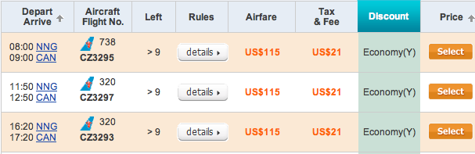
NNG > CAN > HKG: Nanning Flight ? HKG may stop in CAN; No real reason to GOTO CAN
FLY:
www.chinatraveldepot.com
NNG > CAN

Zuo Jiang Scenic Area::
TRANS-IN:

1D
OTE” local bus > TRN STA
2) Rickshaw (30min) > Minzu Shanzhai aka Panlong:
ACCM:
Guidebook Confiscation:

LEFT LUGGAGE:
SITES:
Longrui Nature Reserve:
Huashan Cliff Murals: 2000 yr rock art

TRANS-OUT > Pingxiang:
BUS: reg; Last @ 6:20pm
TRN: 10:43am (49min) & 2:39 (38min)

PINGXIANG (> Friendship Pass)
TRANS-OUT > Friendship Pass

NOTE: If COMING FROM or GOING TO Vietnam SEE LP for additional Sites enroute ( Zuo
Jiang Scenic Area: Huashan Cliff Murals

Jiayuguan
GW (LP848m,
嘉峪关
嘉峪關
or Jiayu Pass (simplified Chinese:
; traditional Chinese:
; pinyin: Jiāyù Guān;
literally "Excellent Valley Pass") is the first pass at the west end of the Great Wall of China,
near the city of Jiayuguan in Gansu province. It has also been called "Jiayuguan Pass";
however, this form is redundant since "guan" means "pass" in Chinese. Along with

Juyongguan and Shanhaiguan, it is one of the main passes of the Great Wall
, 6 kilometers southwest of the city of Jiayuguan in Gansu. The structure lies between two
hills, one of which is called Jiayuguan Hill. It was built near an oasis that was then on the

extreme western edge of China
Yaumenguan Pass
In most NW corner of GANSU PROV, TOO FAR FROM
,
Xian, Shaanxi PROV
75 km from GW of E Wei
located on a hillock 90 km (56 miles) northwest of Dunhuang City, is an important
pass of the north route on the Silk Road. After Zhangqian served as an envoy to the
West Region, a mass of silk and tea from Central China were exported abroad
through this pass, and in return, fruit, specialties and religion culture were brought in.

Jingdezhen > Nanchang
Total Time
Trains
From
Dep. Time
To
Arr. Time
Distance(km)
Hard Seat
Soft Seat
Hard Sleeper
Soft Sleeper
Book
(hh:mm)
$ 3
$ 6
$ 10
$ 15
5205
Jingdezhen
07:39
NanChang
12:28
302
04:49
Inquire!

$ 7
$ 10
$ 16
$ 24
K8729
Jingdezhen
13:50
NanChang
18:09
302
04:19
Inquire!

$ 3
$ 6
$ 10
$ 15
2239
Jingdezhen
23:38
NanChang
06:00
302
16:52
Inquire!

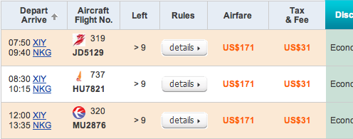
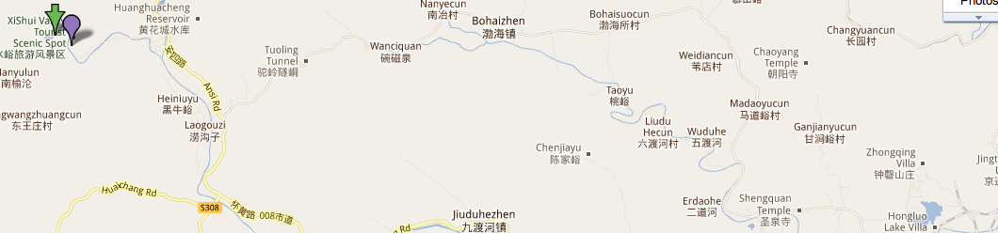
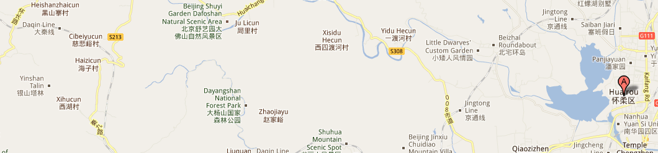
ALT #2:
Xian (SIA) > Nanjing (NKG):
Air :

Nanning > Huangshan
LP439 1 thru Nanjing stop @ Tunxi Ji
Ngdezhen – BUT I found nothing

NO cuz underwater cuz modern reservoir, NOT HIST
Reservoir (&
Xiaoxihu:

Huanghuacheng Great Wall)
TRANS:
By bus: Catch bus # 916 from Dongzhimen long distance bus station to Huairou, then change
to bus no 961 or a minibus to the village of Xishuiyu.

1) 1 ½ jrs from Beijing to Xiao Xi Hu (Huanghaucheng Reservior),
2) passing by Huanhuacheng Village and Huanghuacheng GW.
3) Enter the gate of Huanghuacheng Reservior (Xiao Xi Hu).

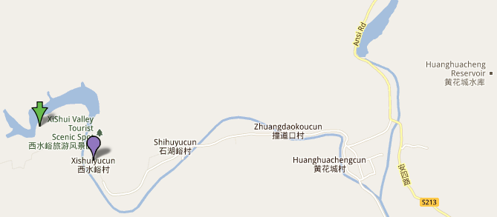

SITE:

extended Huanghuacheng Great Wall at the Reservoir Section. Xiaoxihu Great Wall i@ Xishuiyu
Village near Huanghucheng RES. Huanghuacheng RES cuts the Great Wall into 3 sections
HIKE:
Hike Route: loop, challenging, Great Wall, mountains & water.
Walking Time: 3 hours
Walking Level: 3
lakeside setting: lovely walks, especially in thick forest, 2 TRails:
1) around lake trail : wooded forest. 2) starts near guard’s station on dam wall – 2-3hr -
leads to watch towers of the greatwall on hill top: spectacular views, including a
connecting creek.

Luggage update Irv’s: Repair: 888-300-4787 X 3 Repair Pete
Handle, open seam, wheels
REI Luggage: 800-638-6464

