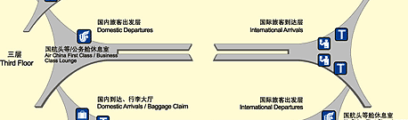
CHINA TO DO
Discount Taxi: 520-388-5000 $25 Other CAB: From TUS > Sandy: $36
BEIJING

Zhong Guo
: (LP117m, 116, DK70m, 115-9m)
(1T/ N, D , 1T)

UAL eTicket Number:

800-538-2929 (say ‘Agent’ or “hit “0”)
0058668467270

UAL Reference Code:

N950LJ

CONT Reference Code:

D8LF8Y
Traveocity Trip ID #:

2119 9280 9993

888.756.2745
1.888.872.8356 /

www.checkmytrip (not available for United)

SERVICE
DATE FROM TO DEPART ARRIVE
DURATION

UAL-X
1Sep TUS SFO 0600am 0823am
2h 23m
6369

THU (TUS>SFO)

Ter: SFO: 3; CAR: 4
Seat: 11D

Time between flights: 2h 39m

CONT
1SEP SFO PEK 1102am 1420pm

12h 18m

4194
THU (SFO>PEK) (next day – FRI, Sep 2)

Ter: PEK 3
Seat: 55K

$ $1115.70
Seat as of 7-19-2011 @ 9am
Total Travel Time: 17h 20m

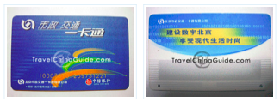
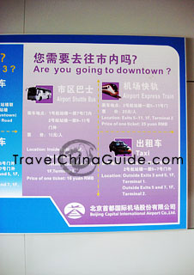
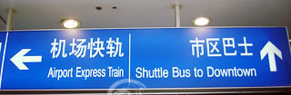
INT ARV - ENTRY PROCEDURE:
All INT ARV @ 3F of T3-E.
A) Inspection & Quarantine,
B) Immigration Check Post for Inspection of : 1) filled-in Entry Registration Card, 2) valid passport
& 3) visa
C) Elevator down > 2F of T3-E > APM mini-train (every 3 min) > International Baggage Claim Area
--- 2F of T3-C. Later, passengers should make a
D) Customs Declaration Form: $6K+ , dried fruit.
CASH: Declare US$6,000+: CAUTION:.GET Declaration receipt ; to show Customs @
China departure. ON DEPARTURE declare between US$6,000 and US$10,000 w/ Chinese
bank permission
Fig bars, granola bars
E) Foreign Currency Exchange:
ICE: Departure Hall at 4F of T3-C;
E exit of International Baggage Claim Area
Travelex: W exit of Intern’l Baggage Claim Area;

China Construction Bank—W of Departure Hall at 4F of T3-C (baggage claim bldg.;
(
)at Airport or Dongzhimen STA
F) Transport “Smart Card”
BPT Reload Card
GEN: take all metro lines, buses (2 RMB) ; quicker btw 4:30-7:00pm; BUS: cheap (0.4
rmb w/ card) , easy once you figure out the routes, www.bjbus.com
st
Card cost: Loaned free, If 1
time: DEP: CNY20/card PLUS CNY20 or more prepaid.
Deposit & balance – refund if not damaged

TO USE? card is tactile.
METRO: (tactile); put card close to read machine & again when exiting – MAX deduction =
only CNY2
CITY BUS: put card close > card reader at bus door . Usually, only once on bus (signed
clearly on bus). But on some fare charged by DIST), maybe used twice: both getting on & off.
G) Express TRN > Beijing: front of T3 Terminal 3: F2 of Parking Garage No. 3
ROUTE: T3 of Capital Airport (Term 3: F2 of Parking Garage No. 3)→T2 of Capital
Airport→Sanyuanqiao→Dongzhimen
28-km of Beijing subway; light rail line ; 20 minutes, highest speed - 110 km/hour.

F) > Metro: SEE NEXT PAGE
F) > Metro:

Exp TRN > Dongzhimen STA > Metro L2 > Jishuitan (18 or 218)
1) Airport Express > Dongzhimen STA ROUTE: Airport Express Train: Airport T3 →T2 →
Sanyuanqiao→ Dongzhimen STA; 20 min, hi-spd:110 km/hr. CAUTION: DO NOT lose TIK
2) Transfer to Subway line2 > STA 18: Jishuitan station - exit C
东直门
Station 14:
( Dongzhimen )
It is a transfer station for Line 2 and Line 13.
Attractions nearby: Dongzhimen Bus Terminal - Bus 916 for Huairou for Mutianyu Great
Wall.
雍和宫
Station 15:
( Yonghegong - Lama Temple )
It is a big transfer station for Line a and Line 5.
Attractions nearby: Lame Temple, Earth Temple, Confucius Temple and Guozijian.
安定门
Station 16:
(Andingmen )
鼓楼大街
Station 17:
( Guloudajie - Bell Tower Street )
Attractions nearby: Bell Tower, Shichahai, hutong tour
积水潭
Station 18:
( Jishuitan 218)
st
3) When exit Jishuitan STA -- EXIT “C” , turn L, walk about 10 meters > 1
L (onto
Xiaotongjing Hutong)
4) Follow street as it bends to right, then continue on this street along the side of the lake.
st
5) When road comes to a “T” at a stone wall (Banqiao 1
Alley), turn L and
6) continue walking about 200 meters to a small intersection with a bridge and beginning of
canal.

7) Turn right at far side of canal --- Sleep Inn about 10 meters ahead on your left
困酒店湖畔
ACCM:
Sleepy Inn Dwntn
(p149)
; (p124m 80D2, 154)
北京市西城区德内大街
号
丽舍什刹海国际青年酒店
Chinese address:
103

No.103 Deshengmen Nei Da Jie, Xicheng District, Beijing 100035, Lynne Chen, MGR; Cathy
10-6406-9954 Email: book@sleepyinn.cn Web: http://www.sleepyinn.com
BOOK: D4: CNY80/bed ; ARV: 02 Sep, 2011- 09 Sep 2011; TOT: 7N, Y560
PERKS: BKFST, Lug STOR, TOURS, A/C, Lockers, Air & train tickets booking, Bike Hire,
Cathy Questions:
1) EMAIL:

) When I get to small intersection with bridge”, do I cross canal and turn Right
alongside the canal? Sleepy Inn is on the canal?
2) OR ARV:

) Ancient (Ruined) Badaling

) Capital Water Tours Tel: 6823-2179 (office) 6821-3366 ext. 4402/4403 (on-
site) Tickets: one-way RMB 40, round trip RMB 70

) C Opera:
FOOD: Supermarkets: Ole Supermarket; Carrefour; April Gourmet; Jenny Lou’s;
MISC:
Boating on Houhai
on lake at sunset in Hired Electric (battery) powered motorboats (cost from RMB60 (with RMB240
deposit/hr.) : leisurely end to afternoon.) ten rental places;. most S lake crowded, especially @
bridge bottleneck, N lake larger Watching the sun go down over the lake is just great!
Gold Ingot Bridge:
Silver Ingot Bridge: ? between Houhai and Qianhai lakes. many hutongs in the area
Jinding Bridge is now focal point of all interesting cultural or hsitoric spots within the shishahai (back
lakes). walk, or rickshaw ride
Jinjiang Inn Nearby
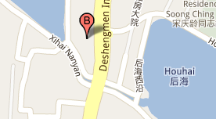
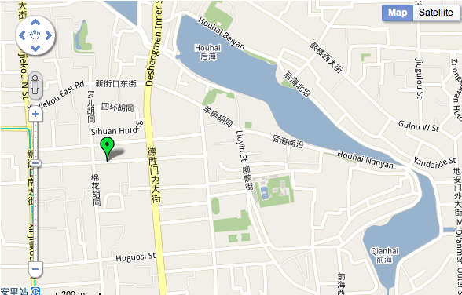
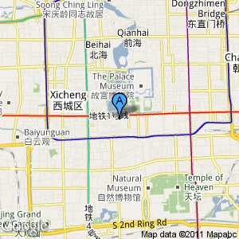
OTHER BEI HOSTELS I researched
Jinjiang Inn
Nearby Jinjiang Inn not so over priced, close to Hutongs, lots of rest. Wifi, beds hard, buy towels,
5-10 min to/from subway station i.e. Jishuitan as well as bus stop, fluent Eng,
Jinshanling-Simatai
great wall trip was Y150 instead of City Wall's extortionate Y270

Red Lantern House 85% (hutong) hostel:
Red Lantern old East Yard; Red Lantern New W Yard
DORMS: 6-8 $10, D4 - $12, 60-70 RMB; East or West Yard
LOCATION: near the Xisi subway stop and walkable to Forbidden City; slow wifi, very cold
rooms;
Reviews:
Xiosi SUB STA (10 min) ;
Need shuttle from E to W so know which one I am booked in beforehand;
NEG: cold, staff controlled heater, vVERY COLD, stinky toilets
Houhai Courtyard GH Dm $10

NO! BEI Downtown BP Accm: 66E2
PEK IYH (48D3) D4-8-12 $15+ & dn
SW: Far East Youth Hostel 69D570% (S of TSq : 4D 45 rmb; 6D 60rmb
SE: Peking International Youth Hostel ; 8 mix D- $16.21USD; next to the Forbidden City and close

to Tiananmen?
.
No.5 Beichizi 2(Er)tiao, Dongcheng District, Beijing 100006

Beijing Lama IH

p152 D4 60
Beijing City Central IH
kit,
p151
D ? 60
Zhaolong IH kit, 6 floors

p153
D460 , D2 70???

TO DO
BUY museum pass for 100Y
Walking areas:
1) Strolling through Dashilan street, Liulichang (fun shopping ??/ ) street and Yandaixiejie,
2) Wangfujing Area “Night” MKT (LP ? NO , DK81-17) (Dong Chang'an Avenue in the south to
Wusi Street in the north, and from Dongdan Bei Street in the east to Nanheyan Street in the west);
3) Lama Temple, the Confucius Temple and Guozijian (Imperial College) along Chengxian Street,
Bell Tower, Yandaixiejie and Shichahai area.
4) Donghuamen night market

st
1
DAY: Orient

1D
nd
2
DAY: Tiananmen Square:(S>N)(LP124m, 130, DK)

2 ¾

1D


SUNRISE flag ceremony;
@ surise- (5:45am) (LP131)
½ hr

emerge thru Gate of Heavenly Peace across Jie > flag pole
33 Chairman Mao Memorial Hall (open 8:30a)

1 hr
(p124m; 33 E4; 8-noon, DK81m-82) (S side of T Sq) (body)
Don’t store camera w/ bag or extra fee
45 Front Gate (p124m; 45 E4, DK81m-?) (actually 2 gates)

½ hr
DK Qian Men (DK81m-2, 84)
Arrow Tower (S of Front Gates)
Orig connected to gates
DK Palace Walls:
Zhengyang Gate (largest of 9 inner city gates) (DK81m-82
Old Station Building (>E)

¼ hr
46 Great Hall of the People

1 hr
(p124m; 46 E4; 8:39 – 3 pm varies, DK81m-82) (W side of T Sq)
Nat. People’s Congress
62 Monument to the People’s Heroes

¼ hr
(p124m, 62; 51 E4, DK81m-82) (N of Mao’s Hall)
Qingdao granite obelisk w/ bas reliefs
Tiananmen Square’s immediate surrounding area:

4 1/4


C Numismatic MUS: early paper $

½ h


34
China National MUS (LP124m; 34E4, DK81m-83)

½h
ceramics / bronzes/Han Au/silver vessel

S of Qian Men (Cianmen) (immediately S)
DK BEI Underground City)
(SE of )
29 Beijing Underground City (LP124m, 29E5, p136,: DK81m-3, 84)
1 hr

giant bomb shelter, tunnels,
ALSO: POST VISIT: Tongle Hutong,

¼ hr
st
one of the narrowest DIRECS: Exit Tunnels E > 1
alley on R
DK BEI Plan & Exhibition Hall (EXT ONLY) (LP124m, 27E4; DK81m-4, 84)
DK Dazhalan & Liulichang HUTONGs (, DK81m-5, 85)
2 hr
(SW of )
DK S Cathedral (, DK81m-6, 85)

nd
2
DAY:
E of T Sq

2 ¾ h / 7 h

1D
Foreign Legation Quarter walk: (p124m; 42 E4)
DIRECS: Up SE steps from T SQ > Dongjiaomin Xiang (St.)
Former Dutch Legation No 40

¼ hr
28 Beijing Police MUS (p133, p124m: 28 E4)

1 hr
Banque de L’Indo-Chine No 34 (Faded char)

¼ hr
DIRECS: @ 4a Zhengyi Lu
44 Yokahama Specie Bank (Domed) (P124 m)

¼ hr
Japanese Legation (R hand/East)

¼ hr

& British Legation (west)
43 French Post Office No 19

¼ hr

now Jingyuan Sichuan REST)

NEAR former French Legation
60 St. Michael’s Church No 11 (p131, p124m:)

¼ hr

& (opposite) Belgian Legation
DIRECS: N on Taijichang (St.)
DIRECS: N wall of Tajichang Dajie is

¼ hr


a Brick St. sign embedded in N wall of

Tajichang Toutiao w/ old name “ Rue Hart”

Further E of FOREIGN LEGATION Area

4 1/4 h

DIREC: E a couple of blocks

YES DK Wanfujing “Night” MKT (LP ? NO , DK81-17)

50 Ming City Wall Ruins Park (LP P124m: 50: F4, 134, DK81m-19)
1 ½ hr
2km of wall;


Imperial City Wall Park & MUS (p134, p138m: ) (SE side of)
LOCATION: 1) N of WangFuLing pedestrianized street OR (???) 2) side st. to W leads to
Imperial City Wall Park; runs parallel w/ WangFuJing Jei: night time food stalls.
HIST: Surviving (rebuilt ?) section of ORIG Imperial City wall; Only very short section of main city
wall left standing today; separated IMP family from subjects; followed Metro L2 path (Originally
Yuan dynasty, extended to current 2nd ring-road shape in Ming, 1550, including a rectangular S
land block.) Climb wall; if - even meet Keeper of the Wall who ilives in original guard tower.

SE Corner Watchtower (LP125m, 59G4, DK81m-19)
DIREC: E a block
INT: impressive & splendid carpentry
“Say” going to Art Gallery for free admission to tower etc.

24 Ancient Observatory (p124m: 24 G4)

1 ¼ h
Reproduction of armillary sphere i.e. a celestial globe model of rings & hoops representing
equator, tropics, and other celestial circles; able to revolve on its axis. Used to show the
recurrence of equinoxes & solstices
Pleasant sitting courtyard & garden – more instruments
ON ROOF: Jesuit designed astronomical instruments
Ritan Beilu (park) LPn74m, B1-2, 65

DIREC: NW on Map129 > Jinbao & Chauyangmen INTERSECTION
15 St Joseph’s Church (LP129m p142,: 15 D2)

½ hr

NOTE; 5 HUTONGs between St. Joes & Zhihua TEMP

16 Zhihua Temple (p143, , p129m, 16 F2)

½ hr
authentic cuz avoided restoration)
Shrine; Zhihua Gate;
Scriptures Hall –wooden library, magnificent UN restore ceiling;
Ten Thousand Buddha’s Hall
Take stair at rear ,if open, clamber up to effigy of Vairocana
39 Dongyue TEMP (Dong Yue Miao)(LP124m / 39 G3144, DK81m-15, 93) ½ h
Due E of FC / 1 ½ mi NE of Observatory (24G4) Chaoyang:
1000 Armed Guanyin (at temple rear)

___ DAY:

TOTAL

2D

S > N
Approach > Forbidden City

2h

Center S > N
Audio tour – NO (useless, difficult to use).
13 Gate of Heavenly Peace (LP138m, DK81m-?)

½ hr
Largest of 4 such gates
5 doors & 7 bridges
Free walk thru gate, but climbing requires fee
8 Duan Gate (LP138m, DK81m-?) (ceiling)

¼ hr
W side (S>N)
Zhongshan Park

¾ hr
(LP138m-B5, P134, S of Site 40 S of FC)
E side (S>N)
Worker’s Cultural Palace

½ hr

(LP138m-C5, P134, ; SW side of)
Huge halls & imperial yellow tiled roofs
11 Front Hall Can’t find
34 Middle Hall
38 Rear Hall

NOTE: Get inside early cuZ(S>N) (p138m) DO ALL Cuz 1 day TICKET

FORBIDDEN CITY :

1D 2h
8:30a; (, DK86m-, 84)

METRO: Tiananamen Xi or Tiananamen Dong
Audio tour – NO (useless, difficult to use).

33 Meridian Gate (TIKs) (LP138m, 33B4; DK86m,

¼ hr
Golden Stream (DK Golden Water)
15 Gate of Supreme Harmony
(LP138m, 15B4; DK87m

¼ hr
24 Hall of Supreme Harmony
(LP138m, 24B3; DK87m,)
¼ hr
INT: Dragon Throne; Bronze shuigang (vats)
21 Hall of Middle Harmony (LP138m, 21B3; DK87m,)

¼ hr
(transit lounge)

23 Hall of Preserving Harmony (LP138m, 23B3; DK87m,)

¼ hr
REAR: 250 ton marble imperil carriageway

INNER COURT: (LP138m, DK87m, 88)
26 Heavenly Purity Gate (LP138m, 26B2, DK88m, 89m – 1, 88)
¼ hr
36 Palace of Heavenly Purity (LP138m, 36B2; 89m – 2, 88)

¼ hr
25 Hall of Union (LP138m, 25B2; DK89m – 3, 88)

¼ hr
9 Earthly Tranquility Palace (LP138m, 9B2; DK89m – 4, 88)

¼ hr
28 Imperial Garden (LP138m, 28B2; DK89m – 5&6, 88)

½ hr
29 Imperial Peace Hall
(LP138m, 29B1; DK89m - 10

¼ hr

Eastern Palaces: (LP138m, DK89m -7--11, 88)

1 ¼ hr
7 DK Eternal Harmony Palace

¼ hr
8 DK Palace of Abstinence

¼ hr
35 Nine Dragon Screen (LP138m, 35C2; DK 89 )

¼ hr
DK IMP Zenith (Supremacy) Hall (LP138m, 30C2; DK89m-10) ¼ hr
11 DK Peacefl Longevity Hall

¼ hr

Western Palaces: (DK89m -12, 89)

¼ hr
DK Mental Cultivation Hall (LP138m, 20B2;DK89-12)
¼ hr
(authentic orig wall paint)
E Warm Chamber
DK Palace Walls & Arrow Towers @ ea corner: (DK89m -13 & 14, 8) ½ h
3 Chengguang Gate

¼ hr
Pair of bronze kneeling elephants

39 Shenwu Gate

½ hr

(14
)
Gate of Devine Prowess DK / Divine Military Genius Gate

NW Quadrant: (LP138m, B2)

1 ½ h


41
Thousand Autumns Pavilion



44
Western Palaces
47 Yikun Palace: authentic orig wall paint

½ h


10
Eternal Spring Palace
20 Hall of Mental Cultivation
authentic orig wall paint

1 hr

NE Quadrant: (LP138m, C2)

3 ¼ h


31
Jadeware Exhibition


4
Chengqian Hall


32
Jingren Hall


5
Clock Exhibition Hall authentic C H2O clock

½ hr
43 Well of Concubine Zhen* (C1)

¼ h


17
Hall of Harmony: Buddha, gems, gold

½ hr
18 Hall of Jewellery*

½ hr
19 Hall of Joyful Longevity: jade, lazuli

½ hr
16 Hall of Character Cultivation

¼ hr
2 Changyin Pavilion old Imperial stage

¼ hr
30 Imperial Supremacy Hall

¼ hr
35 Nine Dragon Screen*

¼ hr

SW Quadrant: (LP138m,

1 ¾ h


27
Hongyl Pavilion (B3)


22
Hall of Military Powers (B3)


Golden Stream (see p138m)

¼ hr

46
Xihua Gate (A4)

¼ hr

14
Gate of Military Prowess (B4)

¼ hr

45
Xihe Gate
(B4)

1 hr
SE Quadrant:

¼ hr


Unmarked bldg.
7 Donghua Gate

¼ hr

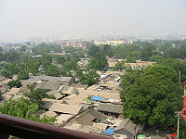
N of FC: (p124m) START by Metro

9h
1D+
38 Ditan Park (Di Tan)

¾ hr
(p142, p124m: 38 F1, DK81m, 14)
If > art gallery, may waive PK fee

•
48 Lama Temple (LP124m , 48 F2, 141, p, DK81m, 12)

1 hr
GO SE of Park
GOTO: Xilou Hutong (Exit Lama TEMP going E) > Bailin Temple

36 Confucious Temple & Imperial College

¾ hr
(p142, 36 F2, p124m, DK81m, 13) 2mi N of
Confucious Temple: bixi , pailou, forest of stelae,
WANDER: Guozijian Jie hutong cafes & shops,

1 hr
40 Drum & Bell Tower

¾ h

Drum performances every ½ hr 9-11:30 & 1:30-5pm

½ hr
(p143, p124m: 40 E2, DK81m, 11) (1 ¼ mi due N of FC)
(hutongs nearby; also near Shichahai Lake ???)

¾ hr
impressive views of hutongs from top;

Nanluogu Xiang (LPn72m, 1B3) (LP59)
DK Prince Gong Mansion (Early; 8/8:30)

¾ h
(LP124m, 55D2, 146; DK81m-10, 90)
Grand Opera House (on E grounds) (LP159 info)
Phone: time, $, dress) 6618 6628 TIKs:
**
26 Beihai Park

1 hr
(p124, p140: 26 E2, DK81m, 9) (3/4 mi N of T SQ)

Large green jade jar
Jade Islet
Thru Yong’an Temple White Dagoba
Xitian Fanjing
Nine Dragon Screen
If XTRA TIME:
Miaoying TEMP ‘White Dagoba’ (LP124, 49C3, DK81m-99)

¾ h
SE > 49 Miaoying Temple White Gagoba

½ h
号
‪171
Fuchengmen Inner Street‬, Xicheng
‪010-66160211‬
(Hutong) (p147, p124m / 49 C3)

¾ h
DIRECS: L2 > Fuchengmen STA; walk E
47 Jingshan Park

1 hr
(p124m, p142: 47 E3,DK81m, 14) (Immediately N of T SQ)
priceless views at top; hanging tree

West & South of T Sq

6 3/4 h
1D
Due W of T SQ:
32 Capital MUS (p145, p124m / 32 B4, DK81m-22, 94)

1 ½ h

63 White Cloud Temple (p144, p124m 63B4, DK81m-5, 98)

½ h

37 Cow Street Mosque

½ hr
(p144, p124m: 37 C5, DK81m-23, 98) (2 ½ mi SW of T SQ)

41 Fayuan Temple

¾ hr
(p145, p124m / 41 D5, DK81m-24, 998) (Near Cow Mosque)

THEN detour N >:

58 Songtangzhai MUS

1 hr
(p136, p124m: 58 D5, DK81m-) (SW 1 ½ mi T Sq)
Traditional Chinese carvings, drum stones, carved lions

106 National Grand Theatre (W of Great Hall)

½ hr
DIREC: Metro (p130, p124m, 106 D4, DK)

Due SE walk or taxi

61 Temple of Heaven Park

2 hr
(LP124m, 61E5, 135; DK81m-81m-21, 96 DRAWing) (Due SSE of T Sq about 2mi) ARV early
Traditional approach S gate, N gate an after thought
Temple: Round Alter; Imperial Vault of Heaven (tablets)
Echo Wall;
Hall of Prayer for Good Harvests 1420 astonishing structure
END DAY

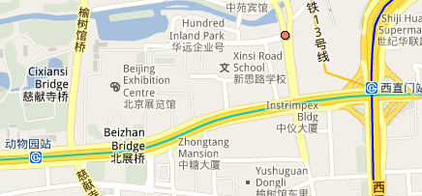
Haidian & Xicheng:

(8 ½ h)
1D

(yiheyuan)
SUMMER PALACE:
(p122m, p146m, 145)

6 h
DIRECS: p 146; LPn70, 69 (via Xiyuan STA &Exit C or Beigong men (L4)
Kumming Lake
Hall of Benevolence & Longevity

½
(p146m, @E gate)
Hardwood throne; bronze animals in courtyard
N Shore:
Long Corridor (N shore)

½
Longevity Hill

¾
N-S axis on hillside -temples
Buddhist Fragrance Pavillion

½
Cloud Dispelling Temple

½
Buddhist Temple of

the Sea of Wisdom (at top)

½
Cixi’s Marble Boat

¼
Qing boathouses

¼
South Lake Island (DIREC: Ferry >)

¾
Dragon King Temple

¼
17-arch bridge(DIREC: back> shore)

¼
Suzhou Street (C1)

1
Boat / cruise to Summer Palace (124m, 126B2)

资本水上旅游
Capital Water Tours

Tel: 6823-2179 (office) 6821-3366 ext. 4402/4403 (on-
site) Tickets: one-way RMB 40, round trip RMB 70
boat boarding: behind Zoo’s Exhibition Center: at top of a road that runs between Exhibition
Centre and Zoo.
Closest METRO: Exhibition Centre is just W of Xi Zhi Men STA (lines 2, 4, and 13) and just E of
北展后湖
Beijing Zoo Station (line 2 ALSO reverse option) Beizhan Houhu (
) Beijing Zhanlanguan
北京展览馆
(Beijing Exhibition Center,
).

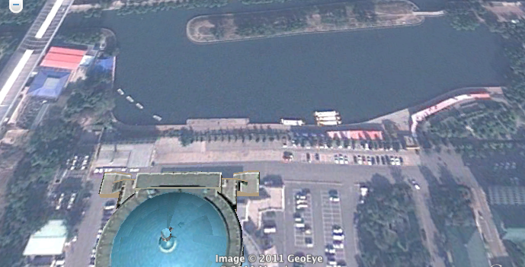

Boat Timetable
Depart Bayi Lake/Yuyuantan Park 8:00, 9:00, 10:00, 11:00, 13:00 and 15:00
Depart (Beijing Zoo ???) Beizhan Back Lake 9:30, 13:00 and 15:30
Depart Summer Palace for Bayi Lake 9:05, 10:05, 11:05, 14:05, 16:05
Depart Summer Palace for Beizhan Back Lake 10:45, 15:15
Call to confirm schedule and ticket availability as prices and times are subject to change.
The ticket booth and pier are a kilometer south of the South Gate of the Summer Palace. Above-
deck seating is limited so arrive early. Standing on deck is permitted.
Reservations cannot be made over the phone. Charters and night rides may be arranged. The
eastern route is nine kilometers, the southern route is 10 kilometers; trip time for either route is
less than an hour total
Route:

NEARBY :

Friendship Store: see C TO DO NOTES fro address & map

14-boat fleet: faux barges-like ancient imperial pleasure ships w/ dragonheads. Also modern
boats: two sizes; largest – outdoor seating
SUM PAL (S) > Zoo: Kunming Lake wharf > Long River Bridge (changhe qiao).: On W: Military
Command College camouflaged in residential area > Eternal Spring Bridge (changchun qiao) >
Changhewan Wharf. (canal forks) > E: > Wanshousi Temple & Wanshousi dock (Qing Dynasty
(1644-1911), Empress Dowager Cixi’s day-long pleasure cruises > Wanshousi, then sedan
chair carried back to Summer Palace) > elegantly refurbished Purple Bamboo Park >

NOTE: This E-W canal section once connected to Beijing's central lake district: Houhai, Beihai,
Zhongnanhai and the moat around the Forbidden City. Not now navigable, but plans to reopen
& of the old Beijing city canal system (huchenghe) entirety.
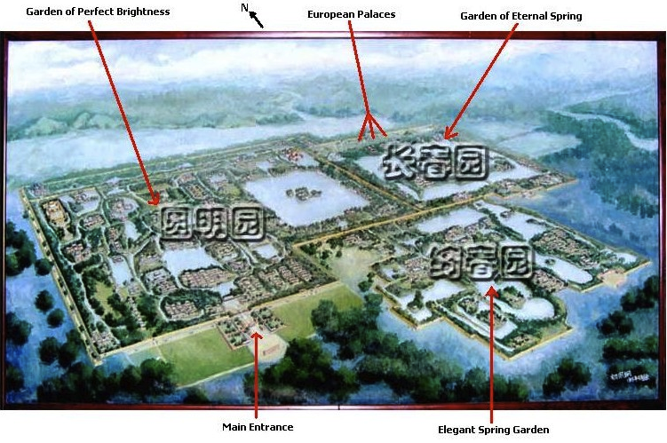
Old Summer Palace (p147, p122m, 9 C1, DKm(use LP), but DK 100-102SPECLAY)

Aka Yuanming Yuan
2 ½ h
DIRECS: LP147, DK1021) Minibus FROM New Summer PAL > old Summer PAL (Y10)
Eternal Spring Garden
¾ h
Great Fountain Ruins

¼ h
Garden of Yellow Flowers
½ h
Perfection & Brightness Garden
½ h
10,000 Spring Garden

½ h

W of Summer Palace
IF TIME

½ D

7 Fragrant Hills Park (LP122m, 7A2 p147,)

2 ¾ h

aka Xiang Shan PK
DIRECS: BUS 360 from ZOO OR BUS 318 from PingguoyuenMETRO STA : L #1
Incense-Burner Peak (chairlift)

¾ h
Azure Clouds Temple ( N gate)

¼ h
Mountain Gate Hall

¼ h
> small courtyard: Drum & Bell towers)
¼ h
>hall: Statute of Milefo

¼ h
> next hall: statutes, golden carved dragon, ¼ h
Sun Yatsen Memorial Hall: glass coffin
¼ h

@very back: marble Vajra Throne Pagoda
¼ h
Hall of Arhats: 500 luohan STATS

¼ h
5 Beijing Botanical Gardens: (p148, p122m / 5 A2) 1 ¼ h
Walk

1 h
Temple of the Reclining Buddha & shoes

Bee Museum of China
west side of the Botanical Gardens in the Fragrant Hills
Address: Beijing Botanic Garden, west of Sleeping Buddha Temple, Fragrant Mountain
Opening Hours: All year around (except November 15-March 5 the next year)
Tel: 8610-82594910, 8610-8259009

SE of Old Summer Palace (Kicheng; Sleepy Inn)
3 ¾ h

½ D

30 IF TIME Beijing Zoo (p147, p124m / 30 B2)

1 ½ h
Pandas

If XTRA TIME:
C MIL HIST MUS: DK81m-26, 99 – way to the W of TSq

DAY TRIPS:
GENERAL INFO:
midweek travel is always better than weekend travel, particularly true at destinations
easily tackled in a weekend, such as Wutai Shan and Pingyao.

Ming Tombs: (SEE G MAP pdff) (LP171 , DK104 SPECLAY)
DIRECS:(if NOT by Tour) LP172:
Entry road: “Spirt Way”: triumphal arch; Great Palace Gate; giant bixi ; & largest C stele; 12
stone & animal guards.
Chang Ling: impressive yellow tiled gate, series of magnificent halls , 3tiered marble terrace,
Hall of Eminent Favors: breath taking INT: w/ Cedarwood columns
Ding Ling: underground interlocking vaults, vast self-locking marble doors

Eastern Qing Tombs (LP172, DK109 SPECLAY)
DIRECS: BEST w/ weekend Line “E” tour bus (LP172) 6:30am-8:30am from BEI Sightseeing Bus
Center (LP124, 124E4)
“Spirit Way”: (Best) , but many tombs:
EMP Kangxi:
EMP Qianlong: beamless stone chambers; Tibetian & Sanskrit bas-reliefs; & Buddist Bodhisttvas
reliefs (unique)
Empress Dowager Cixi: tomb, Ding Dong Ling, SEE Phoenix symbol of Empress Cian above
EMP’s dragon symbol

Marco Polo Bridge
(SW off LP122m)(LP172, DK110) IF LOTS of X Time
DIRECS: BUS 6 from N gate of Temple of Heaven Park > LAST stop @ Liuli Bridge; THE BUS
339 or 309 > Lugou XinqiaoMEM Hall : War of Remembrace against Japan

Peking Man (DK111, ) 8:30-4:30 500,000 BPE PROBABLY NOT

1D
TRANS: 48km SW of BEI ONLY i
Tianqiao BUS STA : BUS 917 > Fangshan; Bus 2 or taxi to site
INFO: No bones, small MUS, run down, Place charisma
Zhoukoudian is a small village situated about 50 km southwest, One half kilometre north, one
finds a narrow pass leading to a basin. Baerhe stream wriggles out of the pass and flows down
south. It passes then to the west of Zhoukoudian and finally drains into Liulihe about 10 km south
of the village. The Peking Man Site is just on the west side of Zhoukoudian Village.
REMEMBER: BUS > Chengde also passes Jinshanling GW

CHENGDE > Shanhaiguan (Hebei):

5D
Train SCHEDs: http://www.chinatravelguide.com/ctgwiki/Special: CNTrainSearch
NOTE: ADDED OPTIONS:
Chengde > BEI RETURN w/ day in Jnshanling GW hike

CHENGDE
(p183m, 187, 188m, DK122-127 SPECLAY)
(1T, 1 D, 2N)
TRANS-IN:
BUS: hrly, 4 hr, FROM:
Liuliqiao LD BUS STA (LP124m, 130A5)
Sihui LD BUS STA (LP 122, 16H5)
exit @ Chengde TRN STA, if possible
BEI Return: Minibus for BEI: every 20 mon., 4hr,
TRN: 4/hr, 8;05am, ARV: 12:31p; TIK OFF in S portion ???
Beijing > Chengde
http://www.chinatravelguide.com/ctgwiki/Special:CNTrainSearch
号
北京站
Main BEI RR STA (1
Beijing Station West Street, Dongcheng, Beijing, China
>
Chengde
Soft
TrainNo
Orgin-Des
From (in )
Dpt
To (in Ch
Arr
Dist(km)
TOT Ti
Seat
Hard Slp
Slp
Shijiazhuang
Beijing
Chengde
4452/4453
00:25
06:31
北京
(
)
- Chengde
承德
(
)
256
06:06
20/34
61/64/66
98/102
Beijing -
Beijing
Chengde
150/15
K7711
08:05
12:31
94/99/102
北京
(
)
Chengde
承德
(
)
256
04:26
36/57
6
2251/2253/2256/225
Beijing -
Beijing
Chengde
144/15
12:15
17:17
256
05:02
31/52
88/93/96
北京
(
)
)
7
Dandong
承德
(
0

TrainNo: K7711

Station Name in
ArrTim
DeptTim
Station
Distanc
Total Time
Chinese
e
e
e (km)
(hh:mm)
北京

Beijing
-
08:05
-
00:00
Tongzhou
通州西

West
08:24
08:26
18
00:19
怀柔

Huairou
09:05
09:07
68
01:00
Xinglong
兴隆县

02:30
County
10:35
10:37
155
承德

Chengde
12:31
-
256
04:26

ACCM:
Ming’s Dynasty Hotel: Chezhan Lu, Zhongzhuzhai Lu Bei, Chengde, Hebei Province, China ;
bar/café, WIFI, DM: $6US Amer woman & C husband; near TRN STA
Booking: Hostelworld http://www.hostelworld.com/hosteldetails.php/Ming-s-Dynasty-
Hostel/Chengde/51149#availability
DIRECS:
FROM TRAIN STATION:
Exit TRN STA, turn L onto main road (Chezhan Lu).
Continue walking, about 5-10 minutes, until you reach a small branch of the Industrial and
Commercial Bank of China (ICBC).
After ICBC, take a L down alley.
Ming's Dynasty Hostel will be on left, between . Look for our sign on the left. If you cross
the railroad tracks, you've walked too far.
Chengde Qain Yang Youth Hostel 86-4008106868; 8, Eacircle city of east road , Chengde,
Hebei Province, China
SITES:
nd
DK idea: 1 day leisurely walk interior, 2
day taxi outer TEMPs
3 EMP- Kangxi
The Wall;
st
OUTSIDE MAIN GATE: 1
DAY (LP189)
11 Guandi (Wumiao) TEMP: several Halls (LP)
Shanmen Hall: Green (or Blue) Dragon & White Tiger (or White Lion)
Chongwen Hall:
Shengmu Hall
Hall ahead: Guandi STAT: 2 stelae
R hall:
L Hall:
Hall of the 3 Clear ones
Centerr rear hall:
st
INSIDE WALL: 1
DAY Bishu Shanzhuang
5:30am-6:30pm (LP188, 190)
Lizheng (Main) Gate: (LP188m, 190,
12 Main Palace
Imperial Palaces:
Main Palace (9 courtyards & wings
st
1
: Hall of Simplicity & Sincerity
Study of Four Knowledges
Pine Crane Palace (190, )
10 Boat Rental
Fragrant Garden House (Fangyuanju)
Ruyi Island
13 Misty Rain Tower
21 Wenjin Pavillion
22 Yongyousi Pagoda
Hhuidiji Gate (E gate)
Beizhen Twin Peaks
Ancient Pavilion ( Guju Ting)
Xibei Gate (N gate)
(W gate) Befeng Gate

nd
8 OUTER TEMPs: 2
DAY (LP190-192, DK 124 SPECLAY)

15 Puning Si TEMP: wooden Guanyin STAT
stele pavilion:
Hall of Heavely Kongs
Mahavira Hall:
@ rear steep step (can climb) > gate tower
Mahayana Hall: some bldgs are actuall slid false bldg
* Guanyin golden STAT


20 Sumeru TEMP: Hapiness & Longevity

17 Putuozongcheng TEMP:
Stele pavilion
3 Arch w/ 5 stupas
2 Gates: elephants
Red Palace – Look up !!!!!
Restored courtyard
Sandalwood pagodas
kapala bowl ( young girl’s skull)
Main Hall: climb for views

14 Pule Si TEMP
Nearby ……….views & tram
Club Rock 30 min walk
Toad Rock: views
18 Puyou NO!!! Too damaged & run down
Xumisushou Zhi Miao
19 Shuxiang Si TEMP
Guang’an TEMP
Arhat Hall RUINS
Red Palace:

TRANS OUT: > Shanhaiguan via Qinhuangdao SEE TRANS on next page

BUS > Qinhuangdao: 5/day; 4-5 hr,
From E Bus STA () (8km S of Chengde TRN STA -- use Bus 118 or taxi)
TRN:
NO Direct TRN > Shanhaiguan: SO, TRN back> BEI, THEn> Shanhaiguan or BUS >
Qinghuangdao > Shanhaiguan
SCHEDs: http://www.cnvol.com
http://www.chinatravelguide.com/ctgwiki/Special:CNTrainSearch
Shanhaiguan & Shanhaiguan Pass

(LP195, DK 128) (AVOID WEEKEND ARV)
DK106-108 “Great Wall” SPECLAY
BEI OPTION: IF RETURN > BEI & THEN > Shanhaighuan:
D5: Sleek Express > Sheyang (2hr) soft seat (9:20a : stop Shanhaiguan 11:27

DK106-108 “Great Wall” SPECLAY
TRANS:
1) TOUR from BEI, or

2) TRANS: Chengde > Shanhaiguan via Qinhuangdao
1) BUS > Qinhuangdao: 5/day; 4-5 hr,
From E Bus STA () (8km S of Chengde TRN STA -- use Bus 118 or taxi)
a few in morning & a few more early afternoon. express bus: 4 hr / 90 rmb.
2) Qinhuangdao City > Shanhaiguan : bus No.25 or 33 (front of TRN STA on Yingbin Lu)
支
(05:50-19:30; 15 km / 90min) (
)
TRN STA: 经常往返北京
——
秦皇岛，其实秦皇岛是一个非常小的站，虽然离北京很近，但很多

??? at Sidaoqiao Bus STA in Qinhuangdao City > Shanhaiguan Nanmen (the South Gate of
Shanhaiguan Pass)
LOCAL TRAN: tricycles Y2 in town
many Taxis: have a photo sheet showing sites -- making it easier to communicate.

ACCM:
口岸兵馆
Lida hotel/restaurant now destroyed but new version now called Kouan Bingguan (
) --
（汽车站:
东大路
right in front of LD bus station in Shanghaiguan
hotel & bus STA on Dongdalu

DIRECS: taxi or walk from train station; 15-25 min walk;
D3 bed: 60-80, but negotate > 40 kuai, not terribly clean, but OK; sink & toilet in rooms, no
showers.

Phone numbers : 0335-5051479 – reception; owners' cell is 138-0338-6244. (he speaks few, very
difficult, Eng words)
京山宾馆
Only other option in town: is expensive Jinshan Binguan
, near "the first pass under
(
),
heaven"; inside city wall - everything dead, pay 200 yuan; very nice though,in old chinese way.
2 hotels have foreigners permission?
Jing Shan Hotel (directly N of entrance to ??? ). takes foreigners, consists of several
buildings both N & S of First Pass w/ courtyards between them. Rooms Y180 & up : Sep (

Seems to suggest either to similar named places of confusing address??)

SITES:

Cable car
4 Dabei Pavillion (rebuilt) (LP197m, 4A1)
5 Drum Tower (rebuilt) (LP197m, A1)
City Walls
E>W running Hutongs (original) w/in Walls
NEAR Shanhaiguan Pass is Great Wall Museum, which displays military relics and details the
history of the Shanhaiguan Pass.
天下第一关
6 First Pass under Heaven (aka E Gate) (LP197m, 196, 6A1) (
)
DIRECS: BUS 25 from A Gate
E tower: “ Zhendong Tower”; area between sea & mts;
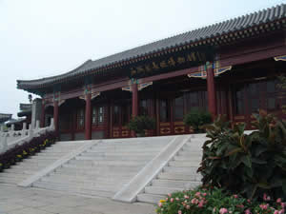
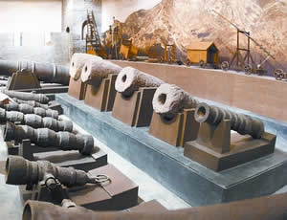
Mini-MUS & Tower (Climb)

•
13.7 mtrs (44.95 feet) high w/2 floors. On tower - big board w/5 huge Chinese
characters 'tian xia di yi guan' (the First Pass under Heaven) inscribed by Ming DYN
calligrapher. From Zhendong Tower top: 1 DIRECT: rolling sea, otgher DIREC:

•
NOTE: Jingbian Tower, Linlu Tower, Muying Tower & Weiyuantang Hall on the same
axis w/Zhendong Tower: a strong protective screen.

•
Zhendong Gate: (part of tower ???)
NOTE: This gate (E gate) has a circuolar ‘enciente’ attached to it , as did others originally

长城博物馆
7) GW MUS (
), (LP197m, 7A1)
DIRECS: 1) SE gate (near train station)> old town, 2) walk N along E wall). If open.

8 N Gate (LP197m, 8A1)
attached wall being restored (climb – DIRECS : LP197)
9 Wang Family Courtyard (LP197m, 9A1)
10 W Gate (LP197m, 10A1)
Excavated ooutlines of enciente visible
Ming DYN road slabs
Laolongtou GW (Old Dragon’s Head) (LP197m, 4A1, 196) = most eastern beginning of GW
extending into Bohai Sea.: peninsula-like sensation. AVOID BUYING TIK – see LP196

Jiaoshan GW: (DK128)

says: 2mi N of town
HIKE up or cable car
option if time:
Jiumenkou Great Wall
p366 15km N of Shanhaiguan Pass; only section that

intentionally forded a river – Jiujiang RIV

SEE NEXT PAGE

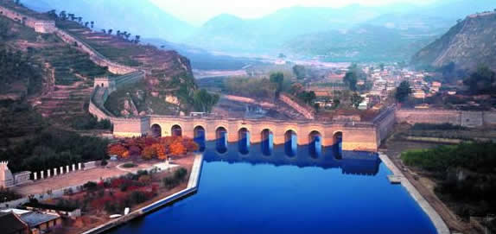
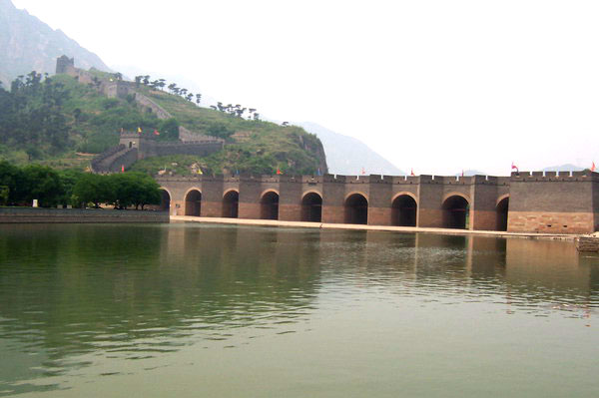

option if time:
Jiumenkou Great Wall
p366 15km N of Shanhaiguan Pass; only section that

intentionally forded a river – Jiujiang RIV
TRANS:
FROM: Shanhaiguan Pass Stop:
Taxi: 15 km NE of Shnhaiguan; 30 RMB., BUS - inconvenient
Minibuses > destination. Visit Time: 3 hrs
Minibuses (in season ??? )
SITE:
Cable car

祁县寺
Qixian Monastery
? ( JIoshan MON)
hike to from Jiumenkou GW
Jiujiang: VERY peaceful & few peeps

TRANS OUT: > Beijing
Shanhaiguan > Qinhuangdao:
Reverse the bus
Qinhuangdao > Beijing:
EXP TRNS: 0636, 0725, 1510 (3:10p) , 1947 (747p)
TRN STA: 经常往返北京
——
秦皇岛，其实秦皇岛是一个非常小的站，虽然离北京很近，但很多

4) NO
Changshoushan MT: (Longevity Mountain)
5) NO
Yansaihu Lake

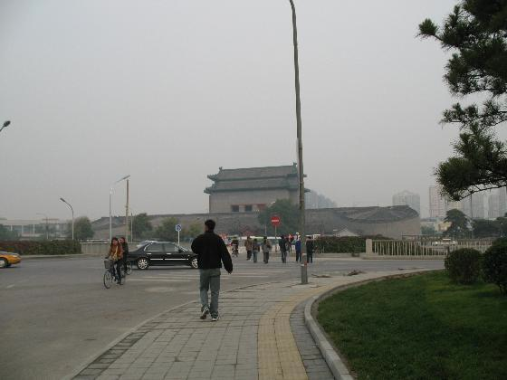
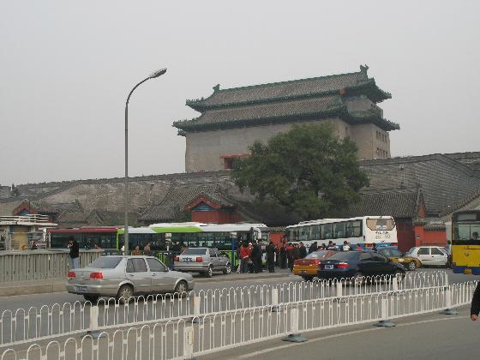
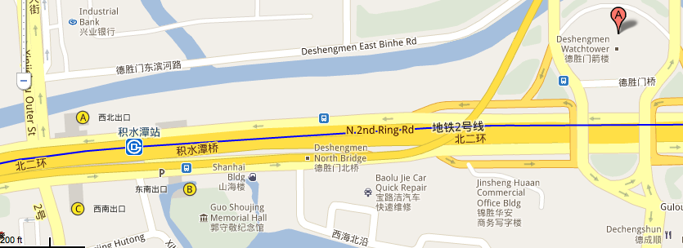
Badaling GW

DK106-108 “Great Wall” SPECLAY
Opening Hours: 06:40 to 18:30
MOST touristy, renovated, crowded, easy to reach
LOCATE:
over 70 kilometres (43 miles) NW of Beijing.
SITE:
Great Wall MUS: (DK108, )
WALKING STRAT:
If you same bus back > city; then use Cable car to top, walk around and then hke down to BUS
TER; 4 hrs (Cable car RT- 2 hrs)
DK: to avoid crowds quickly walk as far E or W of entrance

TRANS:
Badalng, Juyongguan & Ming Tombs BUS (LP124, 127D1,

a) Walk from Deshengmen bus stop (next pic)

b) to tower building where Bus 919 originates
NOTES: Take WATER!
Deshengmen (LP124m, 127D1)
1) Take Bus 919 (Y12) at

There are 3 places w/ numbered 919 buses: all NOT go > Badaling – only one. DEPENDS on
which direction you are coming from towards the tower
NO --- 1st parking lot w/ buses numbered 919
NO --- a bus stop just behind the (first) parking lot numbered 919
'fast' bus scam: 'slow' bus cost 20 RMB ; fast bus: 40 RB CUZ correct fare IS 12 RMB so ignore.
YES --- he pointed to beside the tower building, well out of sight from where we were standing;
just a minute's walk

CAUTION: walk ALL THE WAY to Deshengmen: a whole block E of the Jishuitan Subway Exit A.
: cross the road at end of block, going underneath an overpass road.
NO: On your way you will encounter another 919 bus station (quite close to Jishuitan Exit A) –
GOES > CITY -- WRONG
BOGUS minibus touts: "official tourist information volunteers" w/ red badges on --- walk
away, further towards E, to find Deshengmen bus stop & CORRECT Badaling 919 bus.
headed for Badaling departs.
From Line 2: Jithustan subway Exit A.
1) Exit building (L or R then L or R again ???) TO follow sidewalk EAST for 2000 ft as the
Badling 919 GW bus stop is located on N side of huge monument - Deshengmen Watchtower.
2) You pass three 919 bus stops-- don't stop . Continue to walk until the sidewalk curves left to
the Deshengmen Watchtower.

3) Cross @ cross walk to watchtower -- be careful- no PED roght-of-way.

4) Soonn U see 2 rows of buses: correct 919 bus stop is on L side

5) Look for 919 bus stop sign (in both English and Chinese) or look for tourist with guide books.
6) Scan BUS card & take seat. you let the driver know where you are heading and sit/stand as
close to the front of the bus as possible - 9 out of 10 drivers or passengers will tell you when your
stop is coming up.
DROPPED OFF POINT: at the Bus terminal on the Southside of the Balding Great Wall :: Facilities:
stores, , Ticket booths, cable car:
Side notes: ,
1) food stall behind the exit A building - sells chinese pork / chicken burritos for 5 Yuan filled
with bean sprout last food place I saw until the Great Wall, ALSO btl water
Badaling ARV: GOTO TIK off ; buy TIK You will be dropped off (as I was)
WALKING STRAT:
If same bus back > BEI; then 1) Cable car to top, 2) walk around & 3)
then hike down to BUS TER; 4 hrs (Cable car RT- 2 hrs)
southward to the highest point Haohanpo (heroes slope) and northward to Shierlou (twelve
buildings) with a length of about 3,700 meters (2.3 miles)
HIST
:
PURPOSE: Ming Dynasty defense against Mongolian people:
CONSTRUCT: wall = huge bar-stones & bricks. Wall INT: rammed earth w/ small stones = very
firm & strong. DIMEN: -TOP: actually a brick paved road 6 mtrs (20 feet) wide: 5 horses abreast;
archer’s firing holes drilled in side; “barrel-drain” & moat both inside & outside wall -- paramount

military fortification focus.
SITE:
Very steep slope, tortuous roads = MIL stronghold = ‘strong dragon winding its way along the

mountain ranges – like’;
most well-preserved section; average altitude of over 1,000 meters (3,282
feet ; average 7.5 meters (8.2 yards) HI, 4 mtrs (4.4 yards) thick, 6.5 mtrs (7.1 yds) wide @ base ;

5.8 mtrs (6.3 yds) at top.
FEATURES:
2 gate towers: 1 tablet inscribed w/ “outpost to Juyongguan” hung on E gate & 1 tablet inscribed
w/ “the lock of the northern gateway” hung on W gate
GW MUS:
“Watching Beijing Rock”: E of fortress is huge rock,; 7 met mtrs (7.7 yards) long and 2 mtrs (2.2
yards) high. STORY: When Eighth Allied Forces invaded Beijing in 1900, the Empress Dowager
Cixi made short stop here while fleeing > N: looked toward Beijing and recalled her comfortable
life in Forbidden City .
Signal fire platforms is blockhouse built on wall top to send warning signals; amount of smoke &
gunfire released conveyed specific military enemy information. 1 smoke puff + 1 gun shot = 100
enemies; 2 smoke puffs + 2 gun shots = 500 enemies; 3 smoke puffs + 3 gun shots = 1,000
enemies. Then, sequential platforms fired

The top of the wall is which could allow five or six horses to pass through side by side
2)
??? Ancient / Ruined Badaling Great Wall
LOCATE:
Least tourists

10km southwest of the restored Badaling Great Wall
DIRECS: ???

Distance: 150km (95 mi) one way
TRANS: ???
HIKE:
Hiking Time: 2-4 hours
Hiking Level: Intermediate
Round trip hiking takes approx.3 hrs with 5-6 towers on the wall.
Starting point: Shixia Pass, an open place ; ENTER & turn right (east) and start your
hike
HIST of Shixia Pass used to link both the east and west sections of the Ruined
Badaling Great Wall. It was blasted to the ground in 1644 when Li Zicheng ( 1606–
1645) led his troups having a fierce fighting with Ming defence soldiers. Li Zicheng was
a Chinese rebel leader who overthrew the Ming Dynasty and ruled over China briefly as
emperor of the short-lived Shun Dynasty
Be well prepared, wearing closed shoes and long trousers, sunscreen, insect repellant, sunglass,

lots of water.
W section WILD WALL forbidden
E section ONLY

Only partially restored, more adventurous, not easy to climb. (overnight camping allowed)
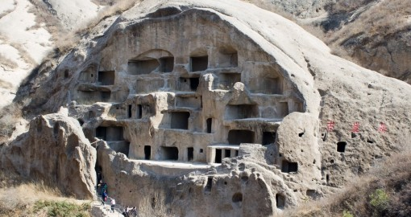
Dongmenying Village
(东门营村),
Ancient
,
Zhangshanying Town, Yanqing County
Cliff House

延庆县张山营镇东门营村
Ancient Cliff Dwellings
(57 miles)
LOCATE: 90km

Daily 7am-7pm. RMB 40

;

TRANS:
Bus:
德胜门
1) Take Bus 919 大站快 from Deshengmen
(LP124m, 127D1) to Yanqing
Dacaiyuan,
2) then change to Bus 920 (下营) or a minibus to Xiaying.
3) Next, change to a minibus heading to Guyaju.
4) Dongmenying Village then follow signs for about 2km
SITE:
Ancient Cliff House, carved in gravelly rock mountain, NW of Dongmenying Village of
Zhangshanying Town, largest ancient C cliff residence. more than 130 remaining
caves. Construction date can’t be verified.
Soft rock = easy cutting , but much weathering = subject to dangerous hazards ie.
collapse due to rainwater leak. Preservation & chemical protection project lightning-
prone area. caused a large-area mountain collapse installed an advanced lightning
protection
many 20 meters tall lightning rods installed in dangerous tourist sections; intergrated
w/ metal guardrails = forming integrated lightning protection network. modified
height and color of lightning rods to fit in with the mountain,.

??? Huangyaguan Pass /
Taiping Mountain Stronghold (Yellow Cliff Pass --nearby

黄崖关: LP176m,

yellowish hills and rocks)
marathon race
LOCATION: 126 km (78 miles) N of Tianjin City Center
HIKING DIST/TIME:

6km / 2-2.5hr / all year
TRANS:
1) METRO: Jishuitan STA (E >S) > Jianguomen STA > L1 (E) > Shui STA (S)
2) Walk (S) to Sihui LD BUS STA (LP122m, 16H5, )
3) Sihui LD BUS STA (LP122m, 16H5, ) > Jixian County: every 10 min; 0630 to 1930.
4) Jixian County > Huangyaguan Pass of GW:
Taxi: (1 hr / Y50)
Minibus:
1) Tricycle from Jixian Passenger Station > to Gulou Xikou (also Xiguan) (Y 3-4)
2) In Gulou Xikou, many minibuses > Huangyaguan Great Wall. (bus holds 7-8 peeps/ Y 5-
10); goes when full.
FEATURE: miniature of GW 20 Various water towers styles , water pass, restored 20 terraces,
the Huangya Water Gate, and the Bagua (Baguaguan) Castle (the Eight Diagrams Castle).
Defensive system is complete: watch towers, frontier cities, drain holes, emplacements, barracks
and other indispensable military facilities neatly arranged along wall.
st
GW stele forests, Beiji Temple, exhibition hall of famous couplets, Great Wall Museum (1
Great
Wall MUS on wall) & Phoenix Fortress newly rebuilt INT. GW library-like
Dramatic: visually overwhelming: hi on mt ridge; To E is cliff, to W, crags; winds dragon-like;
north entrance of Jinxian.
Dangerous: Steep w/ irregular height steps for ruff terrain; look down, then feel dizzy.
Beautiful: mountain scenery, waterfalls and springs.
Ancient: 1400+ years, 1st built in Tianbao 7th of Beiqi (557 A D), repaired in Ming Dynasty w/
nd
bricks; 2
time in 1985 by Tianjin people from Banlagang Mt

Heartbreak Hill

(INter’l marathon race) starting form 1999

Taiping Mountain Stronghold
6 mi NW of Huangyaguan Pass, high stronghold in Xiaopingan Village. Purpose to
control Chongshan Valley east of Huangyaguan Pass City.
Qi Jiguang's stone statue & tower erected by twelve widows

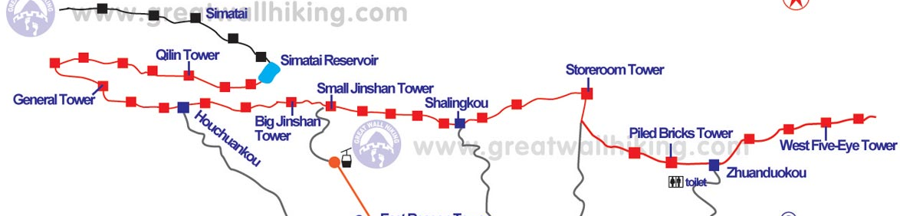
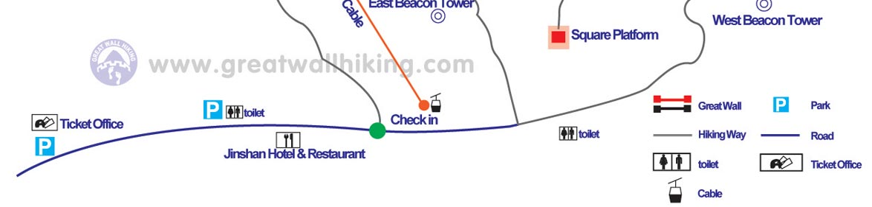
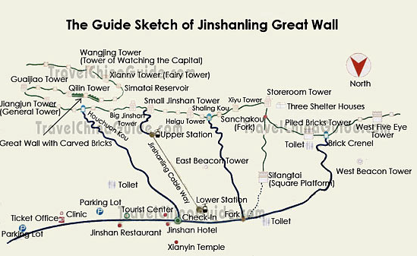
金山岭
Jinshanling
> Simatai Tour:

1D: $78 (LP169)
LOCATE: wild &and original Wall sections
150 km from downtown Beijing
125 km NE of Bei. connected to Simatai section to E. ; to W is S section.
E > Simatai; w > Gubeikou; most difficult hiking
TRANS: CONFUSED

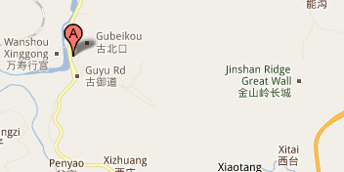
1) TOUR: LP recommends a backpacker tour for TRANS ease (Y180)
2a) MINI BUS OR BUS
东直门交通枢纽站
1) Dongzhimen TRANSPORT HUB STA
(128m, 40A2): BUS 980 > Miyun

密云县

County (5:50a-8p)
2) THEN, local tourist bus or minibus to Gubeikou & Jinshanling Great Wall

OR 2c)
BUS at Liuliqiao Long Distance Bus Station, (08:00 and 18:00; hrly; (LP124m, 130A5, ) >
Chengde STOP @ Jinshanling Intersection,
Taxi or walk > Jinshanling Great Wall.
RETURN > Beijing from Jinshanling Great Wall: 3-27-2011
1) take a local van from Jinshanling to Bus Station for BUS 980 in the downtown Miyun
County. Very often there are some vans waiting at parking area around Jinshanling.
2) direct BUS 980 (last fast bus6:30p; last slow bus 7:30) from Miyun County to downtown
Beijing - Dongzhimen (near Dongzhimen Subway Station of Line 2)
TO DO: Cable car > top
(???) Night Great Wall (2mi) & an eight hundred meters (0.5 miles) cable way. Don’t miss
st
th
HIKE 10km from Jinshanling (18 towers) to Simatai’s 1
tower (19
) then backtrack to
Jinshanling. w/ stunning views; over 2.5-3 hrs travel. RMB 150 (£15),
More remote & rugged, some sections almost vertical & poor condition = difficult climbing,
some damaged sections: no wind break protection. Reward: most spectacular
CHAR: ( temp. closed???)
nd
2
longest continuous section, no tourist stuff, classic views, (Ming Wall ???), peaceful, easy,
Watchtowers: various designs & functions, 1 tiered or 2-tiered. First floor has arrows shooting
windows ; roofs: also varied: flat, arched, quadrangular or octagonal. Some Tower uses: store
weapons & hay; soldiers' bedrooms.M
Most celebrated: Big & Small Jinshan Watchtowers.
Big Jinshan Watchtower: 2 tiers connected by stone stairs. Top tier: small room for soldiers'
sleepin; unque structure: rafters & eaves made from polished bricks.
Small Jinshan Watchtower: constructed by soldiers from Zhejiang & Jiangsu PROV to remind of
hometowns; named Jinshan after a pavilion's on Jiangxin Island in Zhanjiang.
Equally important: each has a legend
Wangjinglou Tower: stone bars carried to the mountain top by Er Lang Shen, the nephew of
the Jade Emperor
General Tower: commemorate Wu Guihua, a heroine who sacrificed herself to resist northern
invader's invasion in the Ming Dynasty.
Black Tower & Taochun Tower: commemorate two girls, Heigu and Taochun, who made
great contributions to the construction of the Great Wall.
Also: The Wall for Preventing the Horses, the Retaining Wall, the Bricks with Words Written on
and the Kylin Screen: renowned & worth a visit.

Meanwhile, there is a three-kilometer (two miles) ???
YES Mutianyu

[moo-tyen-yoo]:
慕田峪
Mutianyu (Chinese:
; pinyin: Mùtiányù)
LOCATE:
Closest; In Huairou County; 70-90 km NE od BEI; connected w/ Jiankou in W & Lianhuachi &
Jinshanling in E
PERKS: cable car,

TRANS: CONFUSION
1) EXIT Dongzhimen subway’ Exit B’: (LP128m, 40A1) bus stop is literally right there. NOTE:
Will also see Airport Express entrance right there).
2) 2 shuttle buses from Dongzhimen STA:
#936: 0600-1400 , hrly, 2.5 hr BLOGGER: BEST cuz DIRECT
#916: 5;30a – 1800p evry 20min, 2.5 hr
Tricky part: SEVERAL 916# bus options.
Really SLOW 916#:
A/C 916 stops several places
Finally, ‘seldom stop – fast’ #916:
st
* Blogger took A/C cuz 1
to come & few peeps.
3) STOP: Huairou Inter’n’l Conference Center STA:
I asked the bus lady to let me
know which stop to get off at for Mutianyu Great Wall and she did. --------- " avoid Touts
demands--
4) Taxi or Mini van: about 60RMB return including waiting; don’t pay him until back at bus
stop later. Set a time.
TRANS > BEI: reverse i.e 936 MAY be best

SITE:
HIKE Options:
1) Cable car RT (.#14 Tower / bldg.)
2) Cable car UP; slide down (#6 Tower / bldg.)
3) MY OPTION: 1) Hike S footpath > top, Back & forth loop of all towers, 2) slide down
ALSO: China Dream Stones City > S at bottom
From parking lot, buy TIKs: 2 TIK OFF near parking lot – N & S
No. 10, 8, 6 Buildings to climb down along the footpath, or No. 6 Building to take the slide way
HIST:
Built in mid-6th century during Northern Qi, older than Badaling.Ming DYN , General Xu Da
supervision. 1404, a pass was built in wall. 1569, Mutianyu GW rebuilt ; most parts well
preserved; lafrgest construction scale & best quality; ruthless Emp. Wenxuan

FEATURES:
Great Wall: Most unique characteristics?: Built mainly w/ granite, 7-8 mtr x 4-5 mtr W.
20 Watchtowers: most densely placed, numbered from R > L-- #1-# 20 (ie. E > W) , snaking for
2,250-mtrs., 20th tower: GW’s highest point; triple tower; & battlements on the both sides (some
saw-toothed) (vs. 1 side as w/ others); square embrasures the top of which are designed in an arc
structure, different from the traditional round embrasures.
Crenelated outer and inner parapets are with merlons, so shots could be fired at enemy on
both sides - a feature very rare on other parts of the Great Wall.
No. 20 Building, highest part of Mutianyu GW The next watchtower is well-known collapsed
Jiankou GW.
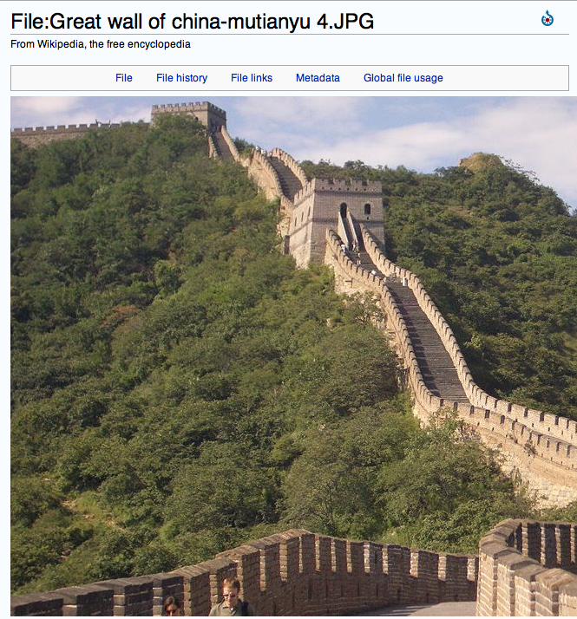
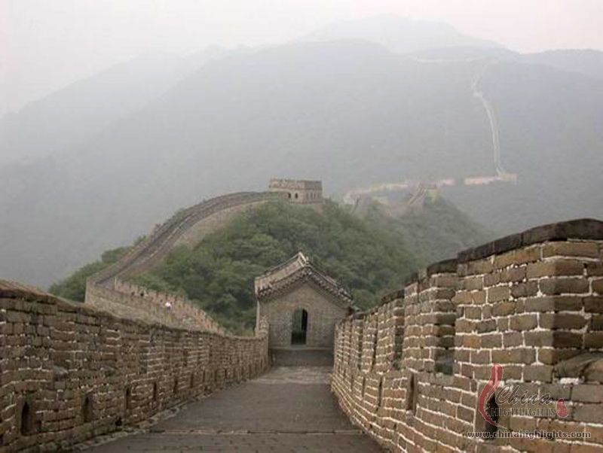
Mutianyu Pass (No. 6 Building to No. 5 Building) has 3 watchtowers, 1 big in center & 2
smaller on both sides. Standing on same terrace, the three watchtowers are connected to each
other inside and compose a rarely seen structure. composed of three connected terraces. On
the top of each terrace, there is a tower respectively. What's more, the gate of the pass is not
built on the middle terrace, but on the two side terraces
Mutianyu village, Adjacent to Mutianyu wall, a model village cuz tourism & glassware industries.

TRANS > BEI: reverse i.e 936 MAY be best

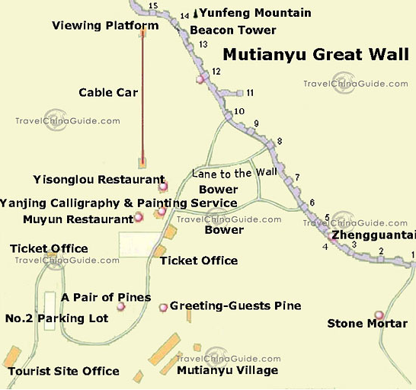

Shanxi: (SW of BEI) p396

Datong:
(LP398, DK131)
( 1T, 1D, 2N)
STRAT: ARV afternon, spend night , tour next day , spend night , leave next morning for Pingyao:
BOOK
CITS:
Mr Gao: MORN OPENS @ btw 08.15 and 08.45, CITS office now located in smaller arrivals
building to L of main STA. office is immediately on the right as you come out of Datong
stationbldg
CITS tours: DP around 0930 am; return around 4 or 5 pm.
Tour driver to drop off in Datyong @ 9-dragon screen; THEN walk > huge temples: Shang Hua
Yan Shi & Xia Hue Yan Si.
??? Are Hanging Moanstery & Overhanging Temple the same?
Datong TOUR: Grottoes & hanging monastery: 1 D; cud do by taxi (Y 200 to 300) or public
TRANS (hassel)
TRANS IN: Beijing < Datong by:
BOOK Day after next: TRN > Pingyao ???
nd
NOTE: In BEI “ foreigners ticketing office” (24hr, 2
floor of BEI West TRN STA
Train SCHEDs: http://www.cnvol.com/
TRAIN: FREQ/REG from BOTH Beijing Main STA,( freq., 6-7 1/2 hrs,)
??? Z19: 9:24pm: Other Trains: Inquire
DON”T travel hardclass seat i.e bottom level , but hard SLP may B OK
Lots trains to & from; only book TIKs very far in advance.
Beijing-Datong sleeper in advance. Note the departure station is Beijing West Station.
www.chinatravel.com http://www.chinatravel.com/china-travel-tools/china-trains/
http://www.chinatravelguide.com/ctgwiki/Special:CNTrainSearch
th
www.china.org.cn 4
Search OPT: detailed + CLK TRN # for STA details; lacks TOT Travel
Time
K1114/K1111
374
US$8
Beijing
02:49
Datong
09:03
US$13
US$16
US$25

Beijing
1458/1455
07:02
Datong
15:07
North
358
US$4
US$7
US$10
US$16

K23
Beijing
Datong
13:51
07:47
374
US$8
US$13
US$16
US$25

K3
Datong
Beijing
07:47
13:51
374
US$8
US$13
US$16
US$25

STA LIST
Beijing North
06:50
07:02
835
Kangzhuang
10:14
10:29
905
Shacheng
11:09
11:12
940
Xuanhua
11:54
11:57
990
Zhangjiakou South
12:22
12:28
1015

Datong
15:07
15:19
TRANS – around town:
BUS 4: TRN STA > downtown (See LP401)
FOOD:
Lunch: fast food section at Yonghe Shifu on Xiao Nanjie...ENG menu & nice dumplings.
Dinner:
Yonghe Shifu is a great restaurant for dinner
Tonghe Dafandian on Zhanquian Jie: - cook own hotpot ; ENG menu.

ACCM:
(LP398m, 1B3, 400): Datong Fandian Luquan:
Feitan Hote: D Y35
#1 Datong Youth Hostel; No.2 Huayansi Street, Cheng District, Datong 037006, China ‬S

On pedestrian Jie, around very busy, , superior, next Huayansi
Owner helpful, walk a few minutes to get to Huayansi, Nine Dragon Wall, the ancient city wall,
#2: Hongru Home Hostel Y60: ‪Datong Hongru Community, Datong‬
#3: Dayou Hotel
‪No.1 Xinping Wangwei Fifth Road, Nanjiao District, Datong‬
AVOID: Tong Tie Hotel (near STA – unclean & TRN noisey)
TOWN SITES: (LP398m, 399, DK131)

2 hr
Ancient city wall??
Hutongs: either side of Huanan Jie , S & SE of Huayan TEMP
12 Nine Dragon Screen (largest glazed-tile wall in C)
¾ hr
11,14 Huayan Temple: p399

¾ hr
oldest Datong bldg; wooden sculptures
13 Shanhua Temple ???

½ hr
grandiose wooden-bracket rear hall
AROUND Datong:

Yingxian Wood Pagoda: (LP
70 km S of Datong ,
Yingxian County) 40 km W from Monastery > W, 200ft
(
(Climb: fee)
high, a 1000 yrs old: entirely w/o nails!
Liao Dynasty, 950 yrs of calamities: earthquakes, lightning storms: decorative iron tip on top protects;
unique octagonal structure defends agains earthquakes. Outside, looks like a 5-story, but - nine
stories; four are hidden inside; built w/ 54 different kinds of brackets. Under eaves: wind chimes--little
bells; . Inside large Buddhas, includ.11-mtr STAT on 1st floor.

1) Yungang (Cloud Harbor) Caves (LP401, DK131-133 SPECLAY)

5 hr
½ +D
gobsmacked & Eng captions (so guide unnecessary)

DIRECS: (8:30a – 6p) (NE of; < 1 hr, 2 hr Visit Time- adequate
1) BUS “3-2” (?) (50 min, 6am – 6pm) Outside train STA
1a) OLD ALT:
1) BUS 4(30min)> Xinkalii
20 3-1> Jinhua Gong
30 Ts-axi . drop off point
1km walk
Or Taxi - Y80
2) At ticket checkpoint, turn L >:
Western Caves 21-45 first
W 16-20: earliest; Exceptional carving quality
Cave #39; heads smashed off
3) THEN, Caves 5 & 6 (Best for LAST)
CAUTION: THis blogger: not find buses > grottoes (???): no BUS cuz road work;

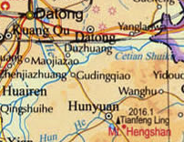
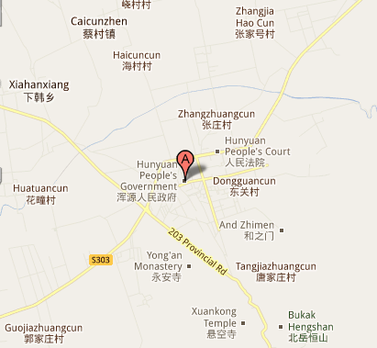
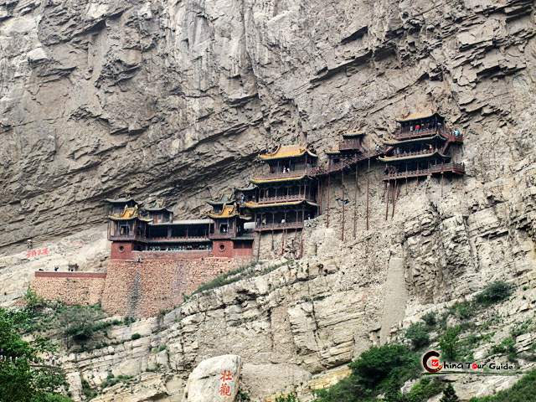
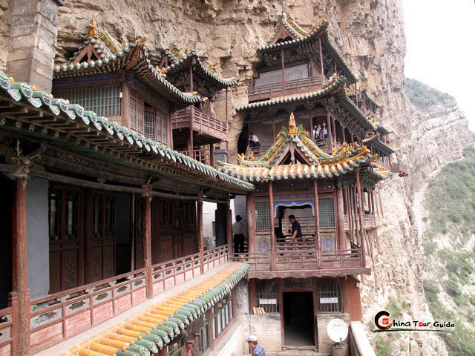
悬空寺
2) Hanging Monastery
(SE 0f Datong) (LP401, DK131) p401; 7:00am, 2 hr Visit Time-
adequate; ½ day

Awesome; in shadow in afternoon, facing E, ; only Chinese tourists. The place, not sure if there
are any later buses.
TRANS: SE of Datong; 80km ; 1 1/2hr
1) BUS: Datong Bus / Coach STA (Yanking Rd) (1½ hrs, 6:30am – 5:30pm) thru Hunyuan &/or
free taxi for last 5km if too few peeps. (Mt. Heng)
2) THEN town BUS 8 (infrequent) or Taxi Y20 > Monastery , BUT to hill bottom only, thereafter
2km uphill walk (presumably taxi goes to top)
(??? advisable to take a taxi or hire a van from Datong; no more than CNY150 (25usd - RT)
NOTE: seem to ride into mountain, then turn R into village of about 50 houses, through village &
then up winding road with trucks passing on your sides in both directions. A huge dam is being
constructed right next to monastery and this explains the trucks, quite a ride, Took 30minutes to
get there
RETURN: closes at 6pm 5:45pm bus back to Datong
Hengshan Mountain, Three Religions Hall Buddha, Laotze and Confucius enshrined

Overhanging Temple:
Heng Shan (8am-6pm) from Datong's long-distance BUS TERM > Hunyuan SE 75km. From
there, frequent tourist buses depart for Heng Shan.
Overhanging Temple, at mountain's foot; N Wei Dynasty (386-534), on high cliff hemmed in by a
precipice on either side; beyond reach, solitude. From bottom you see range upon range of
pavilions supported by dozens of wooden pillars. Entering the temple, people will be surprised by
its half-house and half-cave inner structures. Overhanging Temple deserves a visit.

TRANS OUT: Datong > PIngyao
ALT (???): Datong > Lishi > Xian
TRAIN: from train STA 6 daily, 8 hrs, 5:58pm & 10:56pm
NOTE: Travel times below are strange i.e 2602 = 20 hrs while K7807 = 7 hrs. GUESS: some
trains take circuitous routes or are express

BEST TRAIN SCHED INFO:
http://www.chinahighlights.com/china-trains/ 800-2682918
http://www.chinatravelguide.com/ctgwiki/Special:CNTrainSearch
Chinese characters, STA en route,
From
Total
Dista
Orgin-
Seat
Soft
Sleeper
TrainNo
(in
Dept
To (in
nce
Destination
Chinese
Time
Time
(RMB)
(RMB)
ArrTi
Chinese)
me
)
(km)
(hh:m
m)
Longjiayin
Datong
Pingyao
171/17
2602/2603
06:15
13:58
07:43
54/93
大同
(
)
g - Linfen
平遥
(
)
463
9
Datong -
K7807
Datong
Pingyao
115/12
07:45
15:06
463
07:21
大同
(
)
)
Yuncheng
平遥
(
34/60
0
Datong -
Pingyao
115/12
2671
16:40
00:31
463
Datong
平遥
)
Xian
大同
(
(
)
07:51
34/60
0

STA LIST: K7807
Station Name in
ArrTim
DeptTim
Total Time
Station
Distance
Chinese
e
e
(km)
(hh:mm)
大同

Datong
-
07:45
-
00:00
宁武

Ningwu
10:16
10:18
166
02:31
原平

Yuanping
11:33
11:39
231
03:48
忻州

Xinzhou
12:08
12:12
267
04:23
太原

Taiyuan
13:25
13:36
355
05:40
榆次

Yuci
13:57
14:01
382
06:12
太谷

Taigu
14:28
14:30
418
06:43
祁县

Qixian
14:49
14:51
441
07:04
平遥

Pingyao
15:06
15:09
463
07:21

-Arr.

From - To
Dep.
Duration

Time
Distance
Price

2602/2603
Datong - Pingyao
06:15
-13:58
20:16
463 km
Soft Seat: N/A

BUS: REG , New South Bus STA, 3 hrs, 6:50am – 8:30am (pm ???)

New Bus STA short walk from N Gate
Pingyao

(SW of BEI)
(LP408m, 409, DK138-139 SPECLAY)
(1T, 3D,4N)
If Lijaishan & Back to Pingyao

ADD (1T,1N,1T) (2D)
TOTAL

(1T, 5D, 6N)
CITS: find nearest office
TRANS IN: Datong > PIngyao
Train SCHEDs: http://www.cnvol.com/
TRAIN: from train STA 6 daily, 8 hrs, 5:58pm & 10:56pm

See TRANS OUT above
http://www.chinatravelguide.com/ctgwiki/Special:CNTrainSearch
Chinese characters, STA en route,
Dist
TrainNo
Orgin-Des
From
DeptTime
To (in C
ArrTim
Total T
Soft Slp
(km)
Seat
Hard Slp
Longjiaying
Pingyao
171/17
2602/2603
06:15
13:58
Datong
大同
(
)
- Linfen
平遥
(
)
463
07:43
54/93
107/110/114
9
Datong
Pingyao
Datong -
34/6
115/12
K7807
07:45
15:06
463
07:21
72/74/77

Yuncheng
0
大同

(
)

平遥
(
)

0

TRAIN: from Datong Train STA (6 daily, 8 hrs, 5:58pm & 10:56pm)
Check Travel China Guide for SCHED
BLOG: overnight train from Datong (CITS booked in Datong, 73 Rmb + 30 Rmb commission).
Hard sleeper perfectly adequate
BUS: Near N Gate; REG , New South Bus STA,

CITS or CTS: ON Datong ARV immediately BOOK TRN out, tour & hostel, Store baggage at
hotel tour leaves from
China Industrial Bank a few metres out of the West Gate, towards the train station.

ACCM:
In Old Town: (Along Nan Dajie) many GD & hostels; mozzies at night, many,
competitive, speak Chinese only.
 Harmony GH D ¥30-50, Eng SPK, bike rental, Probably LP jammed
CAUTION: CITS agent may charge a deposit/ kickback for himself; awesome,
Mr Deng tours,
Yamen Hostel : D Y30-40; Blog: seems good
Bi Foo Luo Hotel 平遙百福樓洒店 – partner w/ Zhengjia Hostel across the street
from Yamen Youth Hostel , just outside city walls on the NW corner. grubbyy,
some ENG, friendly staff,
NO: Zhengjia Hostel: (D3, old town; across from Yamen Youth Hostel . just
outside city walls on NW corner. Grubby, no Eng, rude son, smelly bath drains,
YES (OTOH) said opposite, Bob’s Eng; Best value
bed & linen super clean; bed soft. Bathroom: dark, facing ; noisy - eve/morn: street
noise & laughter (GUD).

NOTE: Hostels can book BUS to Xian if necessary to take bus.

FOOD:

TOWN SITES: (Mr. Deng Tours p408)

5 ½ hr

½ D+
City Walls BEST TIME:

3 hr

--- late afternoon,for light & peeps bustling about homes below.

LOwer W Gate:
9 Rishengcheng Financial House MUS p407

½ hr
7 City Tower

½ hr
3D3 Nine Dragon Screen (LPn m, )
4D2 Qingxu Guan: 8 Dacheng Hall (LPn m, )
(in Confucian Temple complex)

½ hr
Slogans” @ #153 Xi Dajie : 2 red blood Cutural REV slogans: L one: “Industry should learn
from Datong; R: “Earnestly undertake strrugle, criticism & reform”
MISC:
Ancient Government Building near Yamen Gate

The City Tower (Climb: Y5); views not better than other places on SITE TIK
PINGYAO SITE TICKET
: (120 Rmb). Valid for 2 days, only 1 time/site; THUS- wall only once
nd
(maybe 10 rm. bribe for 2
time) CAUTION: RETURN > ticket office btw 5 & 8pm purchase date
nd
nd
> stampTIK for 2
Day; 2
Blog: Didn't buy, just wandered
AROUND Pingyao:
Shuanglin Temple (LP408m (SEE map L of TRN STA) 409) by bike (5 mi)

¼ D
NOTE: outside city = NOT includ in TIK
Carved STATs, ARCH; extra 25RMB (What?) . its old, crumbling, but SO different from the other
painted and new temples.
DAY TRIPS:
OPT 1: COMBO trip:
Wang Family Courtyard > Mian Shan (Cotton Mountain) > Zhangbi Underground Castle;
easy > combine if start early enough

OPT 2: 2 trips: 1 combo; 1 alone
Wang: took a taxi there & he waited to bring him back to Pingyao.
1) Wang / Cotton Mt: tour (info in hostels)

1D
2) Zhangbi Underground: separate trip

1/2D
taxi (250 Rmb) > Wang Family Courtyard & Zhangbi Underground Castle.

1) Wang Family Courtyard: (LP409)
SITE:
w/ "city" wall & watch towers - walk walls top Castle-like; spectacular, like Forbidden City
Cave dwellings (behind castle walls
Confucian TEMP - Yuan DYN
TRANS: come early w/ food & lots of water
1) 2 Direct BUSs from STA (8:20am & 2:40am)
BLOG: Bus STA: TIK > Wang Courtyard House (¥20, 1½ hr);
Note : Pingyao bus very infrequent.
2) a) REG BUS > Jiexiu (40 min)
b) BUs 11 > Wang FC (40 min)
However, Reg buses from Jiexiu (about halfway from Pingyao) are very frequent, a town
Jiaxiu is well connected by buses to Pingyao.(see below) TRN STA too.
2) or:
a) regular BUS > Jiexiu (40 min) ;
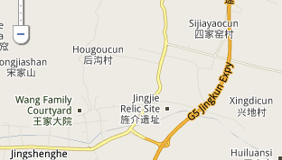
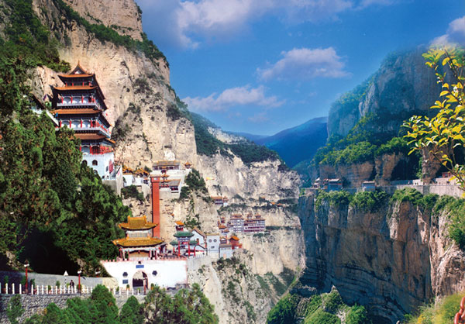
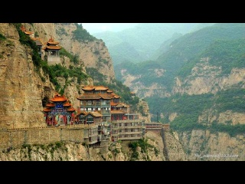
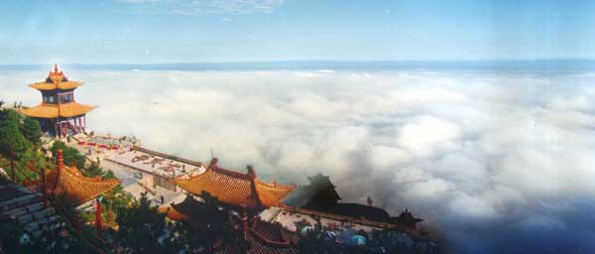
b) THEN BUS # 11 (40 min; terminates at complex.
3) LAST BUS BACK: Wang FCY > Jiexiu: 6pm

Hanging Monastery of Mianshan PIKS

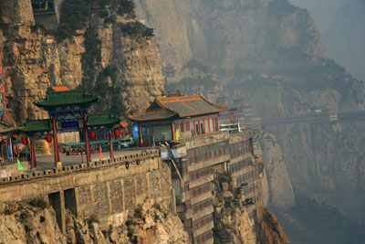
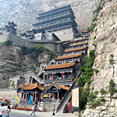
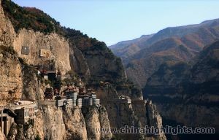

Zhangbi & MIanshan COMBO trip ???
山西綿山
2) Hanging Monastery of Mianshan (Cotton MT.)
:
Hanging Monastery of Pingyao VS of Datong: see both, Mianshan is more of a large park w/
many sites – religious and natural.
N Song prime minister tribute to Jie Zitui & his mother
1Msg Bd says lots more to see than just the Hang MON
(http://www.youtube.com/watch?v=Rh2N0nGcQk8 )
(绵山)
Mianshan MT

Jiexiu RR STA
TRANS / DIRECS: 40km S of Pingyao; 25 km (16mi) S of

1) Pingyao TRN > Jiexiiu:
2) Touts > Mianshan
3) S side of Fen River, 20km S W 9?) of Jiexiu on highway 108.

TO DO:
1) See “Mianshan Mt, Pingyao Options pdf” on iPT
2) Sky Bridge: built btw steep cliffs, 300 mtrs (328 yds) long & 1 mtr / (3.3 feet) wide; suspended
over 300 mtrs (980 ft) above valley floor; 200+ mtrs/ (660 feet) from mountain tops.
Tang DYN route: Dragin Ridge peak & TEMP, Cliff Scenic Zone; springs, waterfalls,
Taoist Route: Daluo PAL, Sky Bridge
natural landscape routeShuitao Gully, Guteng Valley and Shengru Spring

BACKGROUND:
Mian Shan or MianShan: fantastic Buddhist & Taoist mountain w/ temples built on cliff face w/ 100s
of hidden caves - 2500 yrs old.
Most famous:
大
罗
宫
Taoist temple is DaLuo Gong

(or Temple of All Embracing Heaven); many old Taoist
texts, Dao De Jing wooden engravings; LaoZi ‘s (father of Taoism) Taoist classic thus attracting
more Taoist followers.
Buddhist BaoFu Temple: inside so called BaoFu Cave; shaped like "two hands of Buddha
holding onto his stomach"; "stomach" large enuf for 1000s of people plus the temples, 200 over
rooms.
ACCM:
Many guest houses at mt. bottom.
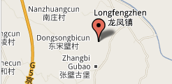
3) Zhangbi Underground Castle (Zhangbi Cun village): (LP410)
TRANS / DIRECS: @

Longfeng Zhen (Dragon & Phoenix Town), Jiexiu City
Opt #1:
1) LP (o&n) says ”Can ONLY get there by TAXI” Y ; Y70 includ. waiting time.
2a) BUT, cut cost w/ bus to Jiexiu (40 min)
2b) Taxi > Tunnel: 40 min
Opt #2: 2007 ADV:
a) Tourist shuttle bus: Runs between Jiexiu and Zhangbi.
b) Taxi: Outside Jiexiu Railway Station miandi (old taxis) run to Longfengzhen (RMB 2 per
person),
c) Rent car for RMB 15 to reach Zhangb

SITE
(40 Rmb + 20 Rmb - Compulsory Guide & Tour - not to get lost: underground - sometimes
Eng)

GEN: Still being excavated, but extensive ; low powered lighting; generals slept & guards
waited to surprise intruders, horse stables

HIST: Ancient tunnel: Sui (581 – 618 AD) & Tang (618 – 907 AD)

Tunnel DESIGN; 3 layers. Top layer = 1 mtr (3 ft) deep, center:8 > 10 mtrs (26-32 ft)
deep, bottom = 17 > 20 mtrs (55-65 ft) dp. Passages hide: mangers, kilns, caves, wells, grain
silos, flood-prevention amenities, wall-hole communication services and assassination devices;
From lowest tunnel level (20 mtrs (55 ft)) U can see sky from Tour continues (includes) >
Zhangbi Cun village outside, above tunnels:

MUS-like : Colects Buddha STATS savaged during Cultural Revolution; tombs through
the Jin Dynasty (1115-1234), theater phases from the Yuan Dynasty (1206-1368) and
residences from the Ming (1368-1644) and Qing (1636-1911) Dynasties.; glaze stele
(NOTE: quality of new roof vs. Old - politically more liberal, few tourists, worth it.)
TRAIN SCEDULE: Pinyao > Jiexiu
CAUTION : These train scheds cnnot be globally changed are ose Chines characters
Pingyao > JIexiu
http://www.chinatravelguide.com/ctgwiki/Special:CNTrainSearch
PUBLIC TRANS: >
Beijing West -
K603
05:39
31
00:23
9/11
94/99/102
150/156

Pingyao
Jiexiu
05:16

平遥
介休
(
)
(
)
Yuncheng

Hohhot East
Pingyao
Jiexiu
2462/2463
06:27
00:22
平遥
(
)
- Linfen
06:49
31
介休
(
)
5/6
61/64/66
98/102
Beijing West
Pingyao
Jiexiu
1163
07:36
07:58
31
7/9
88/93/96
144/
平遥
介休
(
)
(
)
- Hancheng
00:22

RETURN : Jiexiu > Pingyao
Yangquanqu
Pingyao
6816
15:23
15:50
31
94/98
Jiexiu
平遥
)
- Taiyuan
介休
(
(
)
00:27
4/5
57/60/62
Yuncheng -
Pingyao
144/15
4628
Jiexiu
15:46
16:08
31
00:22
介休
(
)
Taiyuan
平遥
(
)
7/9
88/93/96
0
Yuncheng -
Jiexiu
Pingyao
150/15
K866/K867
17:49
18:11
00:22
9/11
94/99/102
介休
(
)
Tangshan
平遥
(
)
31
6
Yuncheng -
K604
Jiexiu
Pingyao
150/15
18:22
18:44
31
9/11
94/99/102
平遥
)
(
)
Beijing West
介休
(
00:22
6
Linfen -
Jiexiu
Pingyao
2464/2461
20:13
20:35
31
00:22
98/102
介休
(
)
)
Hohhot East
平遥
(
5/6
61/64/66
Chengdu -
Jiexiu
Pingyao
1486
20:44
21:06
31
144/15
介休
平遥
(
)
Taiyuan
(
)
00:22
7/9
88/93/96

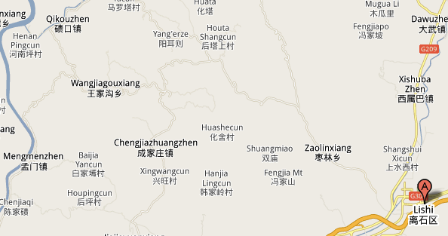
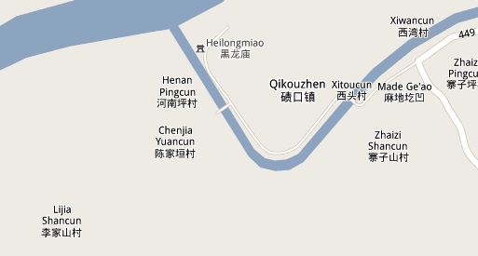
LIJIASHAN
(Lijia Shancun) Near Qikou (LP 410) (1T,1D,1N)
NOTE: Try to find Chinese character for

TRANS IN:
(LAT: 36.77 (36° 46' 0 N), LONG: 111.82 (111° 49' 0 E),
www.chinahighlights.com No Pingyao > Lishi SCHED
http://www.chinatravelguide.com/ctgwiki/Special:CNTrainSearch
Some one in Pingyao write out C DIRECS
st
1
OPT: PIngyao> Lishi > Qikou:
1) from PIngyao train STA: regular BUS > Lishi: (2 ½ hrs, 7:30am & noon (12:30???))

2) Then, from Lishi’s LD BUS STA > BUS 1 > W BUS STA (20min) BUT Note: Ask before I
go) Lishi’s W bus STA - does not exist anymore;
3) Qikou (2 hr) > Lijiashan: walk or tractor
Black Dragon TEMP: DIRECS: LP guide p410

李家山
口
Qikuo (?
): Bus Stop > Lijiashan:
by WALK:
1) Cross bridge & walk along River 2.5KM paved road to the foothill blue sign --1KM >
Lijiashan
Have PIC of Town
1) @ bus stop, X bridge near bus stop & Guessing that I turn R. NOT if PIK shows side river
going into Huang He (Yel R)
2) follow (hitch tractor ride) river 30 min until U see blue sign w/ (See guide book for Chinese
words p 410)
4) follow dirt track uphill for 25 min > village until you get to top. Also it is no longer a dirt track
but concreted so keep on the concrete!

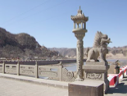
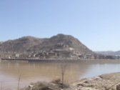
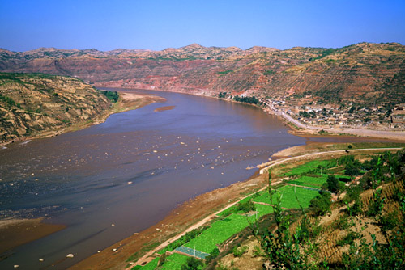
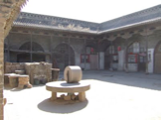
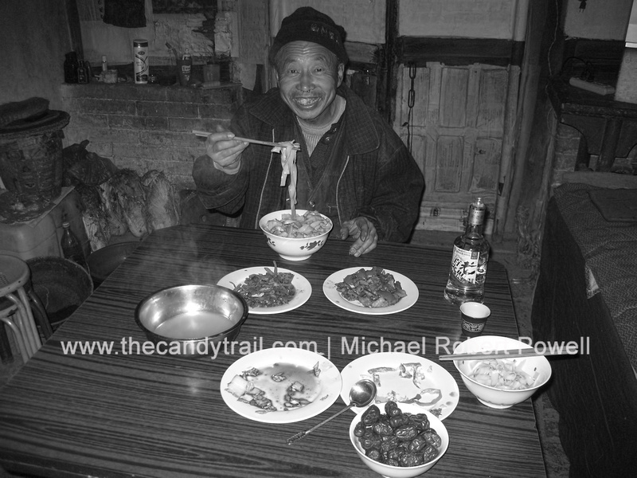
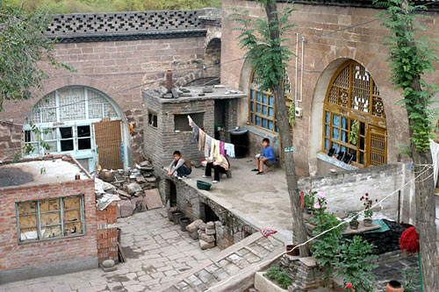

Bridge:
View across river on walk > blue sign Qikou view ???

RETURN:
Usual option : RETURN . Pingyao
1) LAST BUS from Qikou > Lishi (Liliang) @ 12 noon, then mini bus option
2) ??? From Lishi, bus seems > Pingyao leaving at 06:00 too.
??? Lishi > Pingyao: 7:30am & noon
See TRANS OUT below
If POSSIBLE: from Lishi > Xi’an:

BUS: REG , Bus STA,
Check Travel China Guide for SCHED
New Bus STA short walk from N Gate
TRAIN: from train STA () BOOK EARLY:
Check Travel China Guide for SCHED
DON”T travel hardclass i.e bottom level

ACCM: (LP410) see Downloaded web page
DIRECS: Keep climb up > Cave GH at top, lovely, cool rooms on hot day! nice food too
Mr Li’s family has lived in Lijiashan for 6 generations. After kids left to find work, converted
180-yr-old courtyard home into guesthouse w/ cave bedrooms where Chinese art students
stay.

Qikou ACCM (if necessary, but prefer Lijiashan)
Qikou Kezhan hotel: continue on road for about 10 min: very large door (about 15ft high)
w/ lovely rooms, A/C and room Internet access..
TRANS OUT:
Option A: Lishi > Xi’an:

1D
BUS: REG , Bus STA,
Check Travel China Guide for SCHED
New Bus STA (Xian) short walk from N Gate
TRAIN: from train STA () BOOK EARLY:
Check Travel China Guide for SCHED

Option B: Pingyao > Xian

1D
Why don’t DP Time >ARV Time = Total Tie makes sense?

Dep.
Arr.
Trains
From
To
Hard Seat
Soft Seat
Hard Sleeper
Soft Sleeper
Book

Distance
Total Time

Time

Time
(km)

(hh:mm)

2671
Pingyao
00:09
Xian
09:05
543
16:25
$ 6
$ 10
$ 12
$ 19
Inquire!

1674/1675
Pingyao
01:22
Xian
10:27
543
23:29
$ 6
$ 10
$ 12
$ 19
Inquire!

1095
Pingyao
20:42
Xian
07:20
571
12:09
$ 6
$ 10
$ 13
$ 20
Inquire!

2669
Pingyao
23:14
Xian
07:46
543
09:56

$ 6
$ 10
$ 12
$ 19
Inq

PIngyao > Hancheng
(
韩城
Option C:
Dangjiacun village) (p430)> Xi’an
2D
TRN SCHED
BUS: REG , New South Bus STA, (Pinyao or Xian???)
Check Travel China Guide for SCHED
New Bus STA short walk from N Gate
TRAIN: (6 daily, 8 ½ hr-11 1/2hrs) BOOK EARLY:
http://www.chinatravelguide.com/ctgwiki/Special:CNTrainSearch
Pingyao > Hancheng
Dep.
Total Time
Trains
From
To
Arr. Time
Distance(km)
Hard Seat
Soft Seat
Hard Sleeper
Soft Sleeper
Book

Time
(hh:mm)

1163
Pingyao
07:35
Hancheng
13:13
331
18:10
$ 6
$ 10
$ 15
$ 23
Inquire!

1095
Pingyao
20:42
Hancheng
02:08
331
06:57
$ 4
$ 6
$ 10
$ 15
Inquire!

7003/7002
Hancheng - Xian
07:33
07:04

14:37
279 km
Soft Seat: $14
www.chinahighights.com

1163 STA/Times
平遥

Pingyao
07:33
07:36
670
12:30
介休

Jiexiu
07:58
08:04
701
12:55
灵石

Lingshi
08:29
08:33
728
13:26
霍州

Huozhou
09:10
09:13
771
14:07
临汾

Linfen
10:06
10:12
836
15:03
襄汾

Xiangfen
10:34
10:37
862
15:31
侯马

Houma
11:08
11:14
896
16:05
新绛

Xinjiang
11:29
11:33
912
16:26
稷山

Jishan
11:51
11:55
932
16:48
河津

Hejin
12:20
12:25
958
17:17
韩城

Hancheng
13:13
-
1001
18:10

TRANS: Hancheng > Dangjiacun village (LP430,)
TAXI (Y15, 20min, 9km NE)
Minibus (Y3) from BUS STA

Hancheng:

SITES: Confucian Pagoda
NOTE: May be able to to do enroute from Pingyao > Xian Confucian Pagoda
Possible village overnight

DIRECS:
Mini bus/ 2 km walk or taxi
Dangjiacun Village

(1T, 1D, 2N,1T)
(LP414m, 430, see SShots)

(9km NE of Hancheng):
NOTE: May do en route from Pingyao > Hancheng > Xian
Climate
BEST: Spring: Apr & May; Autumn: Sept & Oct
PLAN: 1) Pingyao train > Hancheng, 2) Hancheng > Dangjiacun 3) Overnight Dangjiacun 4) back >
Hancheng hotel 5) overnight 6) DP . XIAN ON TRAIN 7002/7003
TRANS-IN:
Pingyao > Hancheng
http://www.chinatravelguide.com/ctgwiki/Special:CNTrainSearch
Dep.
Total Time
Trains
From
To
Arr. Time
Book
Time
Distance(km)
Hard Seat
Soft Seat
Hard Sleeper
Soft Sleeper
(hh:mm)
1163
Pingyao
07:35
Hancheng
13:13
331
18:10
$ 6
$ 10
$ 15
$ 23
Inquire!
$ 4
$ 6
$ 10
$ 15
1095
Pingyao
20:42
Hancheng
02:08
331
Inquire!

06:57
1163 STA/Times
平遥

Pingyao
07:33
07:36
670
12:30
介休

Jiexiu
07:58
08:04
701
12:55
灵石

Lingshi
08:29
08:33
728
13:26
霍州

Huozhou
09:10
09:13
771
14:07
临汾

Linfen
10:06
10:12
836
15:03
襄汾

Xiangfen
10:34
10:37
862
15:31
侯马

Houma
11:08
11:14
896
16:05
新绛

Xinjiang
11:29
11:33
912
16:26
稷山

Jishan
11:51
11:55
932
16:48
河津

Hejin
12:20
12:25
958
17:17
韩城

Hancheng
13:13
-
1001
18:10
TRAIN: See Pingyao: TRANS OUT:
From Xian:
BUS (7/day, 3 hrs) ; from long distance STA
TRAIN:
1) 4 ½ hr , 7:13am
2) also, daily local train (more fun?): p431)
Return : BUS until 6pm , acroos from TRN STA on Longmen Dajie Beiduan & @ BUS STA
TO Dangjiacun: NE 9km from Hancheng BUS STA (20min) by minibus (30 min) > entrance
road for pleasant 2km walk thru fields to town OR taxi (Y15)
NOTE: Hancheng’s New town on hill w/ RR STA, Old Town at bottom.
ACCM:
Dangjiacun: courtyard house DM 10Y
Hangcheng: Tianyuan Binguan: Across froom TRN STA
GEN & HIST:
Besides courtyards:12 ancient buildings: ancestral halls, temples, ancient stages, pavilions , and
tablets; NW China style: two-storey houses: grain storage above & living below; most interesting
part: gate leading into courtyard: Usually, entrance gate set R or L of gatehouse, & sometimes on
a parados (an intercepting mound, traditionally used for military purposes): parados gates: mostly
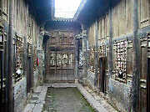
narrow & simple, decoration only. wealthy families: built large impressive gate instead: aka
"Horse Passing Door"; on sides of are: mounting-horse stones, tethering stake and rings of all
kinds -still present.
One wealthy layman dreamed to be an official , so, built sedan-like attic on top of gate, so every
time passed door, he feel like official;
Preserved well cuz wood-framed architectural structure so strong that even if walls fall, frame
structure will not collapse -- bandit protection designs,
“new village” for younger married generations; unaffected local peep customs & morals

TO DO:
Dangjiacun:
Courtyard houses, w/carvings & ATCH mix,
Confucian Pagoda (Wenzxing ge)
Hancheng:
Confucious TEMP: glazed dragon screens,
Chenghuang TEMP: Sacrifice Hall: rof detail
TRANS-OUT:
Hancheng > Xian
http://www.chinatravelguide.com/ctgwiki/Special:CNTrainSearch
TrainNo
Orgin-Des
From
DeptTime
To (in C
ArvT
Dist (km)
TOT
Seat
Hard Slp
SoftSlp
Taiyuan -
1095
19/32
61/64/66
98/102
Hancheng
Xian
02:16
07:22
240
西安
)
(
)
Lanzhou
韩城
(
05:06
Hancheng -
Hancheng
Xian
7003/7002
07:33
14:37
279
07:04
94/98
)
Xian
韩城
(
)
西安
(
18/33
57/60/62
7003/7002 STA/Times
Station
Station Name in C
ArrTim
DeptTim
Dist(km)
Total Time (h
韩城

Hancheng
-
07:33
-
00:00
韦庄

Weizhuang
10:32
10:34
107
02:59
大荔

Dali
11:02
11:04
121
03:29
钟家村

Zhongjiacu
11:49
11:51
153
04:16
张桥

Zhangqiao
12:02
12:04
164
04:29
阎良

Yanliang
12:26
12:29
184
04:53
三原

Sanyuan
12:55
12:57
210
05:22
咸阳

Xianyang
13:57
14:16
256
06:24
西安

Xian
14:37
-
279
07:04

