Rome2rio

<https://www.rome2rio.com/>

**Absolutely my most favorite overall travel routing & scheduling tool.**

Simple to use, broad in scope, yet drills down deep into most transport schedules. etc. Rome2rio may not get you to the remote, tiny village at the ‘far end of the dirt path’, but like “the end of the world”, you can probably see it from Rome2rio’s destination

Once I discovered Rome2rio it became the basis of my trip planning & scheduling for the balance of my 20 years of foreign travel …. replacing arduous hours trying to search for & mix other Internet resources and guidebook info.

**Replaced an prior army of Travel Agents**

**Please SEE ‘[scottsolotravels.com](http://scottsolotravels.com)' Website for in-depth tutorials:**

Transportation: <https://scottsolotravels.com/free-independent-travel/10-fit-transportation-full/>

Research: <https://scottsolotravels.com/free-independent-travel/4-fit-research-full/>

Planning: <https://scottsolotravels.com/free-independent-travel/6-fit-planning-full/>

Lodging: <https://scottsolotravels.com/free-independent-travel/11-fit-lodging-full/>

So, before wasting unimaginable amounts of research time, let’s exp[lore & learn how to use Rome2rio.

What is Rome2rio?

Rome2rio is a “**Start to Destination**” **multimodal transport-options** site & a booking engine. Rome2Rio quickly displays all your travel and booking options AND some car rental, lodging & tours in one convenient spot

Scope of Rome2rio:

Rome2rio transport options Include international & local air, airport to city transportation options, local & long distance bus & trains, cars, ride-shares, and even unique modes like ferries, water taxis & helicopters.

Rome2rio usually offers almost all ground transportation except perhaps to small villages way out in the more off-track remote “tules”, “toolies”, ”boondocks" or "the sticks." Yet, ironically, in 2011, I don’t recall Rome2rio directions to China’s Daxhai Village and its trailhead through & over the Longi Rice Terraces, BUT **NOW** it does (9/6/25)

**What does Rome2rio do?**

Rome2rio quickly, at no cost, finds & compares all your global travel transportation options as well as a few sponsored lodging, car rental & tour options in one convenient app.

In great detail Rome2rio offers multiple options based on a country or city’s available transportation modes including estimated travel times, costs, & distances for each option, all …. displayed on an interactive map.

Rome2rio covers over 240 countries, including nearly 200,000 train lines, 970,000 bus routes, 13,000 ferries, and 53,000 flight paths. It’s particularly useful for planning complex trips, especially to smaller or less-connected destinations facilitated by a user-friendly interface with multi-language support.

25 years ago I used maps & guidebooks to gain ‘iffy’ transport options that could only be verified once there on the ground. Later the internet (think Google Maps, Hostelworld, etc. shed quicker & deeper insights. Finally, in 2010 Rome2rio combined much of transportation information into an with a user friendly interface. Since then its capabilities appear to have increased including interactive maps of each leg of each option offered.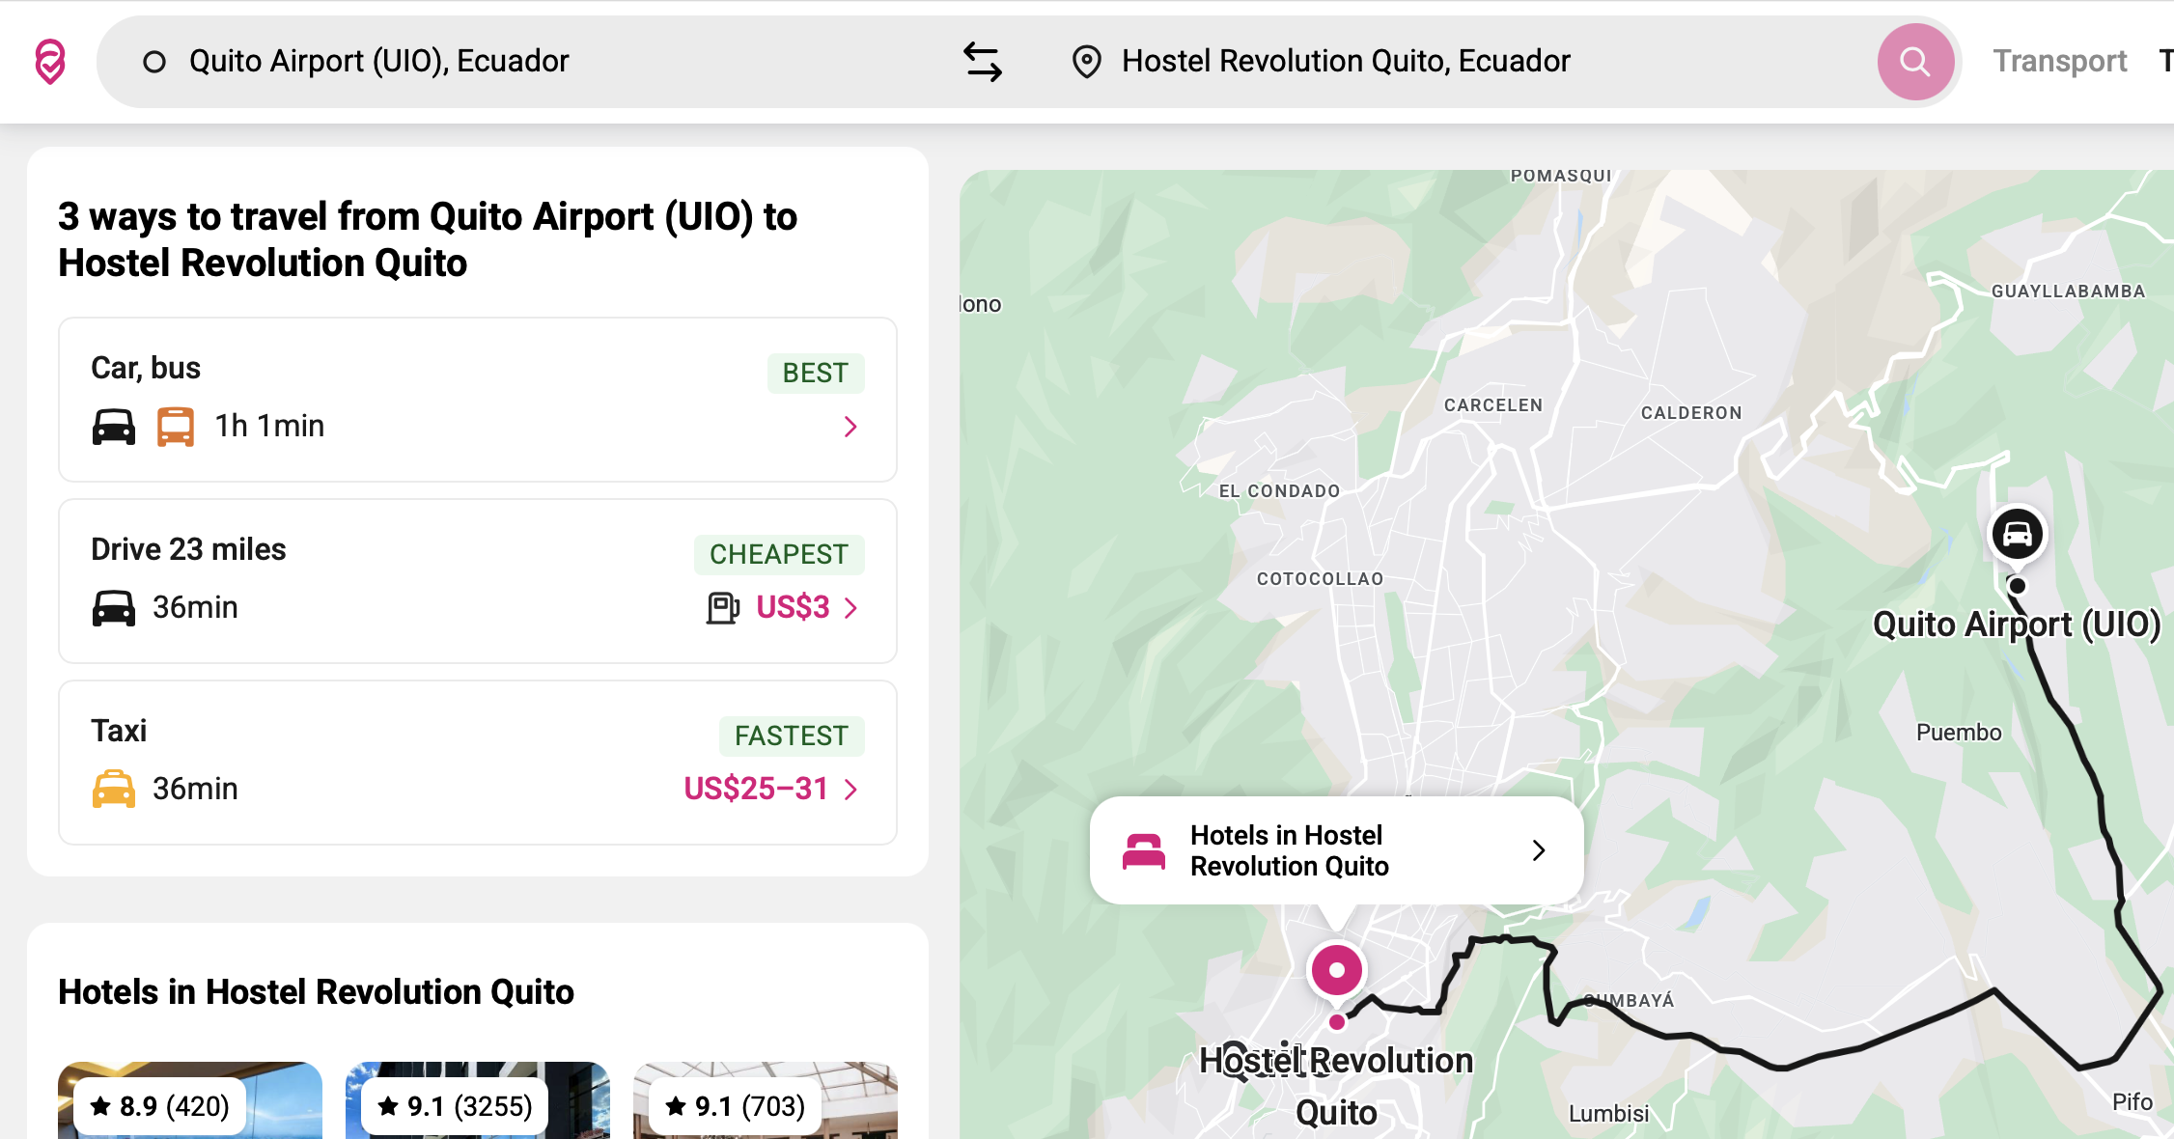

Travel transport agendas that used to take ME a mind-boggling of time time and intense concentration to research and decipher “How to get. there?’ options, …. **now takes minutes**.

**Safety Tool:** Rome2rio is also a **safety tool** because the mix & choice of transportation modes between two places can have serious safety implications.

Imagine navigation from the airport of a large city’s international airport (Quito, Ecuador) to your hostel somewhere in that city? An Airport Shuttle Bus may drop you off at a Main Bus Terminal, to await a local bus or walk several blocks to your hostel. Now, factor in a **dark, late night arrival** and your navigation and safety issues compound.

Often before arriving in a major city I may choose a slower local bus Rome2rio option rather than a fast Shuttle Bus so I can begin to immerse myself in this new city’s neighborhoods & culture, etc. Often, a slower option may include an interesting walk past small shops, grocery stores and homes to my hostel (Budapesh, Hungary). I have even walked in early morning’s dark from a Hanoi, Vietnam bus depot to my hostel because I was returning after a daytrip & by then I knew my way around.

BUT a similar, 1st time, late night Quito, Equador arrval in Quito would be complex, lonely & IMO, foolishly UNsafe … particularly for the 1st time. .

Other Rome2rio Features:

1. **Cost & Time** for each options sub-components.

2. **Interactive map** color-codes the exact route for each options sub-components.

3. **Booking transport/Lodging** **& Tours** website links of course.

**In Sum:** The IMPORTANT POINT, Rome 2rio simplifies & informs your transportation research & decisions long before you leave home so you are well prepared and safer when actually traveling.

~~~~~~~~~~~~~~~~~~~~~~~~~~~~~~~~~~~~

Actual Hypothetical Rome2rio’s use:

**Quito, Equador** Example: Mariscal Sucre International Airport to Hostel Revolution in Quito, Ecuador: Today (9/4/25) Rome2rio offers 3 options from Quito’s Int’l Airport to Hostel Revolution in Quito. Two are fastest & safest by private car or ‘licensed’ taxi. The 3rd is more complex, much slower, & only $7 less expensive, BUT, IMO, far more interesting if you don’t mind dragging your luggage 1 1/2-2 miles.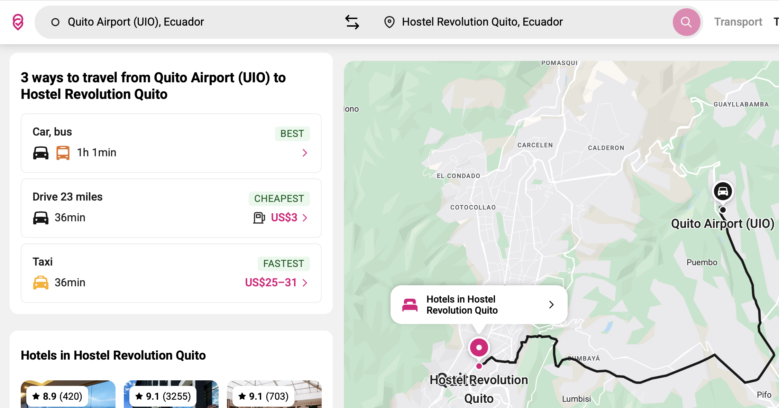

ANECDOTE: 2018/01/21 Late nite Quito arrival:

My only cheap, late day flight from Tucson, Arizona thru Dallas-Fort Worth, arrived well after midnight at Quito, Ecuador Int’l Airport and 45 mi from.Hostel Revolution in Quito. much of the distance is a beautiful high-speed freeway until you hit Quito with its ‘long valley’ deep beneath a complex array of mountain gorges and steep mountain sides draped with a mix of complex street systems, dense neighborhoods and occasional forested areas.

In **2018’s** Rome2rio’s **Worst Option:** was a taxi from Airport to Quito proper, then, a 10 min walk to San Diego bus stop, then, bus to El Tejar bus local bus terminal & short ride, until, finally, a 29 min steep luggage-drag trek to Hostel Revolution at 2:00 am in the darkly lit complex of streets I had never seen before. Too risky for my courage level, …. or lack of. Of course, best Rome2rio options was a taxi.

Fortunately for me, Sandra, Revolution Hostel’s gracious owner, solved my issue at last instant by providing her own taxi driver who met me inside the Airport Terminal after midnight, escorted me to directly to the hostel, handing me off to hostel’s night staff who quickly took me straight to my dorm bed and SLEEP. (Thanks again, Sandra)

2025’s Rome2rio Quito, Ecuador Options Tutorial:

Let’s go thru the search process even tho we know **licensed taxi** is the **best solution**

After opening the Rome2rio app ……………

#1: Choose your **Travel From** (start)**:** your home, airport, or city; even a   
 tourist site

#2: Choose your **To** (destination): an airport, lodging, city or a tourist site.

**Note**: Often when 1st arriving in a country or new city I want directions to my hostel so I can dump my luggage & start sightseeing. First I research my desired hostel in <https://www.hostelworld.com>

, etc, **book it** so it is assured, and plug my booked hostel into Rome2rio’s **TO** search field entry.

#3: Click Red Search button at right of **Travel From** and **To** search fields   
 to display Rome2rio’s 4 transport mode options including:

1. mode description

2. mode symbol/icon,

3. total time,

4. Rome2rio’s evaluation of each mode (Best, Cheapest, or Fastest)   
 **You may or may not agree.**

#4: Click any of Rome2rio’s 3 transport mode options or the magenta chevron icon at right for a detailed vertical flow diagram (see below) of this option’s mode or mix of modes including: transport mode, required time, distance & cost; often color coded for ease of use.

I**mportant Note:** Often when you click on a Mode Option or a Mode Option’s sub-component (bus vs walk vs taxi) you will get even more detailed information including bus/train/etc schedule times, frequency, # of changes, if any, etc.

**See Below for Vertical flow diagram**

Powerful medicine unless you want to spend hours looking for your destination etc.

#5: Explore the Vertical flow diagram (next page at right) for your option’s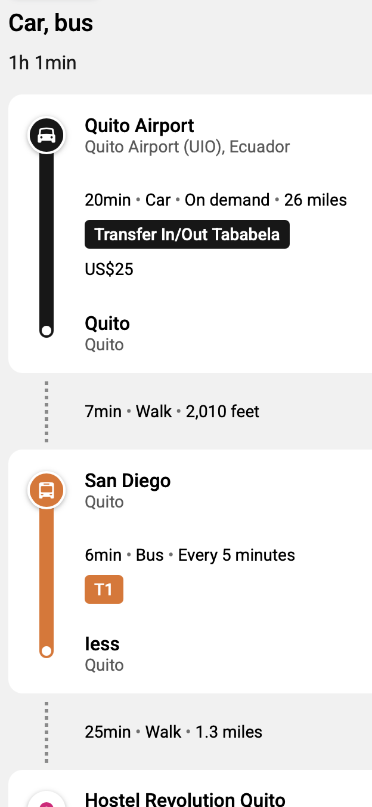   
 1. each transport modes in sequence (car, walk, bus, etc),   
 2. estimated total time for each mode

3. each mode’s frequency,   
 4. total distance,   
 5. specific mode’s Name (T1),   
 6. & cost, if any.   
 NOTE: If you click on some of the items (Example: (T1) it dives   
 even deeper.

#6: Telescope up & down in the embedded Google Maps for detailed street view.

#7 Scroll further down for car rental, lodging & tour options, if needed.

Remember, the more **info** you have

the **less fear** of the unknown & greater confidence in your journey.

USUALLY, useful train/bus schedules are made available for each transport option (Best, Cheapest, etc) and sub-modes (train>bus>walk) including the # of changes required as indicated on screen shot of Paris Option.

(SEE next page at left)

**Paris bus schedule Tutorial:**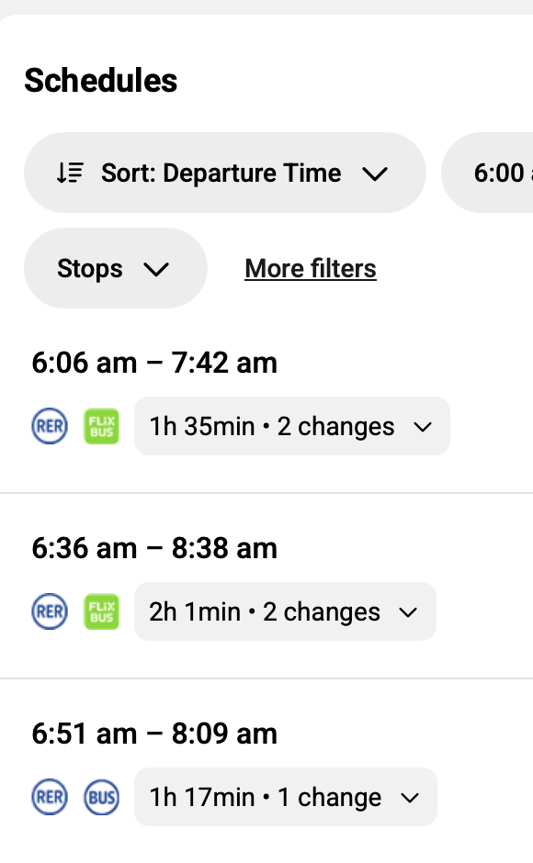

I mean this is deep diving.

I don’t recall this level of detail even 10 years ago.

**Beijing, China Tutorial:** Today (9/4/25) Rome2rio offers 4 options between Beijing’s Capitol International Airport and my Sleepy Inn Downtown Lakeside hosteI: Subway/Metro Line 2, bus, taxi, or Airport Shuttle.

I chose Metro Line 2 to Jishuitan Metro Station because it was fast, cheap ($5) AND I was nervous about my 30 month China visit and wanted as few complications as possible.

Ironically the 15 minute walk from Jishuitan Metro Station to my hostel introduced me to the businesses, pubic exercise park and beautiful lake I would pass many times while in & out of Beijing.

QUOTE:

How about this usage: “out in the toolies” was a phrase common when I was growing up in 70's Salt Lake City, Utah. It was used in my family to mean “way the hell out beyond the fringes of civilization,” otherwise known as Toole, Utah.

Ready for even more practical Rome2rio’s travel skills? Ok, let’s do it

8) Play with the map’s tools to telescope down to street level map view (New to me. Yippee for you!). [LINK] Bangkok ‘old traditional house’ search.

9) Finally, on far right click additional hot buttons for more info resources.

Rome2rio works for almost all ground transportation except perhaps to small villages way “out in the toolies.” [LINK]

How about this usage: “out in the toolies” was a phrase common when I was growing up in 70's Salt Lake City, Utah. It was used in my family to mean “way the hell out beyond the fringes of civilization,” otherwise known as Toole, Utah.

[tulies – A Way with Words, a fun radio show and podcast ...](https://www.waywordradio.org/tulies_1/)

One of travel’s thrills is getting your self way out in the ‘toolies’ even if on a tour. Perhaps the greatest ‘toolie’ is Antarctica almost by definition it at the end of the Road at least the bottom of the planet

*High End Trip Guide:*

Finally, just to be reasonably complete: some online companies & individual specialty guides will do all this work for you saving you much logistics time; precisely tailored to your aspiration (goals), convenience & comfort. you may not actually be able to do or as well.

e.g: I met Carol Walton on a Little Red Ship Antarctica trip she was guiding. She has her own very upscale African guide service.. private planes et al. She takes care of everything fast & in max luxury, I suspect.

*African guide: Carol Walton Expeditions:* <https://www.facebook.com/Carol-Walton-Expeditions-211035475602427/>

Stan Klassen (now passed- - 2011) ( Jackson Hole, WY, USA teacher) used to provide luxury guided tours in Europe for local wealthy folks. Uests would define their countries, sites, amenities etc and Stan would create their detailed itinerary. Then, Stan would travel alone to Europe & scope run thru the itinerary filling in the necessary logistics: flights, transportation, restaurants, hotels , local guides etc. Then returning he would take is covey of folks on their tailored tour. This is top-of-the-line travel.

Again depending on your mode of travel this might work for you.

In my case, I enjoy the research and the confidence I gain knowing the most intimate of travel itinerary details.

Avoid scams: i.e., if I take a taxi from the airport I don't learn the route mechanics & cues; , as much about not only the city but more importantly the route that I'm actually taking and why

Confidence when things go awry ( they will always go awry. _____ lives!) Take advantage of unforeseen opportunities. E. G. Normandy roommates quick decision to rent a car and visit Mount St. Michelle.